On

“SCHOOL FEE MANAGEMENT”

Submitted by:

Keshav Chaurasia

As per the requirement for School Leaving Certificate

Under the guidance of Mr. Suman Dhangol

Signature of guide: ………………………………..

Date of Submission: ……………………………

**Preface**

As per the requirements of S.L.C., this project work is done in QBASIC under the guidance of computer teacher Mr. Suman Dhangol. Doing this project work was a great experience for me. Besides those things up to my knowledge, I have learnt many other things while doing this project work and have helped me to acquire additional knowledge about QBASIC. This project work also provided me a golden opportunity to recall all those I have learned so far in QBASIC. This project work has been like a platform for me to learn new things as well as put together all those I have learnt so far in QBASIC in an organized manner to generate meaningful program and thus, has helped a lot to improve my knowledge in QBASIC. This project work is an outcome of hard work and hopefully comprises all the requirements.

This project is based on the menu driven program which has facilities to add, view, search, and modify records and fee structures. This program displays the name, roll number, class and address of the student. This program allows user to input monthly fee structures and can generate fees of the student according to user’s input. We can also keep individual fees of the student in this program. We also can search student profiles by supplying name, class or roll number. Finally, I would like to thank Mr. Suman Dhangol for guiding me to complete this project.

Keshav Chaurasia

Roll no: 691

**Table of Contents**

1. Background of the project
2. Aims and Objectives
3. Needs Assessment
4. Analyzing the problem
5. Designing the Solution
6. Coding
7. Output
8. Conclusion

**Background of the Project**

A data file that consists of data can be created in QBASIC in order to store data input by the user. So the user does not need to enter the same data repeatedly. This project is designed to fulfill the necessity of S.L.C. project work in QBASIC. This project Work is titled as “A Project Work in QBASIC on School Fee Management”.

This project has 3 data files. The first data file stores name, class, roll number and address of the student. The other file stores common fee structures and the last file stores individual fee structures. This program has facilities to add, search and modify records too. This program displays the name, class or roll number and his/her fees in the final output of the program.

**Aims and Objectives**

The aims and objectives of the project are as follows:

1. To provide concept of modular programming
2. To handle large database properly.
3. To reduce the manual errors.
4. To reduce the evolvement of personal while preparing the school fee
5. To search the information conveniently

**Needs Assessment**

The present age is the age of the science and technology. The development in these vary fields thus far has brought the world to these heights. The world at present has become this facilitated because of the remarkable achievements we have achieved because of science and technology. The world has become quite small for us because of the development of different means of communication in this modern age. I is yet another gift to mankind by science and technology.

In this modern education system it would be difficult in handling fee managements in paper; it’s quite a hectic job to go through the manual student records, their individual debits and make fee. Keeping this on mind, this school fee management has been developed. Though small it is much quicker and easier process to handle school fees. This School fee Management allows you to keep track of student records and generate fees. This allows adding, editing, searching and deleting student profiles, bill structures and individual fee structures of students much faster. If the data being searched is not available, it lets you know instantly and thus, saves your precious time.

**Analyzing the problem**

To fulfill the objective of this project, sequential data files are needed to be created in append mode.

**Structure of the Program**

Structure of Data file

There are three data files used in this program. The data file called “studentrecord.dat” contains fields like name, roll number, class and address of the students.

The data file called “billstructure.dat” contains class, narration and monthly fee structures.

The last data file named “ind.billstructure.dat” contains roll number, narration and monthly fee structure.

Algorithms

|  |  |
| --- | --- |
| Algorithm For Main Menu | |
| Step 1: | Start |
| Step 2: | Declare required variables and procedure |
| Step 3: | Display main menu having options:   1. Student Profiles 2. Fee Structure 3. Individual Feel Structure 4. Fee Generation 5. Exit |
| Step 4: | Stop |

|  |  |
| --- | --- |
| Algorithm For Menu of Student Records | |
| Step 1: | Start |
| Step 2: | Declare variables |
| Step 3: | Display menu having options:   1. Add student profiles 2. Display Student profiles 3. Search Student profiles 4. Edit Student Profiles 5. Delete student profiles |
| Step 4: | Stop |

|  |  |
| --- | --- |
| Algorithm For Adding a student profiles | |
| Step 1: | Start |
| Step 2: | Declare variables |
| Step 3: | Create a data file named “student record.dat” in append mode |
| Step 4: | Accept naam (full name of the Student), rollno (roll number of the student), class (class of the student), add(address of the student) |
| Step 5: | Store all the values of variable in the data file |
| Step 6: | Does user want to add more records?  {if yes then: repeat step 3,4,5} |
| Step 7: | Stop |

|  |  |
| --- | --- |
| Algorithm For Displaying a student profiles | |
| Step 1: | Start |
| Step 2: | Declare variables |
| Step 3: | open a data file named “studentrecord.dat” in input mode |
| Step 4: | Retrieve data from the data file and store them in naam, rollno, class and add |
| Step 5: | Display all those data |
| Step 6: | Is all the data retrieved?  {if no then: repeat step 4and 5} |
| Step 7: | Stop |

|  |  |
| --- | --- |
| Algorithm For Searching a student profiles | |
| Step 1: | Start |
| Step 2: | Declare variables |
| Step 3: | open a data file named “studentrecord.dat” in input mode |
| Step 4: | Do you want to search by name, roll number or class  {choice = name : go to step 5}  {choice = roll number: go to step 6}  {choice = class: go to step 7} |
| Step 5: | Read n(name to be search) |
| Step 6: | Read naam, rollno,class and add |
| Step 7: | Is naam =n?  {if yes then : Display naam, rollno, class and add} |
| Step 8: | Go to step 16 |
| Step 9: | Read r(roll number to be searched) |
| Step 10: | Read naam, rollno, class and add |
| Step 11: | Is r = rollno?  {if yes then: Display naam, rollno, class and add} |
| Step 12 | Go to step 16 |
| Step 13: | Read c(class to be searched) |
| Step 14: | Read naam, rollno,class and add |
| Step 15: | Is c = class?  {if yes then :Display naam, rollno, class and add} |
| Step 16: | Is all data retrieved?  {if no then: go to step 4} |
| Step 17: | Is found = 0?  {if yes then: display message as record not found} |

|  |  |
| --- | --- |
| Algorithm For Editing a student profiles | |
| Step 1: | Start |
| Step 2: | Declare variables |
| Step 3: | open a data file named “studentrecord.dat” in input mode |
| Step 4: | Open a data file named “tempo.dat” in output mode |
| Step 5: | Read n |
| Step 6: | Read r |
| Step7: | Read naam, rollno, class and add |
| Step 8: | Is n= naam and r = roll no?  {if yes then: Accept naam(new name), rollno(new roll number), class(new class) and add(new address) and store it in “tempo.dat” file}  {if no then : store naam, rollno, class and add in the “studentrecord.dat”} |
| Step 9: | Is all the data retrieved?  {if no then: Repeat step 7 and 8} |
| Step 10: | Delete “studentrecord.dat” |
| Step 11: | Change name of “tempo.dat” as “studentrecord.dat” |
| Step 12: | Stop |

|  |  |
| --- | --- |
| Algorithm For Deleting a student profiles | |
| Step 1: | Start |
| Step 2: | Declare variables |
| Step 3: | open a data file named “student record.dat” in input mode |
| Step 4: | Create a data file named “tempo.dat” in output mode |
| Step 5: | Read n |
| Step 6: | Read r |
| Step 7: | Read naam, rollno, class and add |
| Step 8: | Is n = naam and r = rollno  {if no then : store naam, rollno, class and add in data file named “tempo.dat”} |
| Step 9: | Is all data retrieved?  {if no then : repeat step 7 and 8} |
| Step 10: | Delete “studentrecord.dat” |
| Step 11: | Change name of “tempo.dat” as “studentrecord.dat” |
| Step 12: | Stop |

|  |  |
| --- | --- |
| Algorithm For Menu of Fee Structure | |
| Step 1: | Start |
| Step 2: | Declare required variables and procedures |
| Step 3: | Display Menu having options   1. Make Fee structure 2. Display Fee structure 3. Edit Fee Structure 4. Delete Fee structure 5. Exit |
| Step 4: | Stop |

|  |  |
| --- | --- |
| Algorithm For Making of the Fee structure | |
| Step 1: | Start |
| Step 2: | Declare variables |
| Step 3: | Create a data file named “billstructure.dat” in append mode |
| Step 4: | Get class1, n(narration), jan, feb, mar, apr, may, jun, jul, aug, sep, oct, nov, dec |
| Step 5: | Store all the values of the variables in the data file named “billstructure.dat” |
| Step 6: | Does a user want to add more records”  {if yes then : repeat step 3,4,5} |
| Step 7: | Stop |

|  |  |
| --- | --- |
| Algorithm For Viewing of the Fee Structure | |
| Step 1: | Start |
| Step 2: | Declare variables |
| Step 3: | Open a data file named “billstructure.dat” in input mode |
| Step 4: | Retrieve data from the file and store them in class1, n, jan, feb, mar, apr, may, jun, july, aug, sep, oct, nov and dec |
| Step 5: | Display those data |
| Step 6: | Is all the record retrieved?  { If No then : Repeat Step 4 and 5} |
| Step 7: | Stop |

|  |  |
| --- | --- |
| Algorithm For Editing of the Fee structure | |
| Step 1: | Start |
| Step 2: | Declare variables |
| Step 3: | Open a data file named “billstructure.dat” in input mode |
| Step 4: | Open a data file named “tempo.dat” in output mode |
| Step 5: | Read class |
| Step 6: | Read nar |
| Step 7: | Read class1, n, jan, feb, mar, apr, may, jun, july, aug, sep, oct, nov and dec |
| Step 8: | Is class = class1 and nar = n ?  {if Yes then : Accept class1, n, jan, feb, mar, apr, may, jun, july, aug, sep, oct, nov and dec in “tempo.dat”}  {if No then : store class1, n, jan, feb, mar, apr, may, jun, july, aug, sep, oct, nov and dec in the “billstructure.dat”} |
| Step 9: | Is all the record retrieved?  {if No then : Repeat Step 7 and 8} |
| Step 10: | Delete “billstructure.dat” |
| Step 11: | Change name of “tempo.dat” to “billstructure.dat” |
| Step 12: | Stop |

|  |  |
| --- | --- |
| Algorithm For Deleting of the Fee structure | |
| Step 1: | Start |
| Step 2: | Declare variables |
| Step 3: | Open a data file named “billstructure.dat” in the input mode |
| Step 4: | Create a data file named “tempo.dat” in Append mode |
| Step 5: | Read class |
| Step 6: | Read nar |
| Step 7: | Read class1, n, jan, feb, mar, apr, may, jun, july, aug, sep, oct, nov and dec |
| Step 8: | Is class = class 1 and nar = n?  {if No then : Store class1, n, jan, feb, mar, apr, may, jun, july, aug, sep, oct, nov and dec in “tempo.dat” file} |
| Step 9: | Is all records retrievd?  {if No then “ Repeat step 7 and 8} |
| Step 10: | Delete “billstructure.dat” |
| Step 11: | Change name of “tempo.dat” file as “billstructure.dat” |
| Step 12: | Stop |

|  |  |
| --- | --- |
| Algorithm For Menu of the Individual Fee structure | |
| Step 1: | Start |
| Step 2: | Declare required variables and procedures |
| Step 3: | Display Menu having options:   1. Make individual fee structure 2. Display individual fee structure 3. Edit individual fee structure 4. Delete individual fee structure 5. Exit |
| Step 4: | Stop |

|  |  |
| --- | --- |
| Algorithm For Making of the Individual Fee Structure | |
| Step 1: | Start |
| Step 2: | Declare variables |
| Step 3: | Create a data file named “ind.billstructure.dat” in append mode |
| Step 4: | Get r(roll number), n(narration), jan, feb, mar, apr, may, jun, jul, aug, sep, oct, nov and dec |
| Step 5: | Store all the values of the variables in the data file named “ind.billstructure.dat” |
| Step 6: | Does a user want to add more records”  {if Yes then : repeat step 3,4 and 5} |
| Step 7: | Stop |

|  |  |
| --- | --- |
| Algorithm For Viewing of the Individual Fee Structure | |
| Step 1: | Start |
| Step 2: | Declare variables |
| Step 3: | Open a data file named “ind.billstructure.dat” in input mode |
| Step 4: | Retrieve data from the file and store them in r, n, jan, feb, mar, apr, may, jun, jul, aug, sep, oct, nov and dec |
| Step 5: | Display those data |
| Step 6: | Is all the records retrieved?  {if No then : repeat step 4 and 5} |
| Step 7: | Stop |

|  |  |
| --- | --- |
| Algorithm For Editing of the Individual Fee Structure | |
| Step 1: | Start |
| Step 2: | Declare variables |
| Step 3: | Open a data file named “ind.billstructure.dat” in input mode |
| Step 4: | Open a data file named “tempo.dat” in output mode |
| Step 5: | Read ro |
| Step 6: | Read nar |
| Step 7: | Read r, n, jan, feb, mar, apr, may, jun, jul, aug, sep, oct, nov and dec |
| Step 8: | Is ro = r and nar = n?  {if Yes then : Accept r, n, jan, feb, mar, apr, may, jun, jul, aug, sep, oct, nov and dec and store them in the “tempo.dat” file}  {if No then : store r, n, jan, feb, mar, apr, may, jun, jul, aug, sep, oct, nov and dec in the “ind.billstructure.dat” file} |
| Step 9: | Is all the data retrieved?  {if No then : Repeat step 7 and 8} |
| Step 10: | Delete “ind.billstructure.dat” |
| Step 11: | Change name of “tempo.dat” to “ind.billstructure.dat” |
| Step 12: | Stop |

|  |  |
| --- | --- |
| Algorithm For Deleting of the Individual Fee Structure | |
| Step 1: | Start |
| Step 2: | Declare variables |
| Step 3: | Create a data file named “tempo.dat” in append mode |
| Step 4: | Open a data file named “ind.billstructure.dat” in input mode |
| Step 5: | Read ro |
| Step 6: | Read nar |
| Step 7: | Read r, n, jan, feb, mar, apr, may, jun, jul, aug, sep, oct, nov and dec |
| Step 8: | Is ro = r and nar = n?  {if No then : Store r, n, jan, feb, mar, apr, may, jun, jul, aug, sep, oct, nov and dec in “tempo.dat” file} |
| Step 9: | Is all the record retrieved?  {if No then : Repeat Step 7 and 8} |
| Step 10: | Delete “ind.billstructure.dat” |
| Step 11: | Change name of file “tempo.dat” as “ind.billstructure.dat” |
| Step 12: | Stop |

|  |  |
| --- | --- |
| Algorithm For Menu of Fee Generation | |
| Step 1: | Start |
| Step 2: | Declare required variables and procedures |
| Step 3: | Display Menu having options:   1. Fee generation by Roll number 2. Fee generation by Name 3. Exit |
| Step 4: | Stop |

|  |  |
| --- | --- |
| Algorithm For Fee Generation by roll number | |
| Step 1: | Start |
| Step 2: | Open a data file named “studentrecord.dat” in input mode |
| Step 3: | Read roll and mon1 |
| Step 4: | Debt = 0  Finaldebt = 0  Found = 0 |
| Step 5: | Read naam, rollno, class and add |
| Step 6: | Is roll = rollno?  {if Yes then : Go to step 7}  {if No then : Go to step} |
| Step 7: | Found = 1 |
| Step 8: | Display naam and class |
| Step 9: | Read class1, n, jan, feb, mar, apr, may, jun, jul, aug, sep, oct, nov and dec |
| Step 10: | Is class = class1 & mon1 = 1 & n = tuition fee?  {if Yes then : Go to step : 11}  {if No then : Go to step : 13} |
| Step 11: | Debt =debt + jan |
| Step 12: | Print jan |
| Step 13: | Is class = class1 & mon1 = 1 & n = exam fee?  {if Yes then : Go to step : 14}  {if No then : Go to step : 16} |
| Step 14: | Debt =debt + jan |
| Step 15: | Print jan |
| Step 16: | Is class = class1 & mon1 = 1 & n = bus fee?  {if Yes then : Go to step : 17}  {if No then : Go to step : 19} |
| Step 17: | Debt =debt + jan |
| Step 18: | Print jan |
| Step 19: | Is class = class1 & mon1 = 1 & n = library?  {if Yes then : Go to step : 20}  {if No then : Go to step : 22} |
| Step 20: | Debt =debt + jan |
| Step 21: | Print jan |
| Step 22: | Is class = class1 & mon1 = 1 & n = computer?  {if Yes then : Go to step : 23}  {if No then : Go to step : 25} |
| Step 23: | Debt =debt + jan |
| Step 24: | Print jan |
| Step 25: | Is class = class1 & mon1 = 1 & n = activities?  {if Yes then : Go to step : 26}  {if No then : Go to step : 28} |
| Step 26: | Debt =debt + jan |
| Step 27: | Print jan |
| Step 28: | Is class = class1 & mon1 = 1 & n = other?  {if Yes then : Go to step : 29}  {if No then : Go to step : 31} |
| Step 29: | Debt =debt + jan |
| Step 30: | Print jan |
| Step 31: | Is class = class1 & mon1 = 2 & n = tuition fee?  {if Yes then : Go to step : 32}  {if No then : Go to step : 34} |
| Step 32: | Debt =debt + feb |
| Step 33: | Print feb |
| Step 34: | Is class = class1 & mon1 = 2 & n = exam fee?  {if Yes then : Go to step : 35}  {if No then : Go to step : 37} |
| Step 35: | Debt =debt + feb |
| Step 36: | Print feb |
| Step 37: | Is class = class1 & mon1 = 2 & n = bus fee?  {if Yes then : Go to step : 38}  {if No then : Go to step : 40} |
| Step 38: | Debt =debt + feb |
| Step 39: | Print feb |
| Step 40: | Is class = class1 & mon1 = 2 & n = library?  {if Yes then : Go to step : 41}  {if No then : Go to step : 43} |
| Step 41: | Debt =debt + feb |
| Step 42: | Print feb |
| Step 43: | Is class = class1 & mon1 = 2 & n = computer?  {if Yes then : Go to step : 44}  {if No then : Go to step : 46} |
| Step 44: | Debt =debt + feb |
| Step 45: | Print feb |
| Step 46: | Is class = class1 & mon1 = 2 & n = activities?  {if Yes then : Go to step : 47}  {if No then : Go to step : 49} |
| Step 47: | Debt =debt + feb |
| Step 48: | Print feb |
| Step 49: | Is class = class1 & mon1 = 2 & n = other?  {if Yes then : Go to step : 50}  {if No then : Go to step : 52} |
| Step 50: | Debt =debt + feb |
| Step 51: | Print feb |
| Step 52: | Is class = class1 & mon1 = 3 & n = tuition fee?  {if Yes then : Go to step : 53}  {if No then : Go to step : 55} |
| Step 53: | Debt =debt + jan |
| Step 54: | Print mar |
| Step 55: | Is class = class1 & mon1 = 3 & n = exam fee?  {if Yes then : Go to step : 56}  {if No then : Go to step : 58} |
| Step 56: | Debt =debt + mar |
| Step 57: | Print mar |
| Step 58: | Is class = class1 & mon1 = 3 & n = bus fee?  {if Yes then : Go to step : 59}  {if No then : Go to step : 61} |
| Step 59: | Debt =debt + mar |
| Step 60: | Print mar |
| Step 61: | Is class = class1 & mon1 = 3 & n = library?  {if Yes then : Go to step : 62}  {if No then : Go to step : 64} |
| Step 62: | Debt =debt + mar |
| Step 63: | Print mar |
| Step 64: | Is class = class1 & mon1 = 3 & n = computer?  {if Yes then : Go to step : 65}  {if No then : Go to step : 67} |
| Step 65: | Debt =debt + mar |
| Step 66: | Print mar |
| Step 67: | Is class = class1 & mon1 = 3 & n = activities?  {if Yes then : Go to step : 68}  {if No then : Go to step : 70} |
| Step 68: | Debt =debt + mar |
| Step 69: | Print mar |
| Step 70: | Is class = class1 & mon1 = 3 & n = other?  {if Yes then : Go to step : 71}  {if No then : Go to step : 73} |
| Step 71: | Debt =debt + mar |
| Step 72: | Print mar |
| Step 73: | Is class = class1 & mon1 = 4 & n = tuition fee?  {if Yes then : Go to step : 74}  {if No then : Go to step : 76} |
| Step 74: | Debt =debt + apr |
| Step 75: | Print apr |
| Step 76: | Is class = class1 & mon1 = 4 & n = exam fee?  {if Yes then : Go to step : 77}  {if No then : Go to step : 79} |
| Step 77: | Debt =debt + apr |
| Step 78: | Print apr |
| Step 79: | Is class = class1 & mon1 = 4 & n = bus fee?  {if Yes then : Go to step : 80}  {if No then : Go to step : 82} |
| Step 80: | Debt =debt + apr |
| Step 81: | Print apr |
| Step 82: | Is class = class1 & mon1 = 4 & n = library?  {if Yes then : Go to step : 83}  {if No then : Go to step : 85} |
| Step 83: | Debt =debt + apr |
| Step 84: | Print apr |
| Step 85: | Is class = class1 & mon1 = 4 & n = computer?  {if Yes then : Go to step : 86}  {if No then : Go to step : 88} |
| Step 86: | Debt =debt + apr |
| Step 87: | Print apr |
| Step 88: | Is class = class1 & mon1 = 4 & n = activities?  {if Yes then : Go to step : 89}  {if No then : Go to step : 91} |
| Step 89: | Debt =debt + apr |
| Step 90: | Print apr |
| Step 91: | Is class = class1 & mon1 = 4 & n = other?  {if Yes then : Go to step : 92}  {if No then : Go to step : 94} |
| Step 92: | Debt =debt + apr |
| Step 93: | Print apr |
| Step 94: | Is class = class1 & mon1 = 5 & n = tuition fee?  {if Yes then : Go to step : 95}  {if No then : Go to step : 97} |
| Step 95: | Debt =debt + may |
| Step 96: | Print may |
| Step 97: | Is class = class1 & mon1 = 5 & n = exam fee?  {if Yes then : Go to step : 98}  {if No then : Go to step : 100} |
| Step 98: | Debt =debt + may |
| Step 99: | Print may |
| Step 100: | Is class = class1 & mon1 = 5 & n = bus fee?  {if Yes then : Go to step : 101}  {if No then : Go to step : 103} |
| Step 101: | Debt =debt + may |
| Step 102: | Print may |
| Step 103: | Is class = class1 & mon1 = 5 & n = library?  {if Yes then : Go to step : 104}  {if No then : Go to step : 106} |
| Step 104: | Debt =debt + may |
| Step 105: | Print may |
| Step 106: | Is class = class1 & mon1 = 5 & n = computer?  {if Yes then : Go to step : 107}  {if No then : Go to step : 109} |
| Step 107: | Debt =debt + may |
| Step 108: | Print may |
| Step 109: | Is class = class1 & mon1 = 5 & n = activities?  {if Yes then : Go to step : 110}  {if No then : Go to step : 112} |
| Step 110: | Debt =debt + may |
| Step 111: | Print may |
| Step 112: | Is class = class1 & mon1 = 5 & n = other?  {if Yes then : Go to step : 113}  {if No then : Go to step : 115} |
| Step 113: | Debt =debt + may |
| Step 114: | Print may |
| Step 115: | Is class = class1 & mon1 = 6 & n = tuition fee?  {if Yes then : Go to step : 116}  {if No then : Go to step : 118} |
| Step 116: | Debt =debt + jun |
| Step 117: | Print jun |
| Step 118: | Is class = class1 & mon1 = 6 & n = exam fee?  {if Yes then : Go to step : 119}  {if No then : Go to step : 121} |
| Step 119: | Debt =debt + jun |
| Step 120: | Print jun |
| Step 121: | Is class = class1 & mon1 = 6 & n = bus fee?  {if Yes then : Go to step : 122}  {if No then : Go to step : 124} |
| Step 122: | Debt =debt + jun |
| Step 123: | Print jun |
| Step 124: | Is class = class1 & mon1 = 6 & n = library?  {if Yes then : Go to step : 125}  {if No then : Go to step : 127} |
| Step 125: | Debt =debt + jun |
| Step 126: | Print jun |
| Step 127: | Is class = class1 & mon1 = 6 & n = computer?  {if Yes then : Go to step : 128}  {if No then : Go to step : 130} |
| Step 128: | Debt =debt + jun |
| Step 129: | Print jun |
| Step 130: | Is class = class1 & mon1 = 6 & n = activities?  {if Yes then : Go to step : 131}  {if No then : Go to step : 133} |
| Step 131: | Debt =debt + jun |
| Step 132: | Print jun |
| Step 133: | Is class = class1 & mon1 = 6 & n = other?  {if Yes then : Go to step : 134}  {if No then : Go to step : 136} |
| Step 134: | Debt =debt + jun |
| Step 135: | Print jun |
| Step 136: | Is class = class1 & mon1 = 7 & n = tuition fee?  {if Yes then : Go to step : 137}  {if No then : Go to step : 139} |
| Step 137: | Debt =debt + jul |
| Step 138: | Print jul |
| Step 139: | Is class = class1 & mon1 = 7 & n = exam fee?  {if Yes then : Go to step : 140}  {if No then : Go to step : 142} |
| Step 140: | Debt =debt + jul |
| Step 141: | Print jul |
| Step 142: | Is class = class1 & mon1 = 7 & n = bus fee?  {if Yes then : Go to step : 143}  {if No then : Go to step : 145} |
| Step 143: | Debt =debt + jul |
| Step 144: | Print jul |
| Step 145: | Is class = class1 & mon1 = 7 & n = library?  {if Yes then : Go to step : 146}  {if No then : Go to step : 148} |
| Step 146: | Debt =debt + jul |
| Step 147: | Print jul |
| Step 148: | Is class = class1 & mon1 = 7 & n = computer?  {if Yes then : Go to step : 149}  {if No then : Go to step : 151} |
| Step 149: | Debt =debt + jul |
| Step 150: | Print jul |
| Step 151: | Is class = class1 & mon1 = 7 & n = activities?  {if Yes then : Go to step : 152}  {if No then : Go to step : 154} |
| Step 152: | Debt =debt + jul |
| Step 153: | Print jul |
| Step 154: | Is class = class1 & mon1 = 7 & n = other?  {if Yes then : Go to step : 155}  {if No then : Go to step : 157} |
| Step 155: | Debt =debt + jul |
| Step 156: | Print jul |
| Step 157: | Is class = class1 & mon1 = 8 & n = tuition fee?  {if Yes then : Go to step : 158}  {if No then : Go to step : 160} |
| Step 158: | Debt =debt + aug |
| Step 159: | Print aug |
| Step 160: | Is class = class1 & mon1 = 8 & n = exam fee?  {if Yes then : Go to step : 161}  {if No then : Go to step : 163} |
| Step 161: | Debt =debt + aug |
| Step 162: | Print aug |
| Step 163: | Is class = class1 & mon1 = 8 & n = bus fee?  {if Yes then : Go to step : 164}  {if No then : Go to step : 166} |
| Step 164: | Debt =debt + aug |
| Step 165: | Print aug |
| Step 166: | Is class = class1 & mon1 = 8 & n = library?  {if Yes then : Go to step : 167}  {if No then : Go to step : 169} |
| Step 167: | Debt =debt + aug |
| Step 168: | Print aug |
| Step 169: | Is class = class1 & mon1 = 8 & n = computer?  {if Yes then : Go to step : 170}  {if No then : Go to step : 172} |
| Step 170: | Debt =debt + aug |
| Step 171: | Print aug |
| Step 172: | Is class = class1 & mon1 = 8 & n = activities?  {if Yes then : Go to step : 173}  {if No then : Go to step : 175} |
| Step 173: | Debt =debt + aug |
| Step 174: | Print aug |
| Step 175: | Is class = class1 & mon1 = 8 & n = other?  {if Yes then : Go to step : 176}  {if No then : Go to step : 178} |
| Step 176: | Debt =debt + aug |
| Step 177: | Print aug |
| Step 178: | Is class = class1 & mon1 = 9 & n = tuition fee?  {if Yes then : Go to step : 179}  {if No then : Go to step : 181} |
| Step 179: | Debt =debt + sep |
| Step 180: | Print sep |
| Step 181: | Is class = class1 & mon1 = 9 & n = exam fee?  {if Yes then : Go to step : 182}  {if No then : Go to step : 184} |
| Step 182: | Debt =debt + sep |
| Step 183: | Print sep |
| Step 184: | Is class = class1 & mon1 = 9 & n = bus fee?  {if Yes then : Go to step : 185}  {if No then : Go to step : 187} |
| Step 185: | Debt =debt + sep |
| Step 186: | Print sep |
| Step 187: | Is class = class1 & mon1 = 9 & n = library?  {if Yes then : Go to step : 188}  {if No then : Go to step : 190} |
| Step 188: | Debt =debt + sep |
| Step 189: | Print sep |
| Step 190: | Is class = class1 & mon1 = 9 & n = computer?  {if Yes then : Go to step : 191}  {if No then : Go to step : 193} |
| Step 191: | Debt =debt + sep |
| Step 192: | Print sep |
| Step 193: | Is class = class1 & mon1 = 9 & n = activities?  {if Yes then : Go to step : 194}  {if No then : Go to step : 196} |
| Step 194: | Debt =debt + sep |
| Step 195: | Print sep |
| Step 196: | Is class = class1 & mon1 = 9 & n = other?  {if Yes then : Go to step : 197}  {if No then : Go to step : 199} |
| Step 197: | Debt =debt + sep |
| Step 198: | Print sep |
| Step 199: | Is class = class1 & mon1 = 10 & n = tuition fee?  {if Yes then : Go to step : 200}  {if No then : Go to step : 202} |
| Step 200: | Debt =debt + oct |
| Step 201: | Print oct |
| Step 202: | Is class = class1 & mon1 = 10 & n = exam fee?  {if Yes then : Go to step : 203}  {if No then : Go to step : 205} |
| Step 203: | Debt =debt + oct |
| Step 204: | Print oct |
| Step 205: | Is class = class1 & mon1 = 10 & n = bus fee?  {if Yes then : Go to step : 206}  {if No then : Go to step : 208} |
| Step 206: | Debt =debt + oct |
| Step 207: | Print oct |
| Step 208: | Is class = class1 & mon1 = 10 & n = library?  {if Yes then : Go to step : 209}  {if No then : Go to step : 211} |
| Step 209: | Debt =debt + oct |
| Step 210: | Print oct |
| Step 211: | Is class = class1 & mon1 = 10 & n = computer?  {if Yes then : Go to step : 212}  {if No then : Go to step : 214} |
| Step 212: | Debt =debt + oct |
| Step 213: | Print oct |
| Step 214: | Is class = class1 & mon1 = 10 & n = activities?  {if Yes then : Go to step : 215}  {if No then : Go to step : 217} |
| Step 215: | Debt =debt + oct |
| Step 216: | Print oct |
| Step 217: | Is class = class1 & mon1 = 10 & n = other?  {if Yes then : Go to step : 218}  {if No then : Go to step : 220} |
| Step 218: | Debt =debt + oct |
| Step 219: | Print oct |
| Step 220: | Is class = class1 & mon1 = 11 & n = tuition fee?  {if Yes then : Go to step : 221}  {if No then : Go to step : 223} |
| Step 221: | Debt =debt + nov |
| Step 222: | Print nov |
| Step 223: | Is class = class1 & mon1 = 11 & n = exam fee?  {if Yes then : Go to step : 224}  {if No then : Go to step : 226} |
| Step 224: | Debt =debt + nov |
| Step 225: | Print nov |
| Step 226: | Is class = class1 & mon1 = 11 & n = bus fee?  {if Yes then : Go to step : 227}  {if No then : Go to step : 229} |
| Step 227: | Debt =debt + nov |
| Step 228: | Print nov |
| Step 229: | Is class = class1 & mon1 = 11 & n = library?  {if Yes then : Go to step : 230}  {if No then : Go to step : 232} |
| Step 230: | Debt =debt + nov |
| Step 231: | Print nov |
| Step 232: | Is class = class1 & mon1 = 11 & n = computer?  {if Yes then : Go to step : 233}  {if No then : Go to step : 235} |
| Step 233: | Debt =debt + nov |
| Step 234: | Print nov |
| Step 235: | Is class = class1 & mon1 = 11 & n = activities?  {if Yes then : Go to step : 236}  {if No then : Go to step : 238} |
| Step 236: | Debt =debt + nov |
| Step 237: | Print nov |
| Step 238: | Is class = class1 & mon1 = 11 & n = other?  {if Yes then : Go to step : 239}  {if No then : Go to step : 241} |
| Step 239: | Debt =debt + nov |
| Step 240: | Print nov |
| Step 241: | Is class = class1 & mon1 = 12 & n = tuition fee?  {if Yes then : Go to step : 242}  {if No then : Go to step : 244} |
| Step 242: | Debt =debt + dec |
| Step 243: | Print dec |
| Step 244: | Is class = class1 & mon1 = 12 & n = exam fee?  {if Yes then : Go to step : 245}  {if No then : Go to step : 247} |
| Step 245: | Debt =debt + dec |
| Step 246: | Print dec |
| Step 247: | Is class = class1 & mon1 = 12 & n = bus fee?  {if Yes then : Go to step : 248}  {if No then : Go to step : 250} |
| Step 248: | Debt =debt + dec |
| Step 249: | Print dec |
| Step 250: | Is class = class1 & mon1 = 12 & n = library?  {if Yes then : Go to step : 251}  {if No then : Go to step : 253} |
| Step 251: | Debt =debt + dec |
| Step 252: | Print dec |
| Step 253: | Is class = class1 & mon1 = 12 & n = computer?  {if Yes then : Go to step : 254}  {if No then : Go to step : 256} |
| Step 254: | Debt =debt + dec |
| Step 255: | Print dec |
| Step 256: | Is class = class1 & mon1 = 12 & n = activities?  {if Yes then : Go to step : 257}  {if No then : Go to step : 259} |
| Step 257: | Debt =debt + dec |
| Step 258: | Print dec |
| Step 259: | Is class = class1 & mon1 = 12 & n = other?  {if Yes then : Go to step : 260}  {if No then : Go to step : 262} |
| Step 260: | Debt =debt + dec |
| Step 261: | Print dec |
| Step 262: | Are all records of “billstructure.dat” read?  {if No then : Repeat Steps (9 – 261)} |
| Step 263: | Ind.debt = 0 |
| Step 264: | Open a data file named “ind.billstructure.dat” in input mode |
| Step 265: | Read r, n, jan, feb, mar, apr, may, jun, jul, aug, sep, oct, nov &dec |
| Step 266: | Is roll = r and mon1 = 1?  {if Yes then : Go to step 267}  {if No then : Go to step 269} |
| Step 267: | Ind.debt = ind.debt + jan |
| Step 268: | Display jan |
| Step 269: | Is roll = r and mon1 = 2?  {if Yes then : Go to step 270}  {if No then : Go to step 272} |
| Step 270: | Ind.debt = ind.debt + feb |
| Step 271: | Display feb |
| Step 272: | Is roll = r and mon1 = 3?  {if Yes then : Go to step 273}  {if No then : Go to step 275} |
| Step 273: | Ind.debt = ind.debt + mar |
| Step 274: | Display mar |
| Step 275: | Is roll = r and mon1 = 4?  {if Yes then : Go to step 276}  {if No then : Go to step 278} |
| Step 276: | Ind.debt = ind.debt + apr |
| Step 277: | Display apr |
| Step 278: | Is roll = r and mon1 = 5?  {if Yes then : Go to step 279}  {if No then : Go to step 281} |
| Step 279: | Ind.debt = ind.debt + may |
| Step 280: | Display may |
| Step 281: | Is roll = r and mon1 = 6?  {if Yes then : Go to step 282}  {if No then : Go to step 284} |
| Step 282: | Ind.debt = ind.debt + jun |
| Step 283: | Display jun |
| Step 284: | Is roll = r and mon1 = 7?  {if Yes then : Go to step 285}  {if No then : Go to step 287} |
| Step 285: | Ind.debt = ind.debt + jul |
| Step 286: | Display jul |
| Step 287: | Is roll = r and mon1 = 8?  {if Yes then : Go to step 288}  {if No then : Go to step 290} |
| Step 288: | Ind.debt = ind.debt + aug |
| Step 289: | Display aug |
| Step 290: | Is roll = r and mon1 =9?  {if Yes then : Go to step 291}  {if No then : Go to step 293} |
| Step 291: | Ind.debt = ind.debt + sep |
| Step 292: | Display sep |
| Step 293: | Is roll = r and mon1 = 10?  {if Yes then : Go to step 294}  {if No then : Go to step 296} |
| Step 294: | Ind.debt = ind.debt + oct |
| Step 295: | Display oct |
| Step 296: | Is roll = r and mon1 = 11?  {if Yes then : Go to step 297}  {if No then : Go to step 299} |
| Step 297: | Ind.debt = ind.debt + nov |
| Step 298: | Display nov |
| Step 299: | Is roll = r and mon1 = 12?  {if Yes then : Go to step 300}  {if No then : Go to step 302} |
| Step 300: | Ind.debt = ind.debt + dec |
| Step 301: | Display dec |
| Step 302: | Are all records of “ind.billstructure.dat” read?  {if No then : Repeat Steps (265 – 301) |
| Step 303: | Finaldebt = debt + ind.debt |
| Step 304: | Display finaldebt |
| Step 305: | Are all records of “studentrecord.dat” read?  {if No then : Repeat Steps (5 -304) |
| Step 307: | Is found = 0?  {if Yes then : Display “Wrong Entry”} |
| Step 308: | Stop |

|  |  |
| --- | --- |
| Algorithm For Fee Generation by Name | |
| Step 1: | Start |
| Step 2: | Open a data file named “studentrecord.dat” in input mode |
| Step 3: | Read naam1 and mon1 |
| Step 4: | Debt = 0  Finaldebt = 0  Found = 0 |
| Step 5: | Read naam, rollno, class and add |
| Step 6: | Is naam1 = naam?  {if Yes then : Go to step 7}  {if No then : Go to step} |
| Step 7: | Found = 1 |
| Step 8: | Display rollno and class |
| Step 9: | Read class1, n, jan, feb, mar, apr, may, jun, jul, aug, sep, oct, nov and dec |
| Step 10: | Is class = class1 & mon1 = 1 & n = tuition fee?  {if Yes then : Go to step : 11}  {if No then : Go to step : 13} |
| Step 11: | Debt =debt + jan |
| Step 12: | Print jan |
| Step 13: | Is class = class1 & mon1 = 1 & n = exam fee?  {if Yes then : Go to step : 14}  {if No then : Go to step : 16} |
| Step 14: | Debt =debt + jan |
| Step 15: | Print jan |
| Step 16: | Is class = class1 & mon1 = 1 & n = bus fee?  {if Yes then : Go to step : 17}  {if No then : Go to step : 19} |
| Step 17: | Debt =debt + jan |
| Step 18: | Print jan |
| Step 19: | Is class = class1 & mon1 = 1 & n = library?  {if Yes then : Go to step : 20}  {if No then : Go to step : 22} |
| Step 20: | Debt =debt + jan |
| Step 21: | Print jan |
| Step 22: | Is class = class1 & mon1 = 1 & n = computer?  {if Yes then : Go to step : 23}  {if No then : Go to step : 25} |
| Step 23: | Debt =debt + jan |
| Step 24: | Print jan |
| Step 25: | Is class = class1 & mon1 = 1 & n = activities?  {if Yes then : Go to step : 26}  {if No then : Go to step : 28} |
| Step 26: | Debt =debt + jan |
| Step 27: | Print jan |
| Step 28: | Is class = class1 & mon1 = 1 & n = other?  {if Yes then : Go to step : 29}  {if No then : Go to step : 31} |
| Step 29: | Debt =debt + jan |
| Step 30: | Print jan |
| Step 31: | Is class = class1 & mon1 = 2 & n = tuition fee?  {if Yes then : Go to step : 32}  {if No then : Go to step : 34} |
| Step 32: | Debt =debt + feb |
| Step 33: | Print feb |
| Step 34: | Is class = class1 & mon1 = 2 & n = exam fee?  {if Yes then : Go to step : 35}  {if No then : Go to step : 37} |
| Step 35: | Debt =debt + feb |
| Step 36: | Print feb |
| Step 37: | Is class = class1 & mon1 = 2 & n = bus fee?  {if Yes then : Go to step : 38}  {if No then : Go to step : 40} |
| Step 38: | Debt =debt + feb |
| Step 39: | Print feb |
| Step 40: | Is class = class1 & mon1 = 2 & n = library?  {if Yes then : Go to step : 41}  {if No then : Go to step : 43} |
| Step 41: | Debt =debt + feb |
| Step 42: | Print feb |
| Step 43: | Is class = class1 & mon1 = 2 & n = computer?  {if Yes then : Go to step : 44}  {if No then : Go to step : 46} |
| Step 44: | Debt =debt + feb |
| Step 45: | Print feb |
| Step 46: | Is class = class1 & mon1 = 2 & n = activities?  {if Yes then : Go to step : 47}  {if No then : Go to step : 49} |
| Step 47: | Debt =debt + feb |
| Step 48: | Print feb |
| Step 49: | Is class = class1 & mon1 = 2 & n = other?  {if Yes then : Go to step : 50}  {if No then : Go to step : 52} |
| Step 50: | Debt =debt + feb |
| Step 51: | Print feb |
| Step 52: | Is class = class1 & mon1 = 3 & n = tuition fee?  {if Yes then : Go to step : 53}  {if No then : Go to step : 55} |
| Step 53: | Debt =debt + jan |
| Step 54: | Print mar |
| Step 55: | Is class = class1 & mon1 = 3 & n = exam fee?  {if Yes then : Go to step : 56}  {if No then : Go to step : 58} |
| Step 56: | Debt =debt + mar |
| Step 57: | Print mar |
| Step 58: | Is class = class1 & mon1 = 3 & n = bus fee?  {if Yes then : Go to step : 59}  {if No then : Go to step : 61} |
| Step 59: | Debt =debt + mar |
| Step 60: | Print mar |
| Step 61: | Is class = class1 & mon1 = 3 & n = library?  {if Yes then : Go to step : 62}  {if No then : Go to step : 64} |
| Step 62: | Debt =debt + mar |
| Step 63: | Print mar |
| Step 64: | Is class = class1 & mon1 = 3 & n = computer?  {if Yes then : Go to step : 65}  {if No then : Go to step : 67} |
| Step 65: | Debt =debt + mar |
| Step 66: | Print mar |
| Step 67: | Is class = class1 & mon1 = 3 & n = activities?  {if Yes then : Go to step : 68}  {if No then : Go to step : 70} |
| Step 68: | Debt =debt + mar |
| Step 69: | Print mar |
| Step 70: | Is class = class1 & mon1 = 3 & n = other?  {if Yes then : Go to step : 71}  {if No then : Go to step : 73} |
| Step 71: | Debt =debt + mar |
| Step 72: | Print mar |
| Step 73: | Is class = class1 & mon1 = 4 & n = tuition fee?  {if Yes then : Go to step : 74}  {if No then : Go to step : 76} |
| Step 74: | Debt =debt + apr |
| Step 75: | Print apr |
| Step 76: | Is class = class1 & mon1 = 4 & n = exam fee?  {if Yes then : Go to step : 77}  {if No then : Go to step : 79} |
| Step 77: | Debt =debt + apr |
| Step 78: | Print apr |
| Step 79: | Is class = class1 & mon1 = 4 & n = bus fee?  {if Yes then : Go to step : 80}  {if No then : Go to step : 82} |
| Step 80: | Debt =debt + apr |
| Step 81: | Print apr |
| Step 82: | Is class = class1 & mon1 = 4 & n = library?  {if Yes then : Go to step : 83}  {if No then : Go to step : 85} |
| Step 83: | Debt =debt + apr |
| Step 84: | Print apr |
| Step 85: | Is class = class1 & mon1 = 4 & n = computer?  {if Yes then : Go to step : 86}  {if No then : Go to step : 88} |
| Step 86: | Debt =debt + apr |
| Step 87: | Print apr |
| Step 88: | Is class = class1 & mon1 = 4 & n = activities?  {if Yes then : Go to step : 89}  {if No then : Go to step : 91} |
| Step 89: | Debt =debt + apr |
| Step 90: | Print apr |
| Step 91: | Is class = class1 & mon1 = 4 & n = other?  {if Yes then : Go to step : 92}  {if No then : Go to step : 94} |
| Step 92: | Debt =debt + apr |
| Step 93: | Print apr |
| Step 94: | Is class = class1 & mon1 = 5 & n = tuition fee?  {if Yes then : Go to step : 95}  {if No then : Go to step : 97} |
| Step 95: | Debt =debt + may |
| Step 96: | Print may |
| Step 97: | Is class = class1 & mon1 = 5 & n = exam fee?  {if Yes then : Go to step : 98}  {if No then : Go to step : 100} |
| Step 98: | Debt =debt + may |
| Step 99: | Print may |
| Step 100: | Is class = class1 & mon1 = 5 & n = bus fee?  {if Yes then : Go to step : 101}  {if No then : Go to step : 103} |
| Step 101: | Debt =debt + may |
| Step 102: | Print may |
| Step 103: | Is class = class1 & mon1 = 5 & n = library?  {if Yes then : Go to step : 104}  {if No then : Go to step : 106} |
| Step 104: | Debt =debt + may |
| Step 105: | Print may |
| Step 106: | Is class = class1 & mon1 = 5 & n = computer?  {if Yes then : Go to step : 107}  {if No then : Go to step : 109} |
| Step 107: | Debt =debt + may |
| Step 108: | Print may |
| Step 109: | Is class = class1 & mon1 = 5 & n = activities?  {if Yes then : Go to step : 110}  {if No then : Go to step : 112} |
| Step 110: | Debt =debt + may |
| Step 111: | Print may |
| Step 112: | Is class = class1 & mon1 = 5 & n = other?  {if Yes then : Go to step : 113}  {if No then : Go to step : 115} |
| Step 113: | Debt =debt + may |
| Step 114: | Print may |
| Step 115: | Is class = class1 & mon1 = 6 & n = tuition fee?  {if Yes then : Go to step : 116}  {if No then : Go to step : 118} |
| Step 116: | Debt =debt + jun |
| Step 117: | Print jun |
| Step 118: | Is class = class1 & mon1 = 6 & n = exam fee?  {if Yes then : Go to step : 119}  {if No then : Go to step : 121} |
| Step 119: | Debt =debt + jun |
| Step 120: | Print jun |
| Step 121: | Is class = class1 & mon1 = 6 & n = bus fee?  {if Yes then : Go to step : 122}  {if No then : Go to step : 124} |
| Step 122: | Debt =debt + jun |
| Step 123: | Print jun |
| Step 124: | Is class = class1 & mon1 = 6 & n = library?  {if Yes then : Go to step : 125}  {if No then : Go to step : 127} |
| Step 125: | Debt =debt + jun |
| Step 126: | Print jun |
| Step 127: | Is class = class1 & mon1 = 6 & n = computer?  {if Yes then : Go to step : 128}  {if No then : Go to step : 130} |
| Step 128: | Debt =debt + jun |
| Step 129: | Print jun |
| Step 130: | Is class = class1 & mon1 = 6 & n = activities?  {if Yes then : Go to step : 131}  {if No then : Go to step : 133} |
| Step 131: | Debt =debt + jun |
| Step 132: | Print jun |
| Step 133: | Is class = class1 & mon1 = 6 & n = other?  {if Yes then : Go to step : 134}  {if No then : Go to step : 136} |
| Step 134: | Debt =debt + jun |
| Step 135: | Print jun |
| Step 136: | Is class = class1 & mon1 = 7 & n = tuition fee?  {if Yes then : Go to step : 137}  {if No then : Go to step : 139} |
| Step 137: | Debt =debt + jul |
| Step 138: | Print jul |
| Step 139: | Is class = class1 & mon1 = 7 & n = exam fee?  {if Yes then : Go to step : 140}  {if No then : Go to step : 142} |
| Step 140: | Debt =debt + jul |
| Step 141: | Print jul |
| Step 142: | Is class = class1 & mon1 = 7 & n = bus fee?  {if Yes then : Go to step : 143}  {if No then : Go to step : 145} |
| Step 143: | Debt =debt + jul |
| Step 144: | Print jul |
| Step 145: | Is class = class1 & mon1 = 7 & n = library?  {if Yes then : Go to step : 146}  {if No then : Go to step : 148} |
| Step 146: | Debt =debt + jul |
| Step 147: | Print jul |
| Step 148: | Is class = class1 & mon1 = 7 & n = computer?  {if Yes then : Go to step : 149}  {if No then : Go to step : 151} |
| Step 149: | Debt =debt + jul |
| Step 150: | Print jul |
| Step 151: | Is class = class1 & mon1 = 7 & n = activities?  {if Yes then : Go to step : 152}  {if No then : Go to step : 154} |
| Step 152: | Debt =debt + jul |
| Step 153: | Print jul |
| Step 154: | Is class = class1 & mon1 = 7 & n = other?  {if Yes then : Go to step : 155}  {if No then : Go to step : 157} |
| Step 155: | Debt =debt + jul |
| Step 156: | Print jul |
| Step 157: | Is class = class1 & mon1 = 8 & n = tuition fee?  {if Yes then : Go to step : 158}  {if No then : Go to step : 160} |
| Step 158: | Debt =debt + aug |
| Step 159: | Print aug |
| Step 160: | Is class = class1 & mon1 = 8 & n = exam fee?  {if Yes then : Go to step : 161}  {if No then : Go to step : 163} |
| Step 161: | Debt =debt + aug |
| Step 162: | Print aug |
| Step 163: | Is class = class1 & mon1 = 8 & n = bus fee?  {if Yes then : Go to step : 164}  {if No then : Go to step : 166} |
| Step 164: | Debt =debt + aug |
| Step 165: | Print aug |
| Step 166: | Is class = class1 & mon1 = 8 & n = library?  {if Yes then : Go to step : 167}  {if No then : Go to step : 169} |
| Step 167: | Debt =debt + aug |
| Step 168: | Print aug |
| Step 169: | Is class = class1 & mon1 = 8 & n = computer?  {if Yes then : Go to step : 170}  {if No then : Go to step : 172} |
| Step 170: | Debt =debt + aug |
| Step 171: | Print aug |
| Step 172: | Is class = class1 & mon1 = 8 & n = activities?  {if Yes then : Go to step : 173}  {if No then : Go to step : 175} |
| Step 173: | Debt =debt + aug |
| Step 174: | Print aug |
| Step 175: | Is class = class1 & mon1 = 8 & n = other?  {if Yes then : Go to step : 176}  {if No then : Go to step : 178} |
| Step 176: | Debt =debt + aug |
| Step 177: | Print aug |
| Step 178: | Is class = class1 & mon1 = 9 & n = tuition fee?  {if Yes then : Go to step : 179}  {if No then : Go to step : 181} |
| Step 179: | Debt =debt + sep |
| Step 180: | Print sep |
| Step 181: | Is class = class1 & mon1 = 9 & n = exam fee?  {if Yes then : Go to step : 182}  {if No then : Go to step : 184} |
| Step 182: | Debt =debt + sep |
| Step 183: | Print sep |
| Step 184: | Is class = class1 & mon1 = 9 & n = bus fee?  {if Yes then : Go to step : 185}  {if No then : Go to step : 187} |
| Step 185: | Debt =debt + sep |
| Step 186: | Print sep |
| Step 187: | Is class = class1 & mon1 = 9 & n = library?  {if Yes then : Go to step : 188}  {if No then : Go to step : 190} |
| Step 188: | Debt =debt + sep |
| Step 189: | Print sep |
| Step 190: | Is class = class1 & mon1 = 9 & n = computer?  {if Yes then : Go to step : 191}  {if No then : Go to step : 193} |
| Step 191: | Debt =debt + sep |
| Step 192: | Print sep |
| Step 193: | Is class = class1 & mon1 = 9 & n = activities?  {if Yes then : Go to step : 194}  {if No then : Go to step : 196} |
| Step 194: | Debt =debt + sep |
| Step 195: | Print sep |
| Step 196: | Is class = class1 & mon1 = 9 & n = other?  {if Yes then : Go to step : 197}  {if No then : Go to step : 199} |
| Step 197: | Debt =debt + sep |
| Step 198: | Print sep |
| Step 199: | Is class = class1 & mon1 = 10 & n = tuition fee?  {if Yes then : Go to step : 200}  {if No then : Go to step : 202} |
| Step 200: | Debt =debt + oct |
| Step 201: | Print oct |
| Step 202: | Is class = class1 & mon1 = 10 & n = exam fee?  {if Yes then : Go to step : 203}  {if No then : Go to step : 205} |
| Step 203: | Debt =debt + oct |
| Step 204: | Print oct |
| Step 205: | Is class = class1 & mon1 = 10 & n = bus fee?  {if Yes then : Go to step : 206}  {if No then : Go to step : 208} |
| Step 206: | Debt =debt + oct |
| Step 207: | Print oct |
| Step 208: | Is class = class1 & mon1 = 10 & n = library?  {if Yes then : Go to step : 209}  {if No then : Go to step : 211} |
| Step 209: | Debt =debt + oct |
| Step 210: | Print oct |
| Step 211: | Is class = class1 & mon1 = 10 & n = computer?  {if Yes then : Go to step : 212}  {if No then : Go to step : 214} |
| Step 212: | Debt =debt + oct |
| Step 213: | Print oct |
| Step 214: | Is class = class1 & mon1 = 10 & n = activities?  {if Yes then : Go to step : 215}  {if No then : Go to step : 217} |
| Step 215: | Debt =debt + oct |
| Step 216: | Print oct |
| Step 217: | Is class = class1 & mon1 = 10 & n = other?  {if Yes then : Go to step : 218}  {if No then : Go to step : 220} |
| Step 218: | Debt =debt + oct |
| Step 219: | Print oct |
| Step 220: | Is class = class1 & mon1 = 11 & n = tuition fee?  {if Yes then : Go to step : 221}  {if No then : Go to step : 223} |
| Step 221: | Debt =debt + nov |
| Step 222: | Print nov |
| Step 223: | Is class = class1 & mon1 = 11 & n = exam fee?  {if Yes then : Go to step : 224}  {if No then : Go to step : 226} |
| Step 224: | Debt =debt + nov |
| Step 225: | Print nov |
| Step 226: | Is class = class1 & mon1 = 11 & n = bus fee?  {if Yes then : Go to step : 227}  {if No then : Go to step : 229} |
| Step 227: | Debt =debt + nov |
| Step 228: | Print nov |
| Step 229: | Is class = class1 & mon1 = 11 & n = library?  {if Yes then : Go to step : 230}  {if No then : Go to step : 232} |
| Step 230: | Debt =debt + nov |
| Step 231: | Print nov |
| Step 232: | Is class = class1 & mon1 = 11 & n = computer?  {if Yes then : Go to step : 233}  {if No then : Go to step : 235} |
| Step 233: | Debt =debt + nov |
| Step 234: | Print nov |
| Step 235: | Is class = class1 & mon1 = 11 & n = activities?  {if Yes then : Go to step : 236}  {if No then : Go to step : 238} |
| Step 236: | Debt =debt + nov |
| Step 237: | Print nov |
| Step 238: | Is class = class1 & mon1 = 11 & n = other?  {if Yes then : Go to step : 239}  {if No then : Go to step : 241} |
| Step 239: | Debt =debt + nov |
| Step 240: | Print nov |
| Step 241: | Is class = class1 & mon1 = 12 & n = tuition fee?  {if Yes then : Go to step : 242}  {if No then : Go to step : 244} |
| Step 242: | Debt =debt + dec |
| Step 243: | Print dec |
| Step 244: | Is class = class1 & mon1 = 12 & n = exam fee?  {if Yes then : Go to step : 245}  {if No then : Go to step : 247} |
| Step 245: | Debt =debt + dec |
| Step 246: | Print dec |
| Step 247: | Is class = class1 & mon1 = 12 & n = bus fee?  {if Yes then : Go to step : 248}  {if No then : Go to step : 250} |
| Step 248: | Debt =debt + dec |
| Step 249: | Print dec |
| Step 250: | Is class = class1 & mon1 = 12 & n = library?  {if Yes then : Go to step : 251}  {if No then : Go to step : 253} |
| Step 251: | Debt =debt + dec |
| Step 252: | Print dec |
| Step 253: | Is class = class1 & mon1 = 12 & n = computer?  {if Yes then : Go to step : 254}  {if No then : Go to step : 256} |
| Step 254: | Debt =debt + dec |
| Step 255: | Print dec |
| Step 256: | Is class = class1 & mon1 = 12 & n = activities?  {if Yes then : Go to step : 257}  {if No then : Go to step : 259} |
| Step 257: | Debt =debt + dec |
| Step 258: | Print dec |
| Step 259: | Is class = class1 & mon1 = 12 & n = other?  {if Yes then : Go to step : 260}  {if No then : Go to step : 262} |
| Step 260: | Debt =debt + dec |
| Step 261: | Print dec |
| Step 262: | Are all records of “billstructure.dat” read?  {if No then : Repeat Steps (9 – 261)} |
| Step 263: | Ind.debt = 0 |
| Step 264: | Open a data file named “ind.billstructure.dat” in input mode |
| Step 265: | Read r, n, jan, feb, mar, apr, may, jun, jul, aug, sep, oct, nov &dec |
| Step 266: | Is roll = r and mon1 = 1?  {if Yes then : Go to step 267}  {if No then : Go to step 269} |
| Step 267: | Ind.debt = ind.debt + jan |
| Step 268: | Display jan |
| Step 269: | Is roll = r and mon1 = 2?  {if Yes then : Go to step 270}  {if No then : Go to step 272} |
| Step 270: | Ind.debt = ind.debt + feb |
| Step 271: | Display feb |
| Step 272: | Is roll = r and mon1 = 3?  {if Yes then : Go to step 273}  {if No then : Go to step 275} |
| Step 273: | Ind.debt = ind.debt + mar |
| Step 274: | Display mar |
| Step 275: | Is roll = r and mon1 = 4?  {if Yes then : Go to step 276}  {if No then : Go to step 278} |
| Step 276: | Ind.debt = ind.debt + apr |
| Step 277: | Display apr |
| Step 278: | Is roll = r and mon1 = 5?  {if Yes then : Go to step 279}  {if No then : Go to step 281} |
| Step 279: | Ind.debt = ind.debt + may |
| Step 280: | Display may |
| Step 281: | Is roll = r and mon1 = 6?  {if Yes then : Go to step 282}  {if No then : Go to step 284} |
| Step 282: | Ind.debt = ind.debt + jun |
| Step 283: | Display jun |
| Step 284: | Is roll = r and mon1 = 7?  {if Yes then : Go to step 285}  {if No then : Go to step 287} |
| Step 285: | Ind.debt = ind.debt + jul |
| Step 286: | Display jul |
| Step 287: | Is roll = r and mon1 = 8?  {if Yes then : Go to step 288}  {if No then : Go to step 290} |
| Step 288: | Ind.debt = ind.debt + aug |
| Step 289: | Display aug |
| Step 290: | Is roll = r and mon1 =9?  {if Yes then : Go to step 291}  {if No then : Go to step 293} |
| Step 291: | Ind.debt = ind.debt + sep |
| Step 292: | Display sep |
| Step 293: | Is roll = r and mon1 = 10?  {if Yes then : Go to step 294}  {if No then : Go to step 296} |
| Step 294: | Ind.debt = ind.debt + oct |
| Step 295: | Display oct |
| Step 296: | Is roll = r and mon1 = 11?  {if Yes then : Go to step 297}  {if No then : Go to step 299} |
| Step 297: | Ind.debt = ind.debt + nov |
| Step 298: | Display nov |
| Step 299: | Is roll = r and mon1 = 12?  {if Yes then : Go to step 300}  {if No then : Go to step 302} |
| Step 300: | Ind.debt = ind.debt + dec |
| Step 301: | Display dec |
| Step 302: | Are all records of “ind.billstructure.dat” read?  {if No then : Repeat Steps (265 – 301) |
| Step 303: | Finaldebt = debt + ind.debt |
| Step 304: | Display finaldebt |
| Step 305: | Are all records of “studentrecord.dat” read?  {if No then : Repeat Steps (5 -304) |
| Step 307: | Is found = 0?  {if Yes then : Display “Wrong Entry”} |
| Step 308: | Stop |

Flowcharts

Flowchart of the Main Menu:

Flowchart of the Menu of the Student Profile:

Flowchart of Adding Profile:

Flowchart of Viewing Profile:

Flowchart of the Searching Profile:

Flowchart of the Editing Profile:

Flowchart of the Deleting Profile:

Flowchart of the Menu of the Fee Structure:

Flowchart of the adding Fee Structure:

Flowchart of the Viewing Fee Structure:

Flowchart of the Editing Fee Structure:

Flowchart of the Deleting Fee Structure:

Flowchart of the Menu of the Individual Fee Structure:

Flowchart of the Adding Individual Fee Structure:

Flowchart of the Viewing Individual Fee Structure:

Flowchart of the Editing Individual Fee Structure:

Flowchart of the Deleting Individual Fee Structure:

Flowchart of the Menu of the Fee Generation:

Flowchart of the Fee Generation by Roll number:

Flowchart of Fee Generation by Name:

Coding

Coding of the Main Menu:

REM Program of School Fee Management

REM list of variables used on Program

'naam Name of the student

'rollno Roll number of the student

'class Class of the student

'add Address of the student

'n Narration of the fee

'jan Fee of January

'feb Fee of February

'mar Fee of March

'apr Fee of April

'may Fee of May

'jun Fee of June

'jul Fee of July

'aug Fee of August

'sep Fee of September

'oct Fee of October

'nov Fee of November

'dec Fee of December

'debt Sum of common fee structure

'ind.debt Sum of individual fee structure

'finaldebt Sum total of the fee of the student

DECLARE SUB student.rec ()

DECLARE SUB add.student ()

DECLARE SUB display.student ()

DECLARE SUB search.student ()

DECLARE SUB edit.student ()

DECLARE SUB delete.student ()

DECLARE SUB bill.struct ()

DECLARE SUB make.bill.struct()

DECLARE SUB display.bill.struct()

DECLARE SUB edit.bill.struct()

DECLARE SUB delete.bill.struct()

DECLARE SUB ind.bill.struct ()

DECLARE SUB make.ind.bill.struct()

DECLARE SUB display.ind.bill.struct()

DECLARE SUB edit.ind.bill.struct()

DECLARE SUB delete.ind.bill.struct()

DECLARE SUB generate.bill()

DECLARE SUB roll.generate.bill()

DECLARE SUB name.generate.bill()

CLS

LOCATE 3, 28

PRINT "Please Read the Instruction"

COLOR 3

PRINT

LOCATE 5, 10

PRINT "This is a small program written for the school project"

LOCATE 6, 10

PRINT "It has many features like adding, viewing, deleting,"

LOCATE 7, 9

PRINT "searching and editing records. Please don't add the same"

LOCATE 8, 9

PRINT "records because it has limitations. Error can occur if the "

LOCATE 9, 10

PRINT "program has same records to read and extract information."

LOCATE 10, 8

PRINT "While supplying the field 'for the month of' in fee generation"

COLOR 6

LOCATE 12, 10

PRINT "Please write month in number as"

LOCATE 13, 11

PRINT "jan = 1"

LOCATE 14, 11

PRINT "feb = 2"

LOCATE 15, 11

PRINT "mar = 3"

LOCATE 16, 11

PRINT "apr = 4"

LOCATE 13, 33

PRINT "may = 5"

LOCATE 14, 33

PRINT "jun = 6"

LOCATE 15, 33

PRINT "jul = 7"

LOCATE 16, 33

PRINT "aug = 8"

LOCATE 13, 55

PRINT "sep = 9"

LOCATE 14, 55

PRINT "oct = 10"

LOCATE 15, 55

PRINT "nov = 11"

LOCATE 16, 55

PRINT "dec = 12"

COLOR 5

LOCATE 18, 23

PRINT "thank you for your co-operation"

COLOR 7

LOCATE 20, 26

PRINT "Press any key to continue"

a$ = INPUT$(1)

CLS

SCREEN 12

LOCATE 6, 35

COLOR 9

PRINT "LOADING..."

LINE (68, 108)-(570, 132), 9, B

LINE (70, 110)-(568, 130), 8, B

a = 72

LOCATE 10, 32

COLOR 11

PRINT "SCHOOL FEE MANAGEMENT"

FOR i = 1 TO 20

SLEEP 1

LINE (a, 112)-(a + 20, 128), 2, BF

a = a + 25

NEXT i

DO

DO

CLS

SCREEN 12

LINE (18, 28)-(622, 462), 1, B

LINE (38, 109)-(168, 129), 1, B

LOCATE 8, 6

COLOR 4

PRINT "date "; DATE$

LINE (128, 138)-(502, 347), 1, B

LINE (130, 140)-(500, 345), 1, B

LOCATE 10, 24

COLOR 6

PRINT "* * * School Fee Management * * *"

LINE (130, 162)-(500, 162), 8, B

LINE (130, 164)-(500, 164), 8, B

LINE (153, 164)-(153, 280), 8, B

LINE (155, 164)-(155, 280), 8, B

COLOR 4

LOCATE 12, 18

PRINT "*"

LOCATE 13, 18

PRINT "M"

LOCATE 14, 18

PRINT "E"

LOCATE 15, 18

PRINT "N"

LOCATE 16, 18

PRINT "U"

LOCATE 17, 18

PRINT "*"

COLOR 3

LOCATE 12, 23

PRINT "1. Student Profiles"

LOCATE 13, 23

PRINT "2. Fee Structure"

LOCATE 14, 23

PRINT "3. Indiviual Fee Structure"

LOCATE 15, 23

PRINT "4. Fee Generation"

LOCATE 16, 23

PRINT "5. Exit"

LINE (130, 281)-(500, 281), 8, B

LINE (130, 283)-(500, 283), 8, B

LINE (130, 310)-(500, 310), 8, B

LINE (130, 312)-(500, 312), 8, B

LOCATE 19, 24

COLOR 5

INPUT "enter your choice(1/2/3/4/5)"; ch

SELECT CASE ch

CASE 1

CALL student.rec

CASE 2

CALL bill.struct

CASE 3

CALL ind.bill.struct

CASE 4

CALL generate.bill

CASE 5

COLOR 4

LOCATE 21, 24

PRINT "thank you for using this program"

EXIT DO

CASE ELSE

LOCATE 21, 27

PRINT "please enter(1/2/3/4/5)"

SLEEP 1

END SELECT

LOOP UNTIL ch = 1 OR ch = 2 OR ch = 3 OR ch = 4 OR ch = 5

CLS

LINE (128, 138)-(502, 347), 8, B

LINE (132, 142)-(498, 343), 8, B

LINE (138, 148)-(492, 337), 8, B

LINE (142, 152)-(488, 333), 8, B

LINE (150, 160)-(480, 325), 8, B

LINE (154, 164)-(476, 321), 8, B

COLOR 5

LOCATE 15, 22

INPUT "Want to go the main entry(Y/N)"; ans$

LOOP WHILE UCASE$(ans$) = "Y"

END

Student Profiles

SUB student.rec

CLS

SCREEN 12

LOCATE 6, 35

COLOR 9

PRINT "LOADING..."

LINE (68, 108)-(570, 132), 9, B

LINE (70, 110)-(568, 130), 8, B

a = 72

LOCATE 10, 32

COLOR 11

PRINT "STUDENT PROFILES"

FOR i = 1 TO 20

SLEEP 1

LINE (a, 112)-(a + 20, 128), 2, BF

a = a + 25

NEXT i

DO

CLS

SCREEN 12

LINE (18, 28)-(622, 462), 1, B

LINE (38, 109)-(168, 129), 1, B

LOCATE 8, 6

COLOR 4

PRINT "date "; DATE$

LINE (128, 138)-(502, 347), 1, B

LINE (130, 140)-(500, 345), 1, B

LOCATE 10, 24

COLOR 6

PRINT "* * * Student Profiles * * *"

LINE (130, 162)-(500, 162), 8, B

LINE (130, 164)-(500, 164), 8, B

LINE (153, 164)-(153, 280), 8, B

LINE (155, 164)-(155, 280), 8, B

COLOR 4

LOCATE 12, 18

PRINT "*"

LOCATE 13, 18

PRINT "M"

LOCATE 14, 18

PRINT "E"

LOCATE 15, 18

PRINT "N"

LOCATE 16, 18

PRINT "U"

LOCATE 17, 18

PRINT "*"

COLOR 5

LOCATE 12, 23

PRINT "1. Add Student Profiles"

LOCATE 13, 23

PRINT "2. Display Student Profiles"

LOCATE 14, 23

PRINT "3. Search Student Profiles"

LOCATE 15, 23

PRINT "4. Edit Student Profiles"

LOCATE 16, 23

PRINT "5. Delete Student Profiles"

LOCATE 17, 23

PRINT "6. Exit"

PRINT

LINE (130, 281)-(500, 281), 8, B

LINE (130, 283)-(500, 283), 8, B

LINE (130, 310)-(500, 310), 8, B

LINE (130, 312)-(500, 312), 8, B

LOCATE 19, 24

COLOR 2

INPUT "enter your choice(1/2/3/4/5/6)"; ch

SELECT CASE ch

CASE 1

CALL add.student

CASE 2

CALL display.student

CASE 3

CALL search.student

CASE 4

CALL edit.student

CASE 5

CALL delete.student

CASE 6

LOCATE 21, 24

PRINT "thank you for using this program"

EXIT DO

CASE ELSE

LOCATE 21, 27

PRINT "please enter(1/2/3/4/5/6)"

SLEEP 1

END SELECT

LOOP UNTIL ch = 1 OR ch = 2 OR ch = 3 OR ch = 4 OR ch = 5 OR ch = 6

END SUB

Fee Structure

SUB bill.struct

CLS

SCREEN 12

LOCATE 6, 35

COLOR 9

PRINT "LOADING..."

LINE (68, 108)-(570, 132), 9, B

LINE (70, 110)-(568, 130), 8, B

a = 72

LOCATE 10, 32

COLOR 11

PRINT "FEE STRUCTURE"

FOR i = 1 TO 20

SLEEP 1

LINE (a, 112)-(a + 20, 128), 2, BF

a = a + 25

NEXT i

DO

CLS

SCREEN 12

LINE (18, 28)-(622, 462), 1, B

LINE (38, 109)-(168, 129), 1, B

LOCATE 8, 6

COLOR 4

PRINT "date "; DATE$

LINE (128, 138)-(502, 347), 1, B

LINE (130, 140)-(500, 345), 1, B

LOCATE 10, 24

COLOR 6

PRINT "* * * Fee Structures * * *"

LINE (130, 162)-(500, 162), 8, B

LINE (130, 164)-(500, 164), 8, B

LINE (153, 164)-(153, 280), 8, B

LINE (155, 164)-(155, 280), 8, B

COLOR 4

LOCATE 12, 18

PRINT "*"

LOCATE 13, 18

PRINT "M"

LOCATE 14, 18

PRINT "E"

LOCATE 15, 18

PRINT "N"

LOCATE 16, 18

PRINT "U"

LOCATE 17, 18

PRINT "*"

COLOR 5

LINE (130, 281)-(500, 281), 8, B

LINE (130, 283)-(500, 283), 8, B

LINE (130, 310)-(500, 310), 8, B

LINE (130, 312)-(500, 312), 8, B

LOCATE 12, 23

PRINT "1. Make fee structure"

LOCATE 13, 23

PRINT "2. Display fee structure"

LOCATE 14, 23

PRINT "3. Edit fee structure"

LOCATE 15, 23

PRINT "4. Delete fee structure"

LOCATE 16, 23

PRINT "5. Exit"

LOCATE 19, 24

COLOR 4

INPUT "enter your choice(1/2/3/4/5)"; ch

SELECT CASE ch

CASE 1

CALL make.bill.struct

CASE 2

CALL display.bill.struct

CASE 3

CALL edit.bill.struct

CASE 4

CALL delete.bill.struct

CASE 5

LOCATE 21, 24

PRINT "thank you for using this program"

EXIT DO

CASE ELSE

LOCATE 21, 27

PRINT "please enter(1/2/3/4/5)"

SLEEP 1

END SELECT

LOOP UNTIL ch = 1 OR ch = 2 OR ch = 3 OR ch = 4 OR ch = 5

END SUB

Individual Fee Structures:

SUB ind.bill.struct

CLS

SCREEN 12

LOCATE 6, 35

COLOR 9

PRINT "LOADING..."

LINE (68, 108)-(570, 132), 9, B

LINE (70, 110)-(568, 130), 8, B

a = 72

LOCATE 10, 29

COLOR 11

PRINT "INDIVIDUAL FEE STRUCTURE"

FOR i = 1 TO 20

SLEEP 1

LINE (a, 112)-(a + 20, 128), 2, BF

a = a + 25

NEXT i

DO

CLS

SCREEN 12

LINE (18, 28)-(622, 462), 1, B

LINE (38, 109)-(168, 129), 1, B

LOCATE 8, 6

COLOR 4

PRINT "date "; DATE$

LINE (128, 138)-(502, 347), 1, B

LINE (130, 140)-(500, 345), 1, B

LOCATE 10, 24

COLOR 6

PRINT "* * Individual Fee Structures * *"

LINE (130, 162)-(500, 162), 8, B

LINE (130, 164)-(500, 164), 8, B

LINE (153, 164)-(153, 280), 8, B

LINE (155, 164)-(155, 280), 8, B

COLOR 4

LOCATE 12, 18

PRINT "*"

LOCATE 13, 18

PRINT "M"

LOCATE 14, 18

PRINT "E"

LOCATE 15, 18

PRINT "N"

LOCATE 16, 18

PRINT "U"

LOCATE 17, 18

PRINT "*"

COLOR 5

LINE (130, 281)-(500, 281), 8, B

LINE (130, 283)-(500, 283), 8, B

LINE (130, 310)-(500, 310), 8, B

LINE (130, 312)-(500, 312), 8, B

LOCATE 12, 23

PRINT "1. Make individual fee structure"

LOCATE 13, 23

PRINT "2. Display individual fee structure"

LOCATE 14, 23

PRINT "3. Edit individual fee structure"

LOCATE 15, 23

PRINT "4. Delete individual fee structure"

LOCATE 16, 23

PRINT "5. Exit"

LOCATE 19, 24

COLOR 4

INPUT "enter your choice(1/2/3/4/5)"; ch

SELECT CASE ch

CASE 1

CALL make.ind.bill.struct

CASE 2

CALL display.ind.bill.struct

CASE 3

CALL edit.ind.bill.struct

CASE 4

CALL delete.ind.bill.struct

CASE 5

LOCATE 21, 24

PRINT "thank you for using this program"

EXIT DO

CASE ELSE

LOCATE 21, 27

PRINT "please enter(1/2/3/4/5)"

SLEEP 1

END SELECT

LOOP UNTIL ch = 1 OR ch = 2 OR ch = 3 OR ch = 4 OR ch = 5

END SUB

Add Student

SUB add.student

CLS

DO

CLS

OPEN "studentrecord.dat" FOR APPEND AS #1

SCREEN 12

LINE (70, 95)-(194, 115), 1, B 'date

LOCATE 7, 10

COLOR 6

PRINT "date "; DATE$

COLOR 4

LOCATE 12, 12

PRINT "*"

LOCATE 13, 12

PRINT "*"

LOCATE 14, 12

PRINT "*"

LOCATE 15, 12

PRINT "*"

LOCATE 16, 12

PRINT "*"

LOCATE 17, 12

PRINT "*"

LINE (20, 30)-(620, 455), 1, B 'outer box1

LINE (20, 30)-(620, 455), 4, B

LINE (23, 33)-(618, 453), 12, B

LINE (23, 33)-(618, 453), 0, B

LINE (30, 40)-(610, 445), 6, B 'inner box2

LINE (30, 40)-(610, 445), 1, B

LINE (33, 43)-(608, 443), 2, B

LINE (33, 43)-(608, 443), 0, B

LINE (70, 145)-(565, 120), 1, B 'heading box

COLOR 7

LOCATE 9, 13

PRINT "* * * ENTER THE INFORMATION FOR ADDING THE RECORD * * *"

LINE (70, 150)-(565, 390), 1, B 'main inner box

LINE (71, 162)-(565, 162), 8, B

LINE (71, 164)-(565, 164), 8, B

LINE (110, 164)-(110, 280), 8, B

LINE (112, 164)-(112, 280), 8, B

LINE (70, 279)-(565, 279), 8, B

LINE (70, 281)-(565, 281), 8, B

LINE (70, 338)-(565, 338), 8, B

LINE (70, 340)-(565, 340), 8, B

COLOR 5

LOCATE 12, 18

INPUT "Full name of the student: ", naam$

LOCATE 13, 18

INPUT "Roll no of the student : ", rollno$

LOCATE 14, 18

INPUT "Class of the student : ", class

LOCATE 15, 18

INPUT "Address of the student : ", add$

WRITE #1, naam$, rollno$, class, add$

LOCATE 19, 25

COLOR 2

PRINT "***************************"

LOCATE 20, 25

COLOR 4

PRINT "your record has been stored"

LOCATE 21, 25

COLOR 2

PRINT "***************************"

a$ = INPUT$(1)

COLOR 8

LOCATE 23, 25

INPUT "do you want to continue(Y/N)"; a$

a$ = UCASE$(a$)

CLOSE #1

LOOP WHILE a$ = "Y"

END SUB

Delete Student Profile:

SUB delete.student

DO

CLS

SCREEN 12

LINE (70, 95)-(194, 115), 1, B 'date

LOCATE 7, 10

COLOR 6

PRINT "date "; DATE$

COLOR 4

LOCATE 12, 12

PRINT "*"

LOCATE 13, 12

PRINT "*"

LOCATE 14, 12

PRINT "*"

LOCATE 15, 12

PRINT "*"

LOCATE 16, 12

PRINT "*"

LOCATE 17, 12

PRINT "*"

LINE (20, 30)-(620, 455), 1, B 'outer box1

LINE (20, 30)-(620, 455), 4, B

LINE (23, 33)-(618, 453), 12, B

LINE (23, 33)-(618, 453), 0, B

LINE (30, 40)-(610, 445), 6, B 'inner box2

LINE (30, 40)-(610, 445), 1, B

LINE (33, 43)-(608, 443), 2, B

LINE (33, 43)-(608, 443), 0, B

LINE (70, 145)-(565, 120), 1, B 'heading box

COLOR 7

LOCATE 9, 13

PRINT "* * * ENTER THE INFORMATION FOR DELETING THE RECORD * * *"

LINE (70, 150)-(565, 390), 1, B 'main inner box

LINE (71, 162)-(565, 162), 8, B

LINE (71, 164)-(565, 164), 8, B

LINE (110, 164)-(110, 280), 8, B

LINE (112, 164)-(112, 280), 8, B

LINE (70, 279)-(565, 279), 8, B

LINE (70, 281)-(565, 281), 8, B

LINE (70, 338)-(565, 338), 8, B

LINE (70, 340)-(565, 340), 8, B

COLOR 5

LOCATE 13, 18

INPUT "Full name of the Student: ", n$

LOCATE 15, 18

INPUT "roll number of the Student: ", r$

n$ = UCASE$(n$)

OPEN "studentrecord.dat" FOR INPUT AS #1

OPEN "tempo.dat" FOR APPEND AS #2

found = 0

DO UNTIL EOF(1)

INPUT #1, naam$, rollno$, class, add$

naam$ = UCASE$(naam$)

IF n$ = naam$ AND r$ = rollno$ THEN

found = found + 1

ELSEIF n$ <> naam$ THEN

WRITE #2, naam$, rollno$, class, add$

END IF

LOOP

CLOSE #2

CLOSE #1

KILL "studentrecord.dat"

NAME "tempo.dat" AS "studentrecord.dat"

IF found = 0 THEN

LOCATE 20, 25

COLOR 2

PRINT "Sorry your record couldn't be found"

a$ = INPUT$(1)

ELSE

LOCATE 20, 26

PRINT "record is deleted successfully"

a$ = INPUT$(1)

END IF

COLOR 8

LOCATE 23, 26

INPUT "Do you want to delete more(Y/N)"; a$

LOOP WHILE UCASE$(a$) = "Y"

END SUB

Display Student Profile:

SUB display.student

OPEN "studentrecord.dat" FOR INPUT AS #1

DO UNTIL EOF(1)

CLS

SCREEN 12

LINE (70, 95)-(194, 115), 1, B 'date

LOCATE 7, 10

COLOR 6

PRINT "date "; DATE$

COLOR 4

LOCATE 12, 12

PRINT "*"

LOCATE 13, 12

PRINT "*"

LOCATE 14, 12

PRINT "*"

LOCATE 15, 12

PRINT "*"

LOCATE 16, 12

PRINT "*"

LOCATE 17, 12

PRINT "*"

LINE (20, 30)-(620, 455), 1, B 'outer box1

LINE (20, 30)-(620, 455), 4, B

LINE (23, 33)-(618, 453), 12, B

LINE (23, 33)-(618, 453), 0, B

LINE (30, 40)-(610, 445), 6, B 'inner box2

LINE (30, 40)-(610, 445), 1, B

LINE (33, 43)-(608, 443), 2, B

LINE (33, 43)-(608, 443), 0, B

LINE (70, 145)-(565, 120), 1, B 'heading box

COLOR 7

LOCATE 9, 15

PRINT "* * * HERE ARE THE DISPLAY OF STAFF RECORDS * * * *"

LINE (70, 150)-(565, 390), 1, B 'main inner box

LINE (71, 162)-(565, 162), 8, B

LINE (71, 164)-(565, 164), 8, B

LINE (110, 164)-(110, 280), 8, B

LINE (112, 164)-(112, 280), 8, B

LINE (70, 279)-(565, 279), 8, B

LINE (70, 281)-(565, 281), 8, B

LINE (70, 338)-(565, 338), 8, B

LINE (70, 340)-(565, 340), 8, B

INPUT #1, naam$, rollno$, class, add$

naam$ = UCASE$(naam$)

COLOR 5

LOCATE 12, 18

PRINT "Full name of the student : "; naam$

LOCATE 13, 18

PRINT "Roll number of the student : "; rollno$

LOCATE 14, 18

PRINT "Class of the student : "; class

LOCATE 15, 18

PRINT "Address of the student : "; add$

COLOR 8

LOCATE 18, 27

PRINT "Press any key to continue"

a$ = INPUT$(1)

LOOP

COLOR 2

LOCATE 19, 30

PRINT "*********************"

LOCATE 20, 30

COLOR 4

PRINT "these are the records"

LOCATE 21, 30

COLOR 2

PRINT "*********************"

COLOR 8

LOCATE 23, 29

PRINT "Press any key to continue"

a$ = INPUT$(1)

CLOSE #1

CLOSE

END SUB

Edit Record

SUB edit.student

DO

CLS

SCREEN 12

LINE (70, 95)-(194, 115), 1, B 'date

LOCATE 7, 10

COLOR 6

PRINT "date "; DATE$

COLOR 4

LOCATE 12, 12

PRINT "*"

LOCATE 13, 12

PRINT "*"

LOCATE 14, 12

PRINT "*"

LOCATE 15, 12

PRINT "*"

LOCATE 16, 12

PRINT "*"

LOCATE 17, 12

PRINT "*"

LINE (20, 30)-(620, 455), 1, B 'outer box1

LINE (20, 30)-(620, 455), 4, B

LINE (23, 33)-(618, 453), 12, B

LINE (23, 33)-(618, 453), 0, B

LINE (30, 40)-(610, 445), 6, B 'inner box2

LINE (30, 40)-(610, 445), 1, B

LINE (33, 43)-(608, 443), 2, B

LINE (33, 43)-(608, 443), 0, B

LINE (70, 145)-(565, 120), 1, B 'heading box

COLOR 7

LOCATE 9, 13

PRINT "* * * ENTER THE INFORMATION FOR EDITTING THE RECORD * * *"

LINE (70, 150)-(565, 390), 1, B 'main inner box

LINE (71, 162)-(565, 162), 8, B

LINE (71, 164)-(565, 164), 8, B

LINE (110, 164)-(110, 280), 8, B

LINE (112, 164)-(112, 280), 8, B

LINE (70, 279)-(565, 279), 8, B

LINE (70, 281)-(565, 281), 8, B

LINE (70, 338)-(565, 338), 8, B

LINE (70, 340)-(565, 340), 8, B

COLOR 5

LOCATE 13, 18

INPUT "Full name of the student : "; n$

LOCATE 16, 18

INPUT "Roll number of the student : "; r$

n$ = UCASE$(n$)

OPEN "studentrecord.dat" FOR INPUT AS #2

OPEN "tempo.dat" FOR OUTPUT AS #1

found = 0

DO UNTIL EOF(2)

CLS

SCREEN 12

LINE (70, 95)-(194, 115), 1, B 'date

LOCATE 7, 10

COLOR 6

PRINT "date "; DATE$

COLOR 4

LOCATE 12, 12

PRINT "*"

LOCATE 13, 12

PRINT "*"

LOCATE 14, 12

PRINT "*"

LOCATE 15, 12

PRINT "*"

LOCATE 16, 12

PRINT "*"

LOCATE 17, 12

PRINT "*"

LINE (20, 30)-(620, 455), 1, B 'outer box1

LINE (20, 30)-(620, 455), 4, B

LINE (23, 33)-(618, 453), 12, B

LINE (23, 33)-(618, 453), 0, B

LINE (30, 40)-(610, 445), 6, B 'inner box2

LINE (30, 40)-(610, 445), 1, B

LINE (33, 43)-(608, 443), 2, B

LINE (33, 43)-(608, 443), 0, B

LINE (70, 145)-(565, 120), 1, B 'heading box

COLOR 7

LOCATE 9, 13

PRINT "* * * ENTER THE FOLLOWING CHANGES * * *"

LINE (70, 150)-(565, 390), 1, B 'main inner box

LINE (71, 162)-(565, 162), 8, B

LINE (71, 164)-(565, 164), 8, B

LINE (110, 164)-(110, 280), 8, B

LINE (112, 164)-(112, 280), 8, B

LINE (70, 279)-(565, 279), 8, B

LINE (70, 281)-(565, 281), 8, B

LINE (70, 338)-(565, 338), 8, B

LINE (70, 340)-(565, 340), 8, B

INPUT #2, naam$, rollno$, class, add$

naam$ = UCASE$(naam$)

IF n$ = naam$ AND r$ = rollno$ THEN

COLOR 5

LOCATE 12, 18

INPUT "full name of the student : "; naam$

LOCATE 13, 18

INPUT "roll number of the student : "; rollno$

LOCATE 14, 18

INPUT "class of the student : "; class

LOCATE 15, 18

INPUT "Address of the student : "; add$

WRITE #1, naam$, rollno$, class, add$

found = 1

ELSE

WRITE #1, naam$, rollno$, class, add$

END IF

LOOP

CLOSE #1

CLOSE #2

CLOSE

KILL "studentrecord.dat"

NAME "tempo.dat" AS "studentrecord.dat"

IF found = 0 THEN

LOCATE 19, 25

COLOR 2

PRINT "***********************************"

LOCATE 20, 25

COLOR 4

PRINT "Sorry your record couldn't be found"

LOCATE 21, 25

COLOR 2

PRINT "***********************************"

a$ = INPUT$(1)

ELSE

LOCATE 19, 22

COLOR 2

PRINT "*****************************************"

LOCATE 20, 22

COLOR 4

PRINT "your record has been changed successfuly"

LOCATE 21, 22

COLOR 2

PRINT "*****************************************"

a$ = INPUT$(1)

END IF

LOCATE 23, 20

COLOR 8

INPUT "do you want to edit more students profiles(Y/N)"; ans$

PRINT

LOOP WHILE LCASE$(ans$) = "y"

END SUB

Search Record

SUB search.student

DO

CLS

SCREEN 12

LINE (70, 95)-(194, 115), 1, B 'date

LOCATE 7, 10

COLOR 6

PRINT "date "; DATE$

COLOR 4

LOCATE 12, 12

PRINT "*"

LOCATE 13, 12

PRINT "*"

LOCATE 14, 12

PRINT "*"

LOCATE 15, 12

PRINT "*"

LOCATE 16, 12

PRINT "*"

LOCATE 17, 12

PRINT "*"

LINE (20, 30)-(620, 455), 1, B 'outer box1

LINE (20, 30)-(620, 455), 4, B

LINE (23, 33)-(618, 453), 12, B

LINE (23, 33)-(618, 453), 0, B

LINE (30, 40)-(610, 445), 6, B 'inner box2

LINE (30, 40)-(610, 445), 1, B

LINE (33, 43)-(608, 443), 2, B

LINE (33, 43)-(608, 443), 0, B

LINE (70, 145)-(565, 120), 1, B 'heading box

COLOR 7

LOCATE 9, 13

PRINT "* * * ENTER THE METHOD FOR SEARHING THE RECORD * * *"

LINE (70, 150)-(565, 390), 1, B 'main inner box

LINE (71, 162)-(565, 162), 8, B

LINE (71, 164)-(565, 164), 8, B

LINE (110, 164)-(110, 280), 8, B

LINE (112, 164)-(112, 280), 8, B

LINE (70, 279)-(565, 279), 8, B

LINE (70, 281)-(565, 281), 8, B

LINE (70, 338)-(565, 338), 8, B

LINE (70, 340)-(565, 340), 8, B

COLOR 5

LOCATE 12, 18

PRINT "1. Name"

LOCATE 14, 18

PRINT "2. Roll number"

LOCATE 16, 18

PRINT "3. Class"

LOCATE 14, 45

PRINT "4. Exit"

COLOR 7

LOCATE 20, 28

INPUT "Your choices(1/2/3/4)"; ch

SELECT CASE ch

CASE 1

CLS

SCREEN 12

LINE (70, 95)-(194, 115), 1, B 'date

LOCATE 7, 10

COLOR 6

PRINT "date "; DATE$

COLOR 4

LOCATE 12, 12

PRINT "*"

LOCATE 13, 12

PRINT "*"

LOCATE 14, 12

PRINT "*"

LOCATE 15, 12

PRINT "*"

LOCATE 16, 12

PRINT "*"

LOCATE 17, 12

PRINT "*"

LINE (20, 30)-(620, 455), 1, B 'outer box1

LINE (20, 30)-(620, 455), 4, B

LINE (23, 33)-(618, 453), 12, B

LINE (23, 33)-(618, 453), 0, B

LINE (30, 40)-(610, 445), 6, B 'inner box2

LINE (30, 40)-(610, 445), 1, B

LINE (33, 43)-(608, 443), 2, B

LINE (33, 43)-(608, 443), 0, B

LINE (70, 145)-(565, 120), 1, B 'heading box

COLOR 7

LOCATE 9, 13

PRINT "* * * METHOD OF SEARHING BY NAME * * *"

LINE (70, 150)-(565, 390), 1, B 'main inner box

LINE (71, 162)-(565, 162), 8, B

LINE (71, 164)-(565, 164), 8, B

LINE (110, 164)-(110, 280), 8, B

LINE (112, 164)-(112, 280), 8, B

LINE (70, 279)-(565, 279), 8, B

LINE (70, 281)-(565, 281), 8, B

LINE (70, 338)-(565, 338), 8, B

LINE (70, 340)-(565, 340), 8, B

LOCATE 15, 18

COLOR 2

INPUT "Full Name"; n$

n$ = UCASE$(n$)

OPEN "studentrecord.dat" FOR INPUT AS #1

DO UNTIL EOF(1)

INPUT #1, naam$, rollno$, class, add$

naam$ = UCASE$(naam$)

IF n$ = naam$ THEN

COLOR 5

LOCATE 12, 18

PRINT "Full name of the student : "; naam$

LOCATE 13, 18

PRINT "Roll number of the student : "; rollno$

LOCATE 14, 18

PRINT "Class of the student : "; class

LOCATE 15, 18

PRINT "address of the student : "; add$

found = found + 1

COLOR 8

LOCATE 18, 27

PRINT "press any key to continue";

a$ = INPUT$(1)

END IF

LOOP

CLOSE #1

CASE 2

CLS

SCREEN 12

LINE (70, 95)-(194, 115), 1, B 'date

LOCATE 7, 10

COLOR 6

PRINT "date "; DATE$

COLOR 4

LOCATE 12, 12

PRINT "*"

LOCATE 13, 12

PRINT "*"

LOCATE 14, 12

PRINT "*"

LOCATE 15, 12

PRINT "*"

LOCATE 16, 12

PRINT "*"

LOCATE 17, 12

PRINT "*"

LINE (20, 30)-(620, 455), 1, B 'outer box1

LINE (20, 30)-(620, 455), 4, B

LINE (23, 33)-(618, 453), 12, B

LINE (23, 33)-(618, 453), 0, B

LINE (30, 40)-(610, 445), 6, B 'inner box2

LINE (30, 40)-(610, 445), 1, B

LINE (33, 43)-(608, 443), 2, B

LINE (33, 43)-(608, 443), 0, B

LINE (70, 145)-(565, 120), 1, B 'heading box

COLOR 7

LOCATE 9, 13

PRINT "* * * METHOD OF SEARHING BY ROLL NUMBER * * *"

LINE (70, 150)-(565, 390), 1, B 'main inner box

LINE (71, 162)-(565, 162), 8, B

LINE (71, 164)-(565, 164), 8, B

LINE (110, 164)-(110, 280), 8, B

LINE (112, 164)-(112, 280), 8, B

LINE (70, 279)-(565, 279), 8, B

LINE (70, 281)-(565, 281), 8, B

LINE (70, 338)-(565, 338), 8, B

LINE (70, 340)-(565, 340), 8, B

LOCATE 15, 18

INPUT "roll number"; r$

n$ = UCASE$(n$)

OPEN "studentrecord.dat" FOR INPUT AS #1

DO UNTIL EOF(1)

INPUT #1, naam$, rollno$, class, add$

naam$ = UCASE$(naam$)

IF r$ = rollno$ THEN

COLOR 5

LOCATE 12, 18

PRINT "Full name of the student : "; naam$

LOCATE 13, 18

PRINT "Roll number of the student : "; rollno$

LOCATE 14, 18

PRINT "Class of the student : "; class

LOCATE 15, 18

PRINT "address of the student : "; add$

found = found + 1

COLOR 8

LOCATE 18, 27

PRINT "press any key to continue";

a$ = INPUT$(1)

END IF

LOOP

CLOSE #1

CASE 3

CLS

SCREEN 12

LINE (70, 95)-(194, 115), 1, B 'date

LOCATE 7, 10

COLOR 6

PRINT "date "; DATE$

COLOR 4

LOCATE 12, 12

PRINT "*"

LOCATE 13, 12

PRINT "*"

LOCATE 14, 12

PRINT "*"

LOCATE 15, 12

PRINT "*"

LOCATE 16, 12

PRINT "*"

LOCATE 17, 12

PRINT "*"

LINE (20, 30)-(620, 455), 1, B 'outer box1

LINE (20, 30)-(620, 455), 4, B

LINE (23, 33)-(618, 453), 12, B

LINE (23, 33)-(618, 453), 0, B

LINE (30, 40)-(610, 445), 6, B 'inner box2

LINE (30, 40)-(610, 445), 1, B

LINE (33, 43)-(608, 443), 2, B

LINE (33, 43)-(608, 443), 0, B

LINE (70, 145)-(565, 120), 1, B 'heading box

COLOR 7

LOCATE 9, 13

PRINT "* * * METHOD OF SEARHING BY CLASS * * *"

LINE (70, 150)-(565, 390), 1, B 'main inner box

LINE (71, 162)-(565, 162), 8, B

LINE (71, 164)-(565, 164), 8, B

LINE (110, 164)-(110, 280), 8, B

LINE (112, 164)-(112, 280), 8, B

LINE (70, 279)-(565, 279), 8, B

LINE (70, 281)-(565, 281), 8, B

LINE (70, 338)-(565, 338), 8, B

LINE (70, 340)-(565, 340), 8, B

LOCATE 15, 18

INPUT "Class: "; c

OPEN "studentrecord.dat" FOR INPUT AS #1

DO UNTIL EOF(1)

INPUT #1, naam$, rollno$, class, add$

naam$ = UCASE$(naam$)

IF c = class THEN

COLOR 5

LOCATE 12, 18

PRINT "Full name of the student : "; naam$

LOCATE 13, 18

PRINT "Roll number of the student : "; rollno$

LOCATE 14, 18

PRINT "Class of the student : "; class

LOCATE 15, 18

PRINT "address of the student : "; add$

found = found + 1

LOCATE 18, 27

PRINT "press any key to continue";

a$ = INPUT$(1)

END IF

LOOP

CLOSE #1

CASE 4

EXIT DO

END SELECT

IF found = 0 THEN

LOCATE 19, 25

COLOR 2

PRINT "*************************************"

LOCATE 20, 25

COLOR 4

PRINT "Sorry! your record could not be found"

LOCATE 21, 25

COLOR 2

PRINT "*************************************"

a$ = INPUT$(1)

ELSE

LOCATE 19, 25

COLOR 2

PRINT "***************************"

LOCATE 20, 28

COLOR 4

PRINT "These are the record"

LOCATE 21, 25

COLOR 2

PRINT "***************************"

a$ = INPUT$(1)

END IF

PRINT

LOCATE 23, 24

INPUT "do you want to search more(Y/N)"; a$

PRINT

LOOP WHILE UCASE$(a$) = "Y"

END SUB

Making of Fee Structure:

SUB make.bill.struct

DO

CLS

SCREEN 12

LINE (10, 20)-(620, 460), 1, B 'outer box

LINE (15, 25)-(615, 455), 4, B 'out inner box

LINE (25, 30)-(605, 80), 8, B 'info box

LINE (25, 30)-(140, 80), 8, B 'info box

LOCATE 3, 22

COLOR 2

PRINT "****************************"

LOCATE 4, 22

COLOR 4

PRINT "* * * BILL STRUCTURE * * *"

COLOR 2

LOCATE 5, 22

PRINT "****************************"

LINE (25, 83)-(605, 450), 8, B 'inner box

LINE (25, 83)-(605, 115), 8, B '1 inner box

LINE (25, 83)-(605, 150), 8, B

LINE (127, 150)-(130, 450), 8, B 'divider

LINE (317, 150)-(320, 450), 8, B 'divider

LINE (427, 150)-(430, 450), 8, B 'divider

LINE (25, 150)-(27, 450), 8, B 'divider

LINE (25, 187)-(605, 190), 8, B

LINE (25, 225)-(605, 225), 8, B

LINE (25, 260)-(605, 260), 8, B

LINE (25, 295)-(605, 295), 8, B

LINE (25, 330)-(605, 330), 8, B

LINE (25, 365)-(605, 365), 8, B

LINE (25, 400)-(605, 400), 8, B

LINE (27, 390)-(605, 410), 4, BF

LINE (27, 410)-(605, 430), 0, BF

LINE (27, 430)-(605, 450), 6, BF

LINE (427, 20)-(605, 140), 0, BF 'naration box

OPEN "billstructure.dat" FOR APPEND AS #1

COLOR 1

LOCATE 2, 55

PRINT "NARATION INFORMATION"

COLOR 10

LOCATE 3, 55

PRINT "Tuition Fee"

LOCATE 4, 55

PRINT "Exam fee"

LOCATE 5, 55

PRINT "Bus fee"

LOCATE 6, 55

PRINT "Library"

LOCATE 7, 55

PRINT "Computer"

LOCATE 8, 55

PRINT "Activities"

LOCATE 9, 55

PRINT "Other"

COLOR 9

LOCATE 4, 5

INPUT "CLASS: ", class1

LOCATE 7, 6

COLOR 6

INPUT "NARRATION"; n$

COLOR 7

LOCATE 9, 12

PRINT "* * * * MONTHLY STRUCTURE * * * *"

LOCATE 11, 8

COLOR 5

PRINT "MONTH"

LOCATE 11, 26

PRINT "AMOUNT"

LOCATE 11, 45

PRINT "MONTH"

LOCATE 11, 60

PRINT "AMOUNT"

COLOR 7

LOCATE 14, 6

PRINT "JANUARY"

LOCATE 14, 20

INPUT "", jan

LOCATE 16, 6

PRINT "FEBRUARY"

LOCATE 16, 20

INPUT "", feb

LOCATE 18, 6

PRINT "MARCH"

LOCATE 18, 20

INPUT "", mar

LOCATE 20, 6

PRINT "APRIL"

LOCATE 20, 20

INPUT "", apr

LOCATE 22, 6

PRINT "MAY"

LOCATE 22, 20

INPUT "", may

LOCATE 24, 6

PRINT "JUNE"

LOCATE 24, 20

INPUT "", jun

LOCATE 14, 43

PRINT "JULY"

LOCATE 14, 56

INPUT "", jul

LOCATE 16, 43

PRINT "AUGUST"

LOCATE 16, 56

INPUT "", aug

LOCATE 18, 43

PRINT "SEPTEMBER"

LOCATE 18, 56

INPUT "", sep

LOCATE 20, 43

PRINT "OCTOBER"

LOCATE 20, 56

INPUT "", oct

LOCATE 22, 43

PRINT "NOVEMBER"

LOCATE 22, 56

INPUT "", nov

LOCATE 24, 43

PRINT "DECEMBER"

LOCATE 24, 56

INPUT "", dec

WRITE #1, class1, n$, jan, feb, mar, apr, may, jun, jul, aug, sep, oct, nov, dec

LOCATE 27, 23

COLOR 7

a$ = INPUT$(1)

INPUT "do you want to continue(Y/N)"; a$

a$ = UCASE$(a$)

CLOSE #1

LOOP WHILE a$ = "Y"

END SUB

Viewing of Fee Structure:

SUB display.bill.struct

CLS

OPEN "billstructure.dat" FOR INPUT AS #2

DO UNTIL EOF(2)

CLS

SCREEN 12

LINE (10, 20)-(620, 460), 1, B 'outer box

LINE (15, 25)-(615, 455), 4, B 'out inner box

LINE (25, 30)-(605, 80), 8, B 'info box

LINE (25, 30)-(140, 80), 8, B 'info box

LOCATE 3, 22

COLOR 2

PRINT "****************************"

LOCATE 4, 22

COLOR 4

PRINT "* * * BILL STRUCTURE * * *"

COLOR 2

LOCATE 5, 22

PRINT "****************************"

LINE (25, 83)-(605, 450), 8, B 'inner box

LINE (25, 83)-(605, 115), 8, B '1 inner box

LINE (25, 83)-(605, 150), 8, B

LINE (127, 150)-(130, 450), 8, B 'divider

LINE (317, 150)-(320, 450), 8, B 'divider

LINE (427, 150)-(430, 450), 8, B 'divider

LINE (25, 150)-(27, 450), 8, B 'divider

LINE (25, 187)-(605, 190), 8, B

LINE (25, 225)-(605, 225), 8, B

LINE (25, 260)-(605, 260), 8, B

LINE (25, 295)-(605, 295), 8, B

LINE (25, 330)-(605, 330), 8, B

LINE (25, 365)-(605, 365), 8, B

LINE (25, 400)-(605, 400), 8, B

LINE (27, 390)-(605, 410), 4, BF

LINE (27, 410)-(605, 430), 0, BF

LINE (27, 430)-(605, 450), 6, BF

LINE (427, 20)-(605, 140), 0, BF 'naration box

INPUT #2, class1, n$, jan, feb, mar, apr, may, jun, jul, aug, sep, oct, nov, dec

COLOR 1

LOCATE 2, 55

PRINT "NARATION INFORMATION"

COLOR 10

LOCATE 3, 55

PRINT "Tuition Fee"

LOCATE 4, 55

PRINT "Exam fee"

LOCATE 5, 55

PRINT "Bus fee"

LOCATE 6, 55

PRINT "Library"

LOCATE 7, 55

PRINT "Computer"

LOCATE 8, 55

PRINT "Activities"

LOCATE 9, 55

PRINT "Other"

COLOR 9

LOCATE 4, 5

PRINT "CLASS: "; class1

LOCATE 7, 6

COLOR 6

PRINT "NARRATION: ", n$

COLOR 7

LOCATE 9, 12

PRINT "* * * * MONTHLY STRUCTURE * * * *"

LOCATE 11, 8

COLOR 5

PRINT "MONTH"

LOCATE 11, 26

PRINT "AMOUNT"

LOCATE 11, 45

PRINT "MONTH"

LOCATE 11, 60

PRINT "AMOUNT"

COLOR 7

LOCATE 14, 6

PRINT "JANUARY"

LOCATE 14, 20

PRINT jan

LOCATE 16, 6

PRINT "FEBRUARY"

LOCATE 16, 20

PRINT feb

LOCATE 18, 6

PRINT "MARCH"

LOCATE 18, 20

PRINT mar

LOCATE 20, 6

PRINT "APRIL"

LOCATE 20, 20

PRINT apr

LOCATE 22, 6

PRINT "MAY"

LOCATE 22, 20

PRINT may

LOCATE 24, 6

PRINT "JUNE"

LOCATE 24, 20

PRINT jun

LOCATE 14, 43

PRINT "JULY"

LOCATE 14, 56

PRINT jul

LOCATE 16, 43

PRINT "AUGUST"

LOCATE 16, 56

PRINT aug

LOCATE 18, 43

PRINT "SEPTEMBER"

LOCATE 18, 56

PRINT sep

LOCATE 20, 43

PRINT "OCTOBER"

LOCATE 20, 56

PRINT oct

LOCATE 22, 43

PRINT "NOVEMBER"

LOCATE 22, 56

PRINT nov

LOCATE 24, 43

PRINT "DECEMBER"

LOCATE 24, 56

PRINT dec

a$ = INPUT$(1)

LOCATE 26, 23

INPUT "press any key to continue"; a$

a$ = UCASE$(a$)

LOOP

CLOSE #2

END SUB

Menu of Fee Generation:

SUB generate.bill

CLS

SCREEN 12

LOCATE 6, 35

COLOR 9

PRINT "LOADING..."

LINE (68, 108)-(570, 132), 9, B

LINE (70, 110)-(568, 130), 8, B

a = 72

LOCATE 10, 32

COLOR 11

PRINT "FEE GENERATION"

FOR i = 1 TO 20

SLEEP 1

LINE (a, 112)-(a + 20, 128), 2, BF

a = a + 25

NEXT i

DO

CLS

SCREEN 12

LINE (18, 28)-(622, 462), 1, B

LINE (38, 109)-(168, 129), 1, B

LOCATE 8, 6

COLOR 4

PRINT "date "; DATE$

LINE (128, 138)-(502, 347), 1, B

LINE (130, 140)-(500, 345), 1, B

LOCATE 10, 24

COLOR 6

PRINT "* * * Fee Generation * * *"

LINE (130, 162)-(500, 162), 8, B

LINE (130, 164)-(500, 164), 8, B

LINE (153, 164)-(153, 280), 8, B

LINE (155, 164)-(155, 280), 8, B

COLOR 4

LOCATE 12, 18

PRINT "*"

LOCATE 13, 18

PRINT "M"

LOCATE 14, 18

PRINT "E"

LOCATE 15, 18

PRINT "N"

LOCATE 16, 18

PRINT "U"

LOCATE 17, 18

PRINT "*"

COLOR 5

LINE (130, 281)-(500, 281), 8, B

LINE (130, 283)-(500, 283), 8, B

LINE (130, 310)-(500, 310), 8, B

LINE (130, 312)-(500, 312), 8, B

LOCATE 13, 23

PRINT "1. Generate fee by Roll number"

LOCATE 15, 23

PRINT "2. generate fee by Name"

LOCATE 17, 23

PRINT "3. Exit"

LOCATE 19, 24

COLOR 4

INPUT "enter your choice(1/2/3)"; ch

SELECT CASE ch

CASE 1

CALL roll.generate.bill

CASE 2

CALL name.generate.bill

CASE 3

LOCATE 21, 24

PRINT "thank you for using this program"

EXIT DO

CASE ELSE

LOCATE 21, 27

PRINT "please enter(1/2/3/)"

SLEEP 1

END SELECT

LOOP UNTIL ch = 1 OR ch = 2 OR ch = 3

END SUB

Fee Generation by Roll Number:

SUB roll.generate.bill

DO

OPEN "studentrecord.dat" FOR INPUT AS #1

found = 0

debt = 0

finaldebt = 0

CLS

SCREEN 12

LINE (10, 20)-(620, 460), 1, B 'outer box

LINE (15, 25)-(615, 455), 4, B 'out inner box

LINE (20, 30)-(610, 100), 8, B 'info box

LOCATE 3, 24

COLOR 7

PRINT "Mount Himalaya Eniglish School"

LOCATE 4, 29

PRINT "Kupondole , Lalitpur"

LOCATE 5, 17

PRINT "G.P.O Box no. 1500 phone: 015543781, 015443645 "

LOCATE 6, 4

LINE (20, 103)-(610, 130), 8, B 'inner box

LINE (20, 163)-(610, 199), 8, B '1 inner box

COLOR 6

LOCATE 8, 19

PRINT "* * * * * STATEMENT OF SCHOOL FEES * * * * *"

LINE (20, 133)-(610, 160), 8, B

LOCATE 10, 5

COLOR 9

INPUT "Roll number"; roll$

LOCATE 12, 5

INPUT "for the month of:"; mon1

DO UNTIL EOF(1)

SCREEN 12

LINE (10, 20)-(620, 460), 1, B 'outer box

LINE (15, 25)-(615, 455), 4, B 'out inner box

LINE (20, 30)-(610, 100), 8, B 'info box

LOCATE 3, 24

COLOR 7

PRINT "Mount Himalaya Eniglish School"

LOCATE 4, 29

PRINT "Kupondole , Lalitpur"

LOCATE 5, 17

PRINT "G.P.O Box no. 1500 phone: 015543781, 015443645 "

LOCATE 6, 4

LINE (20, 103)-(610, 130), 8, B 'inner box

COLOR 6

LOCATE 8, 19

PRINT "* * * * * STATEMENT OF SCHOOL FEES * * * * *"

LINE (20, 133)-(610, 160), 8, B

INPUT #1, naam$, rollno$, class, add$

IF roll$ = rollno$ THEN

LOCATE 10, 25

PRINT "Name: "; naam$

LOCATE 10, 50

COLOR 3

PRINT "of Class"; class

found = 1

OPEN "billstructure.dat" FOR INPUT AS #2

debt = 0

DO UNTIL EOF(2)

INPUT #2, class1, n$, jan, feb, mar, apr, may, jun, jul, aug, sep, oct, nov, dec

LINE (20, 163)-(610, 199), 8, B '1 inner box

LINE (20, 201)-(610, 233), 8, B

COLOR 5

LOCATE 14, 12

PRINT "NARRATION"

LOCATE 14, 42

PRINT "CREDIT"

LOCATE 20, 42

PRINT 0

LOCATE 14, 63

PRINT "DEBIT"

LOCATE 27, 12

PRINT "TOTAL"

LINE (20, 199)-(23, 450), 8, B

LINE (260, 199)-(263, 450), 8, B 'divider

LINE (427, 199)-(430, 400), 8, B 'divider

LINE (607, 199)-(610, 450), 8, B 'divider

LINE (20, 400)-(610, 400), 8, B

LINE (20, 450)-(610, 450), 8, B

COLOR 3

LOCATE 17, 12

PRINT "tuition fee"

LOCATE 18, 12

PRINT "exam fee"

LOCATE 19, 12

PRINT "bus fee"

LOCATE 20, 12

PRINT "library"

LOCATE 21, 12

PRINT "computer"

LOCATE 22, 12

PRINT "activities"

LOCATE 23, 12

PRINT "other"

LOCATE 24, 12

PRINT "miscellaneous"

IF class = class1 AND mon1 = 1 AND LCASE$(n$) = "tuition fee" THEN

LOCATE 17, 12

COLOR 3

PRINT n$

LOCATE 17, 63

COLOR 7

PRINT jan

debt = debt + jan

END IF

IF class = class1 AND mon1 = 1 AND LCASE$(n$) = "exam fee" THEN

LOCATE 18, 12

COLOR 3

'PRINT n$

LOCATE 18, 63

COLOR 7

PRINT jan

debt = debt + jan

END IF

IF class = class1 AND mon1 = 1 AND LCASE$(n$) = "bus fee" THEN

LOCATE 19, 12

COLOR 3

PRINT n$

LOCATE 19, 63

COLOR 7

PRINT jan

debt = debt + jan

END IF

IF class = class1 AND mon1 = 1 AND LCASE$(n$) = "library" THEN

LOCATE 20, 12

COLOR 3

PRINT n$

LOCATE 20, 63

COLOR 7

PRINT jan

debt = debt + jan

END IF

IF class = class1 AND mon1 = 1 AND LCASE$(n$) = "computer" THEN

LOCATE 21, 12

COLOR 3

PRINT n$

LOCATE 21, 63

COLOR 7

PRINT jan

debt = debt + jan

END IF

IF class = class1 AND mon1 = 1 AND LCASE$(n$) = "activities" THEN

LOCATE 22, 12

COLOR 3

PRINT n$

LOCATE 22, 63

COLOR 7

PRINT jan

debt = debt + jan

END IF

IF class = class1 AND mon1 = 1 AND LCASE$(n$) = "other" THEN

LOCATE 23, 12

COLOR 3

PRINT n$

LOCATE 23, 63

COLOR 7

PRINT jan

debt = debt + jan

END IF

IF class = class1 AND mon1 = 2 AND LCASE$(n$) = "tuition fee" THEN

LOCATE 17, 12

COLOR 3

PRINT n$

LOCATE 17, 63

COLOR 7

PRINT feb

debt = debt + feb

END IF

IF class = class1 AND mon1 = 2 AND LCASE$(n$) = "exam fee" THEN

LOCATE 18, 12

COLOR 3

'PRINT n$

LOCATE 18, 63

COLOR 7

PRINT feb

debt = debt + feb

END IF

IF class = class1 AND mon1 = 2 AND LCASE$(n$) = "bus fee" THEN

LOCATE 19, 12

COLOR 3

PRINT n$

LOCATE 19, 63

COLOR 7

PRINT feb

debt = debt + feb

END IF

IF class = class1 AND mon1 = 2 AND LCASE$(n$) = "library" THEN

LOCATE 20, 12

COLOR 3

PRINT n$

LOCATE 20, 63

COLOR 7

PRINT feb

debt = debt + feb

END IF

IF class = class1 AND mon1 = 2 AND LCASE$(n$) = "computer" THEN

LOCATE 21, 12

COLOR 3

PRINT n$

LOCATE 21, 63

COLOR 7

PRINT feb

debt = debt + feb

END IF

IF class = class1 AND mon1 = 2 AND LCASE$(n$) = "activities" THEN

LOCATE 22, 12

COLOR 3

PRINT n$

LOCATE 22, 63

COLOR 7

PRINT feb

debt = debt + feb

END IF

IF class = class1 AND mon1 = 2 AND LCASE$(n$) = "other" THEN

LOCATE 23, 12

COLOR 3

PRINT n$

LOCATE 23, 63

COLOR 7

PRINT feb

debt = debt + feb

END IF

IF class = class1 AND mon1 = 3 AND LCASE$(n$) = "tuition fee" THEN

LOCATE 17, 12

COLOR 3

PRINT n$

LOCATE 17, 63

COLOR 7

PRINT mar

debt = debt + mar

END IF

IF class = class1 AND mon1 = 3 AND LCASE$(n$) = "exam fee" THEN

LOCATE 18, 12

COLOR 3

' PRINT n$

LOCATE 18, 63

COLOR 7

PRINT mar

debt = debt + mar

END IF

IF class = class1 AND mon1 = 3 AND LCASE$(n$) = "bus fee" THEN

LOCATE 19, 12

COLOR 3

PRINT n$

LOCATE 19, 63

COLOR 7

PRINT mar

debt = debt + mar

END IF

IF class = class1 AND mon1 = 3 AND LCASE$(n$) = "library" THEN

LOCATE 20, 12

COLOR 3

PRINT n$

LOCATE 20, 63

COLOR 7

PRINT mar

debt = debt + mar

END IF

IF class = class1 AND mon1 = 3 AND LCASE$(n$) = "computer" THEN

LOCATE 21, 12

COLOR 3

PRINT n$

LOCATE 21, 63

COLOR 7

PRINT mar

debt = debt + mar

END IF

IF class = class1 AND mon1 = 3 AND LCASE$(n$) = "activities" THEN

LOCATE 22, 12

COLOR 3

PRINT n$

LOCATE 22, 63

COLOR 7

PRINT mar

debt = debt + mar

END IF

IF class = class1 AND mon1 = 3 AND LCASE$(n$) = "other" THEN

LOCATE 23, 12

COLOR 3

PRINT n$

LOCATE 23, 63

COLOR 7

PRINT mar

debt = debt + mar

END IF

IF class = class1 AND mon1 = 4 AND LCASE$(n$) = "tuition fee" THEN

LOCATE 17, 12

COLOR 3

PRINT n$

LOCATE 17, 63

COLOR 7

PRINT apr

debt = debt + apr

END IF

IF class = class1 AND mon1 = 4 AND LCASE$(n$) = "exam fee" THEN

LOCATE 18, 12

COLOR 3

'PRINT n$

LOCATE 18, 63

COLOR 7

PRINT apr

debt = debt + apr

END IF

IF class = class1 AND mon1 = 4 AND LCASE$(n$) = "bus fee" THEN

LOCATE 19, 12

COLOR 3

PRINT n$

LOCATE 19, 63

COLOR 7

PRINT apr

debt = debt + apr

END IF

IF class = class1 AND mon1 = 4 AND LCASE$(n$) = "library" THEN

LOCATE 20, 12

COLOR 3

PRINT n$

LOCATE 20, 63

COLOR 7

PRINT apr

debt = debt + apr

END IF

IF class = class1 AND mon1 = 4 AND LCASE$(n$) = "computer" THEN

LOCATE 21, 12

COLOR 3

PRINT n$

LOCATE 21, 63

COLOR 7

PRINT apr

debt = debt + apr

END IF

IF class = class1 AND mon1 = 4 AND LCASE$(n$) = "activities" THEN

LOCATE 22, 12

COLOR 3

PRINT n$

LOCATE 22, 63

COLOR 7

PRINT apr

debt = debt + apr

END IF

IF class = class1 AND mon1 = 4 AND LCASE$(n$) = "other" THEN

LOCATE 23, 12

COLOR 3

PRINT n$

LOCATE 23, 63

COLOR 7

PRINT apr

debt = debt + apr

END IF

IF class = class1 AND mon1 = 5 AND LCASE$(n$) = "tuition fee" THEN

LOCATE 17, 12

COLOR 3

PRINT n$

LOCATE 17, 63

COLOR 7

PRINT may

debt = debt + may

END IF

IF class = class1 AND mon1 = 5 AND LCASE$(n$) = "exam fee" THEN

LOCATE 18, 12

COLOR 3

'PRINT n$

LOCATE 18, 63

COLOR 7

PRINT may

debt = debt + may

END IF

IF class = class1 AND mon1 = 5 AND LCASE$(n$) = "bus fee" THEN

LOCATE 19, 12

COLOR 3

PRINT n$

LOCATE 19, 63

COLOR 7

PRINT may

debt = debt + may

END IF

IF class = class1 AND mon1 = 5 AND LCASE$(n$) = "library" THEN

LOCATE 20, 12

COLOR 3

PRINT n$

LOCATE 20, 63

COLOR 7

PRINT may

debt = debt + may

END IF

IF class = class1 AND mon1 = 5 AND LCASE$(n$) = "computer" THEN

LOCATE 21, 12

COLOR 3

PRINT n$

LOCATE 21, 63

COLOR 7

PRINT may

debt = debt + may

END IF

IF class = class1 AND mon1 = 5 AND LCASE$(n$) = "activities" THEN

LOCATE 22, 12

COLOR 3

PRINT n$

LOCATE 22, 63

COLOR 7

PRINT may

debt = debt + may

END IF

IF class = class1 AND mon1 = 5 AND LCASE$(n$) = "other" THEN

LOCATE 23, 12

COLOR 3

PRINT n$

LOCATE 23, 63

COLOR 7

PRINT may

debt = debt + may

END IF

IF class = class1 AND mon1 = 6 AND LCASE$(n$) = "tuition fee" THEN

LOCATE 17, 12

COLOR 3

PRINT n$

LOCATE 17, 63

COLOR 7

PRINT jun

debt = debt + jun

END IF

IF class = class1 AND mon1 = 6 AND LCASE$(n$) = "exam fee" THEN

LOCATE 18, 12

COLOR 3

'PRINT n$

LOCATE 18, 63

COLOR 7

PRINT jun

debt = debt + jun

END IF

IF class = class1 AND mon1 = 6 AND LCASE$(n$) = "bus fee" THEN

LOCATE 19, 12

COLOR 3

PRINT n$

LOCATE 19, 63

COLOR 7

PRINT jun

debt = debt + jun

END IF

IF class = class1 AND mon1 = 6 AND LCASE$(n$) = "library" THEN

LOCATE 20, 12

COLOR 3

PRINT n$

LOCATE 20, 63

COLOR 7

PRINT jun

debt = debt + jun

END IF

IF class = class1 AND mon1 = 6 AND LCASE$(n$) = "computer" THEN

LOCATE 21, 12

COLOR 3

PRINT n$

LOCATE 21, 63

COLOR 7

PRINT jun

debt = debt + jun

END IF

IF class = class1 AND mon1 = 6 AND LCASE$(n$) = "activities" THEN

LOCATE 22, 12

COLOR 3

PRINT n$

LOCATE 22, 63

COLOR 7

PRINT jun

debt = debt + jun

END IF

IF class = class1 AND mon1 = 6 AND LCASE$(n$) = "other" THEN

LOCATE 23, 12

COLOR 3

PRINT n$

LOCATE 23, 63

COLOR 7

PRINT jun

debt = debt + jun

END IF

IF class = class1 AND mon1 = 7 AND LCASE$(n$) = "tuition fee" THEN

LOCATE 17, 12

COLOR 3

PRINT n$

LOCATE 17, 63

COLOR 7

PRINT jul

debt = debt + jul

END IF

IF class = class1 AND mon1 = 7 AND LCASE$(n$) = "exam fee" THEN

LOCATE 18, 12

COLOR 3

'PRINT n$

LOCATE 18, 63

COLOR 7

PRINT jul

debt = debt + jul

END IF

IF class = class1 AND mon1 = 7 AND LCASE$(n$) = "bus fee" THEN

LOCATE 19, 12

COLOR 3

PRINT n$

LOCATE 19, 63

COLOR 7

PRINT jul

debt = debt + jul

END IF

IF class = class1 AND mon1 = 7 AND LCASE$(n$) = "library" THEN

LOCATE 20, 12

COLOR 3

PRINT n$

LOCATE 20, 63

COLOR 7

PRINT jul

debt = debt + jul

END IF

IF class = class1 AND mon1 = 7 AND LCASE$(n$) = "computer" THEN

LOCATE 21, 12

COLOR 3

PRINT n$

LOCATE 21, 63

COLOR 7

PRINT jul

debt = debt + jul

END IF

IF class = class1 AND mon1 = 7 AND LCASE$(n$) = "activities" THEN

LOCATE 22, 12

COLOR 3

PRINT n$

LOCATE 22, 63

COLOR 7

PRINT jul

debt = debt + jul

END IF

IF class = class1 AND mon1 = 7 AND LCASE$(n$) = "other" THEN

LOCATE 23, 12

COLOR 3

PRINT n$

LOCATE 23, 63

COLOR 7

PRINT jul

debt = debt + jul

END IF

IF class = class1 AND mon1 = 8 AND LCASE$(n$) = "tuition fee" THEN

LOCATE 17, 12

COLOR 3

PRINT n$

LOCATE 17, 63

COLOR 7

PRINT aug

debt = debt + aug

END IF

IF class = class1 AND mon1 = 8 AND LCASE$(n$) = "exam fee" THEN

LOCATE 18, 12

COLOR 3

'PRINT n$

LOCATE 18, 63

COLOR 7

PRINT aug

debt = debt + aug

END IF

IF class = class1 AND mon1 = 8 AND LCASE$(n$) = "bus fee" THEN

LOCATE 19, 12

COLOR 3

PRINT n$

LOCATE 19, 63

COLOR 7

PRINT aug

debt = debt + aug

END IF

IF class = class1 AND mon1 = 8 AND LCASE$(n$) = "library" THEN

LOCATE 20, 12

COLOR 3

PRINT n$

LOCATE 20, 63

COLOR 7

PRINT aug

debt = debt + aug

END IF

IF class = class1 AND mon1 = 8 AND LCASE$(n$) = "computer" THEN

LOCATE 21, 12

COLOR 3

PRINT n$

LOCATE 21, 63

COLOR 7

PRINT aug

debt = debt + aug

END IF

IF class = class1 AND mon1 = 8 AND LCASE$(n$) = "activities" THEN

LOCATE 22, 12

COLOR 3

PRINT n$

LOCATE 22, 63

COLOR 7

PRINT aug

debt = debt + aug

END IF

IF class = class1 AND mon1 = 8 AND LCASE$(n$) = "other" THEN

LOCATE 23, 12

COLOR 3

PRINT n$

LOCATE 23, 63

COLOR 7

PRINT aug

debt = debt + aug

END IF

IF class = class1 AND mon1 = 9 AND LCASE$(n$) = "tuition fee" THEN

LOCATE 17, 12

COLOR 3

PRINT n$

LOCATE 17, 63

COLOR 7

PRINT sep

debt = debt + sep

END IF

IF class = class1 AND mon1 = 9 AND LCASE$(n$) = "exam fee" THEN

LOCATE 18, 12

COLOR 3

'PRINT n$

LOCATE 18, 63

COLOR 7

PRINT sep

debt = debt + sep

END IF

IF class = class1 AND mon1 = 9 AND LCASE$(n$) = "bus fee" THEN

LOCATE 19, 12

COLOR 3

PRINT n$

LOCATE 19, 63

COLOR 7

PRINT sep

debt = debt + sep

END IF

IF class = class1 AND mon1 = 9 AND LCASE$(n$) = "library" THEN

LOCATE 20, 12

COLOR 3

PRINT n$

LOCATE 20, 63

COLOR 7

PRINT sep

debt = debt + sep

END IF

IF class = class1 AND mon1 = 9 AND LCASE$(n$) = "computer" THEN

LOCATE 21, 12

COLOR 3

PRINT n$

LOCATE 21, 63

COLOR 7

PRINT sep

debt = debt + sep

END IF

IF class = class1 AND mon1 = 9 AND LCASE$(n$) = "activities" THEN

LOCATE 22, 12

COLOR 3

PRINT n$

LOCATE 22, 63

COLOR 7

PRINT sep

debt = debt + sep

END IF

IF class = class1 AND mon1 = 9 AND LCASE$(n$) = "other" THEN

LOCATE 23, 12

COLOR 3

PRINT n$

LOCATE 23, 63

COLOR 7

PRINT sep

debt = debt + sep

END IF

IF class = class1 AND mon1 = 10 AND LCASE$(n$) = "tuition fee" THEN

LOCATE 17, 12

COLOR 3

PRINT n$

LOCATE 17, 63

COLOR 7

PRINT oct

debt = debt + oct

END IF

IF class = class1 AND mon1 = 10 AND LCASE$(n$) = "exam fee" THEN

LOCATE 18, 12

COLOR 3

'PRINT n$

LOCATE 18, 63

COLOR 7

PRINT oct

debt = debt + oct

END IF

IF class = class1 AND mon1 = 10 AND LCASE$(n$) = "bus fee" THEN

LOCATE 19, 12

COLOR 3

PRINT n$

LOCATE 19, 63

COLOR 7

PRINT oct

debt = debt + oct

END IF

IF class = class1 AND mon1 = 10 AND LCASE$(n$) = "library" THEN

LOCATE 20, 12

COLOR 3

PRINT n$

LOCATE 20, 63

COLOR 7

PRINT oct

debt = debt + oct

END IF

IF class = class1 AND mon1 = 10 AND LCASE$(n$) = "computer" THEN

LOCATE 21, 12

COLOR 3

PRINT n$

LOCATE 21, 63

COLOR 7

PRINT oct

debt = debt + oct

END IF

IF class = class1 AND mon1 = 10 AND LCASE$(n$) = "activities" THEN

LOCATE 22, 12

COLOR 3

PRINT n$

LOCATE 22, 63

COLOR 7

PRINT oct

debt = debt + oct

END IF

IF class = class1 AND mon1 = 10 AND LCASE$(n$) = "other" THEN

LOCATE 23, 12

COLOR 3

PRINT n$

LOCATE 23, 63

COLOR 7

PRINT oct

debt = debt + oct

END IF

IF class = class1 AND mon1 = 11 AND LCASE$(n$) = "tuition fee" THEN

LOCATE 17, 12

COLOR 3

PRINT n$

LOCATE 17, 63

COLOR 7

PRINT nov

debt = debt + nov

END IF

IF class = class1 AND mon1 = 11 AND LCASE$(n$) = "exam fee" THEN

LOCATE 18, 12

COLOR 3

'PRINT n$

LOCATE 18, 63

COLOR 7

PRINT nov

debt = debt + nov

END IF

IF class = class1 AND mon1 = 11 AND LCASE$(n$) = "bus fee" THEN

LOCATE 19, 12

COLOR 3

PRINT n$

LOCATE 19, 63

COLOR 7

PRINT nov

debt = debt + nov

END IF

IF class = class1 AND mon1 = 11 AND LCASE$(n$) = "library" THEN

LOCATE 20, 12

COLOR 3

PRINT n$

LOCATE 20, 63

COLOR 7

PRINT nov

debt = debt + nov

END IF

IF class = class1 AND mon1 = 11 AND LCASE$(n$) = "computer" THEN

LOCATE 21, 12

COLOR 3

PRINT n$

LOCATE 21, 63

COLOR 7

PRINT nov

debt = debt + nov

END IF

IF class = class1 AND mon1 = 11 AND LCASE$(n$) = "activities" THEN

LOCATE 22, 12

COLOR 3

PRINT n$

LOCATE 22, 63

COLOR 7

PRINT nov

debt = debt + nov

END IF

IF class = class1 AND mon1 = 11 AND LCASE$(n$) = "other" THEN

LOCATE 23, 12

COLOR 3

PRINT n$

LOCATE 23, 63

COLOR 7

PRINT nov

debt = debt + nov

END IF

IF class = class1 AND mon1 = 12 AND LCASE$(n$) = "tuition fee" THEN

LOCATE 17, 12

COLOR 3

PRINT n$

LOCATE 17, 63

COLOR 7

PRINT dec

debt = debt + dec

END IF

IF class = class1 AND mon1 = 12 AND LCASE$(n$) = "exam fee" THEN

LOCATE 18, 12

COLOR 3

'PRINT n$

LOCATE 18, 63

COLOR 7

PRINT dec

debt = debt + dec

END IF

IF class = class1 AND mon1 = 12 AND LCASE$(n$) = "bus fee" THEN

LOCATE 19, 12

COLOR 3

PRINT n$

LOCATE 19, 63

COLOR 7

PRINT dec

debt = debt + dec

END IF

IF class = class1 AND mon1 = 12 AND LCASE$(n$) = "library" THEN

LOCATE 20, 12

COLOR 3

PRINT n$

LOCATE 20, 63

COLOR 7

PRINT dec

debt = debt + dec

END IF

IF class = class1 AND mon1 = 12 AND LCASE$(n$) = "computer" THEN

LOCATE 21, 12

COLOR 3

PRINT n$

LOCATE 21, 63

COLOR 7

PRINT dec

debt = debt + dec

END IF

IF class = class1 AND mon1 = 12 AND LCASE$(n$) = "activities" THEN

LOCATE 22, 12

COLOR 3

PRINT n$

LOCATE 22, 63

COLOR 7

PRINT dec

debt = debt + dec

END IF

IF class = class1 AND mon1 = 12 AND LCASE$(n$) = "other" THEN

LOCATE 23, 12

COLOR 3

PRINT n$

LOCATE 23, 63

COLOR 7

PRINT dec

debt = debt + dec

END IF

LOOP

CLOSE #2

ind.debt = 0

OPEN "ind.billstructure.dat" FOR INPUT AS #4

DO UNTIL EOF(4)

INPUT #4, r$, n$, jan, feb, mar, apr, may, jun, jul, aug, sep, oct, nov, dec

IF roll$ = r$ AND mon1 = 1 THEN

ind.debt = ind.debt + jan

LOCATE 24, 63

COLOR 7

PRINT ind.debt

END IF

IF roll$ = r$ AND mon1 = 2 THEN

ind.debt = ind.debt + feb

LOCATE 24, 63

COLOR 7

PRINT ind.debt

END IF

IF roll$ = r$ AND mon1 = 3 THEN

ind.debt = ind.debt + mar

LOCATE 24, 63

COLOR 7

PRINT ind.debt

END IF

IF roll$ = r$ AND mon1 = 4 THEN

ind.debt = ind.debt + apr

LOCATE 24, 63

COLOR 7

PRINT ind.debt

END IF

IF roll$ = r$ AND mon1 = 5 THEN

ind.debt = ind.debt + may

LOCATE 24, 63

COLOR 7

PRINT ind.debt

END IF

IF roll$ = r$ AND mon1 = 6 THEN

ind.debt = ind.debt + jun

LOCATE 24, 63

COLOR 7

PRINT ind.debt

END IF

IF roll$ = r$ AND mon1 = 7 THEN

ind.debt = ind.debt + jul

LOCATE 24, 63

COLOR 7

PRINT ind.debt

END IF

IF roll$ = r$ AND mon1 = 8 THEN

ind.debt = ind.debt + aug

LOCATE 24, 63

COLOR 7

PRINT ind.debt

END IF

IF roll$ = r$ AND mon1 = 9 THEN

ind.debt = ind.debt + sep

LOCATE 24, 63

COLOR 7

PRINT ind.debt

END IF

IF roll$ = r$ AND mon1 = 10 THEN

ind.debt = ind.debt + oct

LOCATE 24, 63

COLOR 7

PRINT ind.debt

END IF

IF roll$ = r$ AND mon1 = 11 THEN

ind.debt = ind.debt + nov

LOCATE 24, 63

COLOR 7

PRINT ind.debt

END IF

IF roll$ = r$ AND mon1 = 12 THEN

ind.debt = ind.debt + dec

LOCATE 24, 63

COLOR 7

PRINT ind.debt

END IF

LOOP

CLOSE #4

END IF

finaldebt = debt + ind.debt

LOCATE 27, 51

PRINT finaldebt

LOOP

IF found = 0 THEN

CLS

SCREEN 12

LINE (10, 20)-(620, 460), 1, B 'outer box

LINE (15, 25)-(615, 455), 4, B 'out inner box

LINE (20, 30)-(610, 100), 8, B 'info box

LOCATE 3, 24

COLOR 7

PRINT "Mount Himalaya Eniglish School"

LOCATE 4, 29

PRINT "Kupondole , Lalitpur"

LOCATE 5, 17

PRINT "G.P.O Box no. 1500 phone: 015543781, 015443645 "

LOCATE 6, 4

LINE (20, 103)-(610, 130), 8, B 'inner box

COLOR 6

LOCATE 8, 19

PRINT "* * * * * STATEMENT OF SCHOOL FEES * * * * *"

LINE (20, 133)-(610, 160), 8, B

LOCATE 10, 25

PRINT "WRONG ENTRY"

END IF

CLOSE #1

COLOR 8

LOCATE 28, 44

a$ = INPUT$(1)

INPUT "do you want to continue(Y/N)"; a$

a$ = UCASE$(a$)

LOOP WHILE a$ = "Y"

END SUB

Fee Generation by Name:

SUB name.generate.bill

DO

OPEN "studentrecord.dat" FOR INPUT AS #1

found = 0

debt = 0

finaldebt = 0

CLS

SCREEN 12

LINE (10, 20)-(620, 460), 1, B 'outer box

LINE (15, 25)-(615, 455), 4, B 'out inner box

LINE (20, 30)-(610, 100), 8, B 'info box

LOCATE 3, 24

COLOR 7

PRINT "Mount Himalaya Eniglish School"

LOCATE 4, 29

PRINT "Kupondole , Lalitpur"

LOCATE 5, 17

PRINT "G.P.O Box no. 1500 phone: 015543781, 015443645 "

LOCATE 6, 4

LINE (20, 103)-(610, 130), 8, B 'inner box

LINE (20, 163)-(610, 199), 8, B '1 inner box

COLOR 6

LOCATE 8, 19

PRINT "* * * * * STATEMENT OF SCHOOL FEES * * * * *"

LINE (20, 133)-(610, 160), 8, B

LOCATE 10, 5

COLOR 9

INPUT "Name"; naam1$

naam1$ = UCASE$(naam1$)

LOCATE 12, 5

INPUT "for the month of:"; mon1

DO UNTIL EOF(1)

SCREEN 12

LINE (10, 20)-(620, 460), 1, B 'outer box

LINE (15, 25)-(615, 455), 4, B 'out inner box

LINE (20, 30)-(610, 100), 8, B 'info box

LOCATE 3, 24

COLOR 7

PRINT "Mount Himalaya Eniglish School"

LOCATE 4, 29

PRINT "Kupondole , Lalitpur"

LOCATE 5, 17

PRINT "G.P.O Box no. 1500 phone: 015543781, 015443645 "

LOCATE 6, 4

LINE (20, 103)-(610, 130), 8, B 'inner box

COLOR 6

LOCATE 8, 19

PRINT "* * * * * STATEMENT OF SCHOOL FEES * * * * *"

LINE (20, 133)-(610, 160), 8, B

LOCATE 10, 5

COLOR 9

INPUT #1, naam$, rollno$, class, add$

naam$ = UCASE$(naam$)

IF naam$ = naam1$ THEN

COLOR 6

LOCATE 10, 35

PRINT "Roll number: "; rollno$

COLOR 3

LOCATE 10, 60

PRINT "of Class: "; class

found = 1

OPEN "billstructure.dat" FOR INPUT AS #2

debt = 0

DO UNTIL EOF(2)

INPUT #2, class1, n$, jan, feb, mar, apr, may, jun, jul, aug, sep, oct, nov, dec

LINE (20, 163)-(610, 199), 8, B '1 inner box

LINE (20, 201)-(610, 233), 8, B

COLOR 5

LOCATE 14, 12

PRINT "NARRATION"

LOCATE 14, 42

PRINT "CREDIT"

LOCATE 20, 42

PRINT 0

LOCATE 14, 63

PRINT "DEBIT"

LOCATE 27, 12

PRINT "TOTAL"

LINE (20, 199)-(23, 450), 8, B

LINE (260, 199)-(263, 450), 8, B 'divider

LINE (427, 199)-(430, 400), 8, B 'divider

LINE (607, 199)-(610, 450), 8, B 'divider

LINE (20, 400)-(610, 400), 8, B

LINE (20, 450)-(610, 450), 8, B

COLOR 3

LOCATE 17, 12

PRINT "tuition fee"

LOCATE 18, 12

PRINT "exam fee"

LOCATE 19, 12

PRINT "bus fee"

LOCATE 20, 12

PRINT "library"

LOCATE 21, 12

PRINT "computer"

LOCATE 22, 12

PRINT "activities"

LOCATE 23, 12

PRINT "other"

LOCATE 24, 12

PRINT "miscellaneous"

IF class = class1 AND mon1 = 1 AND LCASE$(n$) = "tuition fee" THEN

LOCATE 17, 12

COLOR 3

PRINT n$

LOCATE 17, 63

COLOR 7

PRINT jan

debt = debt + jan

END IF

IF class = class1 AND mon1 = 1 AND LCASE$(n$) = "exam fee" THEN

LOCATE 18, 12

COLOR 3

' PRINT n$

LOCATE 18, 63

COLOR 7

PRINT jan

debt = debt + jan

END IF

IF class = class1 AND mon1 = 1 AND LCASE$(n$) = "bus fee" THEN

LOCATE 19, 12

COLOR 3

PRINT n$

LOCATE 19, 63

COLOR 7

PRINT jan

debt = debt + jan

END IF

IF class = class1 AND mon1 = 1 AND LCASE$(n$) = "library" THEN

LOCATE 20, 12

COLOR 3

PRINT n$

LOCATE 20, 63

COLOR 7

PRINT jan

debt = debt + jan

END IF

IF class = class1 AND mon1 = 1 AND LCASE$(n$) = "computer" THEN

LOCATE 21, 12

COLOR 3

PRINT n$

LOCATE 21, 63

COLOR 7

PRINT jan

debt = debt + jan

END IF

IF class = class1 AND mon1 = 1 AND LCASE$(n$) = "activities" THEN

LOCATE 22, 12

COLOR 3

PRINT n$

LOCATE 22, 63

COLOR 7

PRINT jan

debt = debt + jan

END IF

IF class = class1 AND mon1 = 1 AND LCASE$(n$) = "other" THEN

LOCATE 23, 12

COLOR 3

PRINT n$

LOCATE 23, 63

COLOR 7

PRINT jan

debt = debt + jan

END IF

IF class = class1 AND mon1 = 2 AND LCASE$(n$) = "tuition fee" THEN

LOCATE 17, 12

COLOR 3

PRINT n$

LOCATE 17, 63

COLOR 7

PRINT feb

debt = debt + feb

END IF

IF class = class1 AND mon1 = 2 AND LCASE$(n$) = "exam fee" THEN

LOCATE 18, 12

COLOR 3

'PRINT n$

LOCATE 18, 63

COLOR 7

PRINT feb

debt = debt + feb

END IF

IF class = class1 AND mon1 = 2 AND LCASE$(n$) = "bus fee" THEN

LOCATE 19, 12

COLOR 3

PRINT n$

LOCATE 19, 63

COLOR 7

PRINT feb

debt = debt + feb

END IF

IF class = class1 AND mon1 = 2 AND LCASE$(n$) = "library" THEN

LOCATE 20, 12

COLOR 3

PRINT n$

LOCATE 20, 63

COLOR 7

PRINT feb

debt = debt + feb

END IF

IF class = class1 AND mon1 = 2 AND LCASE$(n$) = "computer" THEN

LOCATE 21, 12

COLOR 3

PRINT n$

LOCATE 21, 63

COLOR 7

PRINT feb

debt = debt + feb

END IF

IF class = class1 AND mon1 = 2 AND LCASE$(n$) = "activities" THEN

LOCATE 22, 12

COLOR 3

PRINT n$

LOCATE 22, 63

COLOR 7

PRINT feb

debt = debt + feb

END IF

IF class = class1 AND mon1 = 2 AND LCASE$(n$) = "other" THEN

LOCATE 23, 12

COLOR 3

PRINT n$

LOCATE 23, 63

COLOR 7

PRINT feb

debt = debt + feb

END IF

IF class = class1 AND mon1 = 3 AND LCASE$(n$) = "tuition fee" THEN

LOCATE 17, 12

COLOR 3

PRINT n$

LOCATE 17, 63

COLOR 7

PRINT mar

debt = debt + mar

END IF

IF class = class1 AND mon1 = 3 AND LCASE$(n$) = "exam fee" THEN

LOCATE 18, 12

COLOR 3

'PRINT n$

LOCATE 18, 63

COLOR 7

PRINT mar

debt = debt + mar

END IF

IF class = class1 AND mon1 = 3 AND LCASE$(n$) = "bus fee" THEN

LOCATE 19, 12

COLOR 3

PRINT n$

LOCATE 19, 63

COLOR 7

PRINT mar

debt = debt + mar

END IF

IF class = class1 AND mon1 = 3 AND LCASE$(n$) = "library" THEN

LOCATE 20, 12

COLOR 3

PRINT n$

LOCATE 20, 63

COLOR 7

PRINT mar

debt = debt + mar

END IF

IF class = class1 AND mon1 = 3 AND LCASE$(n$) = "computer" THEN

LOCATE 21, 12

COLOR 3

PRINT n$

LOCATE 21, 63

COLOR 7

PRINT mar

debt = debt + mar

END IF

IF class = class1 AND mon1 = 3 AND LCASE$(n$) = "activities" THEN

LOCATE 22, 12

COLOR 3

PRINT n$

LOCATE 22, 63

COLOR 7

PRINT mar

debt = debt + mar

END IF

IF class = class1 AND mon1 = 3 AND LCASE$(n$) = "other" THEN

LOCATE 23, 12

COLOR 3

PRINT n$

LOCATE 23, 63

COLOR 7

PRINT mar

debt = debt + mar

END IF

IF class = class1 AND mon1 = 4 AND LCASE$(n$) = "tuition fee" THEN

LOCATE 17, 12

COLOR 3

PRINT n$

LOCATE 17, 63

COLOR 7

PRINT apr

debt = debt + apr

END IF

IF class = class1 AND mon1 = 4 AND LCASE$(n$) = "exam fee" THEN

LOCATE 18, 12

COLOR 3

'PRINT n$

LOCATE 18, 63

COLOR 7

PRINT apr

debt = debt + apr

END IF

IF class = class1 AND mon1 = 4 AND LCASE$(n$) = "bus fee" THEN

LOCATE 19, 12

COLOR 3

PRINT n$

LOCATE 19, 63

COLOR 7

PRINT apr

debt = debt + apr

END IF

IF class = class1 AND mon1 = 4 AND LCASE$(n$) = "library" THEN

LOCATE 20, 12

COLOR 3

PRINT n$

LOCATE 20, 63

COLOR 7

PRINT apr

debt = debt + apr

END IF

IF class = class1 AND mon1 = 4 AND LCASE$(n$) = "computer" THEN

LOCATE 21, 12

COLOR 3

PRINT n$

LOCATE 21, 63

COLOR 7

PRINT apr

debt = debt + apr

END IF

IF class = class1 AND mon1 = 4 AND LCASE$(n$) = "activities" THEN

LOCATE 22, 12

COLOR 3

PRINT n$

LOCATE 22, 63

COLOR 7

PRINT apr

debt = debt + apr

END IF

IF class = class1 AND mon1 = 4 AND LCASE$(n$) = "other" THEN

LOCATE 23, 12

COLOR 3

PRINT n$

LOCATE 23, 63

COLOR 7

PRINT apr

debt = debt + apr

END IF

IF class = class1 AND mon1 = 5 AND LCASE$(n$) = "tuition fee" THEN

LOCATE 17, 12

COLOR 3

PRINT n$

LOCATE 17, 63

COLOR 7

PRINT may

debt = debt + may

END IF

IF class = class1 AND mon1 = 5 AND LCASE$(n$) = "exam fee" THEN

LOCATE 18, 12

COLOR 3

'PRINT n$

LOCATE 18, 63

COLOR 7

PRINT may

debt = debt + may

END IF

IF class = class1 AND mon1 = 5 AND LCASE$(n$) = "bus fee" THEN

LOCATE 19, 12

COLOR 3

PRINT n$

LOCATE 19, 63

COLOR 7

PRINT may

debt = debt + may

END IF

IF class = class1 AND mon1 = 5 AND LCASE$(n$) = "library" THEN

LOCATE 20, 12

COLOR 3

PRINT n$

LOCATE 20, 63

COLOR 7

PRINT may

debt = debt + may

END IF

IF class = class1 AND mon1 = 5 AND LCASE$(n$) = "computer" THEN

LOCATE 21, 12

COLOR 3

PRINT n$

LOCATE 21, 63

COLOR 7

PRINT may

debt = debt + may

END IF

IF class = class1 AND mon1 = 5 AND LCASE$(n$) = "activities" THEN

LOCATE 22, 12

COLOR 3

PRINT n$

LOCATE 22, 63

COLOR 7

PRINT may

debt = debt + may

END IF

IF class = class1 AND mon1 = 5 AND LCASE$(n$) = "other" THEN

LOCATE 23, 12

COLOR 3

PRINT n$

LOCATE 23, 63

COLOR 7

PRINT may

debt = debt + may

END IF

IF class = class1 AND mon1 = 6 AND LCASE$(n$) = "tuition fee" THEN

LOCATE 17, 12

COLOR 3

PRINT n$

LOCATE 17, 63

COLOR 7

PRINT jun

debt = debt + jun

END IF

IF class = class1 AND mon1 = 6 AND LCASE$(n$) = "exam fee" THEN

LOCATE 18, 12

COLOR 3

' PRINT n$

LOCATE 18, 63

COLOR 7

PRINT jun

debt = debt + jun

END IF

IF class = class1 AND mon1 = 6 AND LCASE$(n$) = "bus fee" THEN

LOCATE 19, 12

COLOR 3

PRINT n$

LOCATE 19, 63

COLOR 7

PRINT jun

debt = debt + jun

END IF

IF class = class1 AND mon1 = 6 AND LCASE$(n$) = "library" THEN

LOCATE 20, 12

COLOR 3

PRINT n$

LOCATE 20, 63

COLOR 7

PRINT jun

debt = debt + jun

END IF

IF class = class1 AND mon1 = 6 AND LCASE$(n$) = "computer" THEN

LOCATE 21, 12

COLOR 3

PRINT n$

LOCATE 21, 63

COLOR 7

PRINT jun

debt = debt + jun

END IF

IF class = class1 AND mon1 = 6 AND LCASE$(n$) = "activities" THEN

LOCATE 22, 12

COLOR 3

PRINT n$

LOCATE 22, 63

COLOR 7

PRINT jun

debt = debt + jun

END IF

IF class = class1 AND mon1 = 6 AND LCASE$(n$) = "other" THEN

LOCATE 23, 12

COLOR 3

PRINT n$

LOCATE 23, 63

COLOR 7

PRINT jun

debt = debt + jun

END IF

IF class = class1 AND mon1 = 7 AND LCASE$(n$) = "tuition fee" THEN

LOCATE 17, 12

COLOR 3

PRINT n$

LOCATE 17, 63

COLOR 7

PRINT jul

debt = debt + jul

END IF

IF class = class1 AND mon1 = 7 AND LCASE$(n$) = "exam fee" THEN

LOCATE 18, 12

COLOR 3

'PRINT n$

LOCATE 18, 63

COLOR 7

PRINT jul

debt = debt + jul

END IF

IF class = class1 AND mon1 = 7 AND LCASE$(n$) = "bus fee" THEN

LOCATE 19, 12

COLOR 3

PRINT n$

LOCATE 19, 63

COLOR 7

PRINT jul

debt = debt + jul

END IF

IF class = class1 AND mon1 = 7 AND LCASE$(n$) = "library" THEN

LOCATE 20, 12

COLOR 3

PRINT n$

LOCATE 20, 63

COLOR 7

PRINT jul

debt = debt + jul

END IF

IF class = class1 AND mon1 = 7 AND LCASE$(n$) = "computer" THEN

LOCATE 21, 12

COLOR 3

PRINT n$

LOCATE 21, 63

COLOR 7

PRINT jul

debt = debt + jul

END IF

IF class = class1 AND mon1 = 7 AND LCASE$(n$) = "activities" THEN

LOCATE 22, 12

COLOR 3

PRINT n$

LOCATE 22, 63

COLOR 7

PRINT jul

debt = debt + jul

END IF

IF class = class1 AND mon1 = 7 AND LCASE$(n$) = "other" THEN

LOCATE 23, 12

COLOR 3

PRINT n$

LOCATE 23, 63

COLOR 7

PRINT jul

debt = debt + jul

END IF

IF class = class1 AND mon1 = 8 AND LCASE$(n$) = "tuition fee" THEN

LOCATE 17, 12

COLOR 3

PRINT n$

LOCATE 17, 63

COLOR 7

PRINT aug

debt = debt + aug

END IF

IF class = class1 AND mon1 = 8 AND LCASE$(n$) = "exam fee" THEN

LOCATE 18, 12

COLOR 3

'PRINT n$

LOCATE 18, 63

COLOR 7

PRINT aug

debt = debt + aug

END IF

IF class = class1 AND mon1 = 8 AND LCASE$(n$) = "bus fee" THEN

LOCATE 19, 12

COLOR 3

PRINT n$

LOCATE 19, 63

COLOR 7

PRINT aug

debt = debt + aug

END IF

IF class = class1 AND mon1 = 8 AND LCASE$(n$) = "library" THEN

LOCATE 20, 12

COLOR 3

PRINT n$

LOCATE 20, 63

COLOR 7

PRINT aug

debt = debt + aug

END IF

IF class = class1 AND mon1 = 8 AND LCASE$(n$) = "computer" THEN

LOCATE 21, 12

COLOR 3

PRINT n$

LOCATE 21, 63

COLOR 7

PRINT aug

debt = debt + aug

END IF

IF class = class1 AND mon1 = 8 AND LCASE$(n$) = "activities" THEN

LOCATE 22, 12

COLOR 3

PRINT n$

LOCATE 22, 63

COLOR 7

PRINT aug

debt = debt + aug

END IF

IF class = class1 AND mon1 = 8 AND LCASE$(n$) = "other" THEN

LOCATE 23, 12

COLOR 3

PRINT n$

LOCATE 23, 63

COLOR 7

PRINT aug

debt = debt + aug

END IF

IF class = class1 AND mon1 = 9 AND LCASE$(n$) = "tuition fee" THEN

LOCATE 17, 12

COLOR 3

PRINT n$

LOCATE 17, 63

COLOR 7

PRINT sep

debt = debt + sep

END IF

IF class = class1 AND mon1 = 9 AND LCASE$(n$) = "exam fee" THEN

LOCATE 18, 12

COLOR 3

'PRINT n$

LOCATE 18, 63

COLOR 7

PRINT sep

debt = debt + sep

END IF

IF class = class1 AND mon1 = 9 AND LCASE$(n$) = "bus fee" THEN

LOCATE 19, 12

COLOR 3

PRINT n$

LOCATE 19, 63

COLOR 7

PRINT sep

debt = debt + sep

END IF

IF class = class1 AND mon1 = 9 AND LCASE$(n$) = "library" THEN

LOCATE 20, 12

COLOR 3

PRINT n$

LOCATE 20, 63

COLOR 7

PRINT sep

debt = debt + sep

END IF

IF class = class1 AND mon1 = 9 AND LCASE$(n$) = "computer" THEN

LOCATE 21, 12

COLOR 3

PRINT n$

LOCATE 21, 63

COLOR 7

PRINT sep

debt = debt + sep

END IF

IF class = class1 AND mon1 = 9 AND LCASE$(n$) = "activities" THEN

LOCATE 22, 12

COLOR 3

PRINT n$

LOCATE 22, 63

COLOR 7

PRINT sep

debt = debt + sep

END IF

IF class = class1 AND mon1 = 9 AND LCASE$(n$) = "other" THEN

LOCATE 23, 12

COLOR 3

PRINT n$

LOCATE 23, 63

COLOR 7

PRINT sep

debt = debt + sep

END IF

IF class = class1 AND mon1 = 10 AND LCASE$(n$) = "tuition fee" THEN

LOCATE 17, 12

COLOR 3

PRINT n$

LOCATE 17, 63

COLOR 7

PRINT oct

debt = debt + oct

END IF

IF class = class1 AND mon1 = 10 AND LCASE$(n$) = "exam fee" THEN

LOCATE 18, 12

COLOR 3

'PRINT n$

LOCATE 18, 63

COLOR 7

PRINT oct

debt = debt + oct

END IF

IF class = class1 AND mon1 = 10 AND LCASE$(n$) = "bus fee" THEN

LOCATE 19, 12

COLOR 3

PRINT n$

LOCATE 19, 63

COLOR 7

PRINT oct

debt = debt + oct

END IF

IF class = class1 AND mon1 = 10 AND LCASE$(n$) = "library" THEN

LOCATE 20, 12

COLOR 3

PRINT n$

LOCATE 20, 63

COLOR 7

PRINT oct

debt = debt + oct

END IF

IF class = class1 AND mon1 = 10 AND LCASE$(n$) = "computer" THEN

LOCATE 21, 12

COLOR 3

PRINT n$

LOCATE 21, 63

COLOR 7

PRINT oct

debt = debt + oct

END IF

IF class = class1 AND mon1 = 10 AND LCASE$(n$) = "activities" THEN

LOCATE 22, 12

COLOR 3

PRINT n$

LOCATE 22, 63

COLOR 7

PRINT oct

debt = debt + oct

END IF

IF class = class1 AND mon1 = 10 AND LCASE$(n$) = "other" THEN

LOCATE 23, 12

COLOR 3

PRINT n$

LOCATE 23, 63

COLOR 7

PRINT oct

debt = debt + oct

END IF

IF class = class1 AND mon1 = 11 AND LCASE$(n$) = "tuition fee" THEN

LOCATE 17, 12

COLOR 3

PRINT n$

LOCATE 17, 63

COLOR 7

PRINT nov

debt = debt + nov

END IF

IF class = class1 AND mon1 = 11 AND LCASE$(n$) = "exam fee" THEN

LOCATE 18, 12

COLOR 3

'PRINT n$

LOCATE 18, 63

COLOR 7

PRINT nov

debt = debt + nov

END IF

IF class = class1 AND mon1 = 11 AND LCASE$(n$) = "bus fee" THEN

LOCATE 19, 12

COLOR 3

PRINT n$

LOCATE 19, 63

COLOR 7

PRINT nov

debt = debt + nov

END IF

IF class = class1 AND mon1 = 11 AND LCASE$(n$) = "library" THEN

LOCATE 20, 12

COLOR 3

PRINT n$

LOCATE 20, 63

COLOR 7

PRINT nov

debt = debt + nov

END IF

IF class = class1 AND mon1 = 11 AND LCASE$(n$) = "computer" THEN

LOCATE 21, 12

COLOR 3

PRINT n$

LOCATE 21, 63

COLOR 7

PRINT nov

debt = debt + nov

END IF

IF class = class1 AND mon1 = 11 AND LCASE$(n$) = "activities" THEN

LOCATE 22, 12

COLOR 3

PRINT n$

LOCATE 22, 63

COLOR 7

PRINT nov

debt = debt + nov

END IF

IF class = class1 AND mon1 = 11 AND LCASE$(n$) = "other" THEN

LOCATE 23, 12

COLOR 3

PRINT n$

LOCATE 23, 63

COLOR 7

PRINT nov

debt = debt + nov

END IF

IF class = class1 AND mon1 = 12 AND LCASE$(n$) = "tuition fee" THEN

LOCATE 17, 12

COLOR 3

PRINT n$

LOCATE 17, 63

COLOR 7

PRINT dec

debt = debt + dec

END IF

IF class = class1 AND mon1 = 12 AND LCASE$(n$) = "exam fee" THEN

LOCATE 18, 12

COLOR 3

'PRINT n$

LOCATE 18, 63

COLOR 7

PRINT dec

debt = debt + dec

END IF

IF class = class1 AND mon1 = 12 AND LCASE$(n$) = "bus fee" THEN

LOCATE 19, 12

COLOR 3

PRINT n$

LOCATE 19, 63

COLOR 7

PRINT dec

debt = debt + dec

END IF

IF class = class1 AND mon1 = 12 AND LCASE$(n$) = "library" THEN

LOCATE 20, 12

COLOR 3

PRINT n$

LOCATE 20, 63

COLOR 7

PRINT dec

debt = debt + dec

END IF

IF class = class1 AND mon1 = 12 AND LCASE$(n$) = "computer" THEN

LOCATE 21, 12

COLOR 3

PRINT n$

LOCATE 21, 63

COLOR 7

PRINT dec

debt = debt + dec

END IF

IF class = class1 AND mon1 = 12 AND LCASE$(n$) = "activities" THEN

LOCATE 22, 12

COLOR 3

PRINT n$

LOCATE 22, 63

COLOR 7

PRINT dec

debt = debt + dec

END IF

IF class = class1 AND mon1 = 12 AND LCASE$(n$) = "other" THEN

LOCATE 23, 12

COLOR 3

PRINT n$

LOCATE 23, 63

COLOR 7

PRINT dec

debt = debt + dec

END IF

LOOP

CLOSE #2

ind.debt = 0

OPEN "ind.billstructure.dat" FOR INPUT AS #4

DO UNTIL EOF(4)

INPUT #4, r$, n$, jan, feb, mar, apr, may, jun, jul, aug, sep, oct, nov, dec

IF rollno$ = r$ AND mon1 = 1 THEN

ind.debt = ind.debt + jan

LOCATE 24, 63

PRINT ind.debt

END IF

IF rollno$ = r$ AND mon1 = 2 THEN

ind.debt = ind.debt + feb

LOCATE 24, 63

PRINT ind.debt

END IF

IF rollno$ = r$ AND mon1 = 3 THEN

ind.debt = ind.debt + mar

LOCATE 24, 63

PRINT ind.debt

END IF

IF rollno$ = r$ AND mon1 = 4 THEN

ind.debt = ind.debt + apr

LOCATE 24, 63

PRINT ind.debt

END IF

IF rollno$ = r$ AND mon1 = 5 THEN

ind.debt = ind.debt + may

LOCATE 24, 63

PRINT ind.debt

END IF

IF rollno$ = r$ AND mon1 = 6 THEN

ind.debt = ind.debt + jun

LOCATE 24, 63

PRINT ind.debt

END IF

IF rollno$ = r$ AND mon1 = 7 THEN

ind.debt = ind.debt + jul

LOCATE 24, 63

PRINT ind.debt

END IF

IF rollno$ = r$ AND mon1 = 8 THEN

ind.debt = ind.debt + aug

LOCATE 24, 63

PRINT ind.debt

END IF

IF rollno$ = r$ AND mon1 = 9 THEN

ind.debt = ind.debt + sep

LOCATE 24, 63

PRINT ind.debt

END IF

IF rollno$ = r$ AND mon1 = 10 THEN

ind.debt = ind.debt + oct

LOCATE 24, 63

PRINT ind.debt

END IF

IF rollno$ = r$ AND mon1 = 11 THEN

ind.debt = ind.debt + nov

LOCATE 24, 63

PRINT ind.debt

END IF

IF rollno$ = r$ AND mon1 = 12 THEN

ind.debt = ind.debt + dec

LOCATE 24, 63

PRINT ind.debt

END IF

LOOP

CLOSE #4

END IF

finaldebt = debt + ind.debt

LOCATE 27, 51

PRINT finaldebt

LOOP

IF found = 0 THEN

CLS

SCREEN 12

LINE (10, 20)-(620, 460), 1, B 'outer box

LINE (15, 25)-(615, 455), 4, B 'out inner box

LINE (20, 30)-(610, 100), 8, B 'info box

LOCATE 3, 24

COLOR 7

PRINT "Mount Himalaya Eniglish School"

LOCATE 4, 29

PRINT "Kupondole , Lalitpur"

LOCATE 5, 17

PRINT "G.P.O Box no. 1500 phone: 015543781, 015443645 "

LOCATE 6, 4

LINE (20, 103)-(610, 130), 8, B 'inner box

COLOR 6

LOCATE 8, 19

PRINT "* * * * * STATEMENT OF SCHOOL FEES * * * * *"

LINE (20, 133)-(610, 160), 8, B

LOCATE 10, 25

PRINT "WRONG ENTRY"

END IF

CLOSE #1

COLOR 8

LOCATE 28, 44

a$ = INPUT$(1)

INPUT "do you want to continue(Y/N)"; a$

a$ = UCASE$(a$)

LOOP WHILE a$ = "Y"

END SUB

Making of Individual Fee Structure:

SUB make.ind.bill.struct

DO

OPEN "studentrecord.dat" FOR INPUT AS #1

CLS

SCREEN 12

LINE (10, 20)-(620, 460), 1, B 'outer box

LINE (15, 25)-(615, 455), 4, B 'out inner box

LINE (25, 30)-(605, 80), 8, B 'info box

LOCATE 3, 18

COLOR 2

PRINT "*******************************************"

LOCATE 4, 19

COLOR 7

PRINT "* * * * MONTHLY BILL STRUCTURE * * * *"

COLOR 2

LOCATE 5, 18

PRINT "*******************************************"

LINE (25, 83)-(605, 450), 8, B 'inner box

LINE (25, 83)-(605, 115), 8, B '1 inner box

LINE (25, 83)-(605, 150), 8, B

LINE (127, 150)-(130, 450), 8, B 'divider

LINE (317, 150)-(320, 450), 8, B 'divider

LINE (427, 150)-(430, 450), 8, B 'divider

LINE (25, 150)-(27, 450), 8, B 'divider

LINE (25, 187)-(605, 190), 8, B

LINE (25, 225)-(605, 225), 8, B

LINE (25, 260)-(605, 260), 8, B

LINE (25, 295)-(605, 295), 8, B

LINE (25, 330)-(605, 330), 8, B

LINE (25, 365)-(605, 365), 8, B

LINE (25, 400)-(605, 400), 8, B

LINE (27, 390)-(605, 410), 4, BF

LINE (27, 410)-(605, 430), 0, BF

LINE (27, 430)-(605, 450), 6, BF

COLOR 9

LOCATE 7, 5

INPUT "roll number: "; r$

DO UNTIL EOF(1)

INPUT #1, naam$, rollno$, class, add$

IF r$ = rollno$ THEN

LOCATE 7, 30

PRINT "Name: "; naam$

OPEN "ind.billstructure.dat" FOR APPEND AS #2

LOCATE 9, 5

COLOR 6

INPUT "NARRATION"; n$

LOCATE 11, 8

COLOR 5

PRINT "MONTH"

LOCATE 11, 26

PRINT "AMOUNT"

LOCATE 11, 45

PRINT "MONTH"

LOCATE 11, 60

PRINT "AMOUNT"

COLOR 7

LOCATE 14, 6

PRINT "JANUARY"

LOCATE 14, 20

INPUT "", jan

LOCATE 16, 6

PRINT "FEBRUARY"

LOCATE 16, 20

INPUT "", feb

LOCATE 18, 6

PRINT "MARCH"

LOCATE 18, 20

INPUT "", mar

LOCATE 20, 6

PRINT "APRIL"

LOCATE 20, 20

INPUT "", apr

LOCATE 22, 6

PRINT "MAY"

LOCATE 22, 20

INPUT "", may

LOCATE 24, 6

PRINT "JUNE"

LOCATE 24, 20

INPUT "", jun

LOCATE 14, 43

PRINT "JULY"

LOCATE 14, 56

INPUT "", jul

LOCATE 16, 43

PRINT "AUGUST"

LOCATE 16, 56

INPUT "", aug

LOCATE 18, 43

PRINT "SEPTEMBER"

LOCATE 18, 56

INPUT "", sep

LOCATE 20, 43

PRINT "OCTOBER"

LOCATE 20, 56

INPUT "", oct

LOCATE 22, 43

PRINT "NOVEMBER"

LOCATE 22, 56

INPUT "", nov

LOCATE 24, 43

PRINT "DECEMBER"

LOCATE 24, 56

INPUT "", dec

WRITE #2, r$, n$, jan, feb, mar, apr, may, jun, jul, aug, sep, oct, nov, dec

CLOSE #2

LOCATE 27, 23

COLOR 7

a$ = INPUT$(1)

INPUT "do you want to continue(Y/N)"; a$

a$ = UCASE$(a$)

ELSE

END IF

LOOP

CLOSE #1

LOOP WHILE a$ = "Y"

END SUB

Viewing of Fee Structure:

SUB display.ind.bill.struct

DO

CLS

SCREEN 12

LINE (10, 20)-(620, 460), 1, B 'outer box

LINE (15, 25)-(615, 455), 4, B 'out inner box

LINE (25, 30)-(605, 80), 8, B 'info box

LOCATE 3, 18

COLOR 2

PRINT "*******************************************"

LOCATE 4, 19

COLOR 7

PRINT "* * * * MONTHLY BILL STRUCTURE * * * *"

COLOR 2

LOCATE 5, 18

PRINT "*******************************************"

LINE (25, 83)-(605, 450), 8, B 'inner box

LINE (25, 83)-(605, 115), 8, B '1 inner box

LINE (25, 83)-(605, 150), 8, B

LINE (127, 150)-(130, 450), 8, B 'divider

LINE (317, 150)-(320, 450), 8, B 'divider

LINE (427, 150)-(430, 450), 8, B 'divider

LINE (25, 150)-(27, 450), 8, B 'divider

LINE (25, 187)-(605, 190), 8, B

LINE (25, 225)-(605, 225), 8, B

LINE (25, 260)-(605, 260), 8, B

LINE (25, 295)-(605, 295), 8, B

LINE (25, 330)-(605, 330), 8, B

LINE (25, 365)-(605, 365), 8, B

LINE (25, 400)-(605, 400), 8, B

LINE (27, 390)-(605, 410), 4, BF

LINE (27, 410)-(605, 430), 0, BF

LINE (27, 430)-(605, 450), 6, BF

OPEN "ind.billstructure.dat" FOR INPUT AS #2

DO UNTIL EOF(2)

INPUT #2, r$, n$, jan, feb, mar, apr, may, jun, jul, aug, sep, oct, nov, dec

LOCATE 7, 5

COLOR 9

PRINT "Roll number: ", r$

LOCATE 9, 28

COLOR 6

PRINT n$

LOCATE 11, 8

COLOR 5

PRINT "MONTH"

LOCATE 11, 26

PRINT "AMOUNT"

LOCATE 11, 45

PRINT "MONTH"

LOCATE 11, 60

PRINT "AMOUNT"

COLOR 7

LOCATE 14, 6

PRINT "JANUARY"

LOCATE 14, 20

PRINT "", jan

LOCATE 16, 6

PRINT "FEBRUARY"

LOCATE 16, 20

PRINT "", feb

LOCATE 18, 6

PRINT "MARCH"

LOCATE 18, 20

PRINT "", mar

LOCATE 20, 6

PRINT "APRIL"

LOCATE 20, 20

PRINT "", apr

LOCATE 22, 6

PRINT "MAY"

LOCATE 22, 20

PRINT "", may

LOCATE 24, 6

PRINT "JUNE"

LOCATE 24, 20

PRINT "", jun

LOCATE 14, 43

PRINT "JULY"

LOCATE 14, 56

PRINT "", jul

LOCATE 16, 43

PRINT "AUGUST"

LOCATE 16, 56

PRINT "", aug

LOCATE 18, 43

PRINT "SEPTEMBER"

LOCATE 18, 56

PRINT "", sep

LOCATE 20, 43

PRINT "OCTOBER"

LOCATE 20, 56

PRINT "", oct

LOCATE 22, 43

PRINT "NOVEMBER"

LOCATE 22, 56

PRINT "", nov

LOCATE 24, 43

PRINT "DECEMBER"

LOCATE 24, 56

PRINT "", dec

LOCATE 27, 23

COLOR 7

a$ = INPUT$(1)

INPUT "Press any key to continue"; a$

LOOP

CLOSE #2

LOOP WHILE a$ = "Y"

END SUB

Editing of Fee Generation:

SUB edit.bill.struct

DO

CLS

SCREEN 12

LINE (10, 20)-(620, 460), 1, B 'outer box

LINE (15, 25)-(615, 455), 4, B 'out inner box

LINE (25, 30)-(605, 80), 8, B 'info box

LINE (25, 30)-(140, 80), 8, B 'info box

LOCATE 3, 20

COLOR 2

PRINT "***********************************"

LOCATE 4, 20

COLOR 4

PRINT "* * ENTER FOLLOWING FOR EDITING * *"

COLOR 2

LOCATE 5, 20

PRINT "***********************************"

LINE (25, 83)-(605, 450), 8, B 'inner box

LINE (25, 83)-(605, 115), 8, B '1 inner box

LINE (25, 83)-(605, 150), 8, B

LINE (127, 150)-(130, 450), 8, B 'divider

LINE (317, 150)-(320, 450), 8, B 'divider

LINE (427, 150)-(430, 450), 8, B 'divider

LINE (25, 150)-(27, 450), 8, B 'divider

LINE (25, 187)-(605, 190), 8, B

LINE (25, 225)-(605, 225), 8, B

LINE (25, 260)-(605, 260), 8, B

LINE (25, 295)-(605, 295), 8, B

LINE (25, 330)-(605, 330), 8, B

LINE (25, 365)-(605, 365), 8, B

LINE (25, 400)-(605, 400), 8, B

LINE (27, 390)-(605, 410), 4, BF

LINE (27, 410)-(605, 430), 0, BF

LINE (27, 430)-(605, 450), 6, BF

LINE (427, 20)-(605, 140), 0, BF 'naration box

COLOR 1

LOCATE 2, 55

PRINT "NARATION INFORMATION"

COLOR 10

LOCATE 3, 55

PRINT "Tuition Fee"

LOCATE 4, 55

PRINT "Exam fee"

LOCATE 5, 55

PRINT "Bus fee"

LOCATE 6, 55

PRINT "Library"

LOCATE 7, 55

PRINT "Computer"

LOCATE 8, 55

PRINT "Activities"

LOCATE 9, 55

PRINT "Other"

COLOR 9

LOCATE 4, 6

INPUT "CLASS: ", class

LOCATE 7, 6

COLOR 6

INPUT "NARRATION"; nar$

nar$ = UCASE$(nar$)

OPEN "billstructure.dat" FOR INPUT AS #2

OPEN "tempo.dat" FOR OUTPUT AS #1

found = 0

DO UNTIL EOF(2)

CLS

SCREEN 12

LINE (10, 20)-(620, 460), 1, B 'outer box

LINE (15, 25)-(615, 455), 4, B 'out inner box

LINE (25, 30)-(605, 80), 8, B 'info box

LINE (25, 30)-(140, 80), 8, B 'info box

LOCATE 3, 22

COLOR 2

PRINT "****************************"

LOCATE 4, 22

COLOR 4

PRINT "* * * BILL STRUCTURE * * *"

COLOR 2

LOCATE 5, 22

PRINT "****************************"

LINE (25, 83)-(605, 450), 8, B 'inner box

LINE (25, 83)-(605, 115), 8, B '1 inner box

LINE (25, 83)-(605, 150), 8, B

LINE (127, 150)-(130, 450), 8, B 'divider

LINE (317, 150)-(320, 450), 8, B 'divider

LINE (427, 150)-(430, 450), 8, B 'divider

LINE (25, 150)-(27, 450), 8, B 'divider

LINE (25, 187)-(605, 190), 8, B

LINE (25, 225)-(605, 225), 8, B

LINE (25, 260)-(605, 260), 8, B

LINE (25, 295)-(605, 295), 8, B

LINE (25, 330)-(605, 330), 8, B

LINE (25, 365)-(605, 365), 8, B

LINE (25, 400)-(605, 400), 8, B

LINE (27, 390)-(605, 410), 4, BF

LINE (27, 410)-(605, 430), 0, BF

LINE (27, 430)-(605, 450), 6, BF

LINE (427, 20)-(605, 140), 0, BF 'naration box

COLOR 1

LOCATE 2, 55

PRINT "NARATION INFORMATION"

COLOR 10

LOCATE 3, 55

PRINT "Tuition Fee"

LOCATE 4, 55

PRINT "Exam fee"

LOCATE 5, 55

PRINT "Bus fee"

LOCATE 6, 55

PRINT "Library"

LOCATE 7, 55

PRINT "Computer"

LOCATE 8, 55

PRINT "Activities"

LOCATE 9, 55

PRINT "Other"

INPUT #2, class1, n$, jan, feb, mar, apr, may, jun, jul, aug, sep, oct, nov, dec

n$ = UCASE$(n$)

IF class = class1 AND nar$ = n$ THEN

COLOR 9

LOCATE 4, 6

INPUT "CLASS: ", class1

LOCATE 7, 6

COLOR 6

INPUT "NARRATION"; n$

COLOR 7

LOCATE 9, 12

PRINT "* * * * MONTHLY STRUCTURE * * * *"

LOCATE 11, 8

COLOR 5

PRINT "MONTH"

LOCATE 11, 26

PRINT "AMOUNT"

LOCATE 11, 45

PRINT "MONTH"

LOCATE 11, 60

PRINT "AMOUNT"

COLOR 7

LOCATE 14, 6

PRINT "JANUARY"

LOCATE 14, 20

INPUT "", jan

LOCATE 16, 6

PRINT "FEBRUARY"

LOCATE 16, 20

INPUT "", feb

LOCATE 18, 6

PRINT "MARCH"

LOCATE 18, 20

INPUT "", mar

LOCATE 20, 6

PRINT "APRIL"

LOCATE 20, 20

INPUT "", apr

LOCATE 22, 6

PRINT "MAY"

LOCATE 22, 20

INPUT "", may

LOCATE 24, 6

PRINT "JUNE"

LOCATE 24, 20

INPUT "", jun

LOCATE 14, 43

PRINT "JULY"

LOCATE 14, 56

INPUT "", jul

LOCATE 16, 43

PRINT "AUGUST"

LOCATE 16, 56

INPUT "", aug

LOCATE 18, 43

PRINT "SEPTEMBER"

LOCATE 18, 56

INPUT "", sep

LOCATE 20, 43

PRINT "OCTOBER"

LOCATE 20, 56

INPUT "", oct

LOCATE 22, 43

PRINT "NOVEMBER"

LOCATE 22, 56

INPUT "", nov

LOCATE 24, 43

PRINT "DECEMBER"

LOCATE 24, 56

INPUT "", dec

WRITE #1, class1, n$, jan, feb, mar, apr, may, jun, jul, aug, sep, oct, nov, dec

found = 1

ELSE

WRITE #1, class1, n$, jan, feb, mar, apr, may, jun, jul, aug, sep, oct, nov, dec

END IF

LOOP

CLOSE #1

CLOSE #2

KILL "billstructure.dat"

NAME "tempo.dat" AS "billstructure.dat"

IF found = 0 THEN

LOCATE 27, 23

COLOR 8

PRINT "Sorry your record couldn't be edited"

a$ = INPUT$(1)

ELSE

LOCATE 27, 23

COLOR 8

PRINT "your record has been changed successfuly"

a$ = INPUT$(1)

END IF

PRINT

LOCATE 27, 23

COLOR 8

INPUT "do you want to edit more records(Y/N)"; ans$

PRINT

LOOP WHILE LCASE$(ans$) = "y"

END SUB

SUB delete.bill.struct

DO

CLS

SCREEN 12

LINE (70, 95)-(194, 115), 1, B 'date

LOCATE 7, 10

COLOR 6

PRINT "date "; DATE$

COLOR 4

LOCATE 12, 12

PRINT "*"

LOCATE 13, 12

PRINT "*"

LOCATE 14, 12

PRINT "*"

LOCATE 15, 12

PRINT "*"

LOCATE 16, 12

PRINT "*"

LOCATE 17, 12

PRINT "*"

LINE (20, 30)-(620, 455), 1, B 'outer box1

LINE (20, 30)-(620, 455), 4, B

LINE (23, 33)-(618, 453), 12, B

LINE (23, 33)-(618, 453), 0, B

LINE (30, 40)-(610, 445), 6, B 'inner box2

LINE (30, 40)-(610, 445), 1, B

LINE (33, 43)-(608, 443), 2, B

LINE (33, 43)-(608, 443), 0, B

LINE (70, 145)-(565, 120), 1, B 'heading box

COLOR 7

LOCATE 9, 13

PRINT "* * * ENTER THE INFORMATION FOR DELETING THE RECORD * * *"

LINE (70, 150)-(565, 390), 1, B 'main inner box

LINE (71, 162)-(565, 162), 8, B

LINE (71, 164)-(565, 164), 8, B

LINE (110, 164)-(110, 280), 8, B

LINE (112, 164)-(112, 280), 8, B

LINE (70, 279)-(565, 279), 8, B

LINE (70, 281)-(565, 281), 8, B

LINE (70, 338)-(565, 338), 8, B

LINE (70, 340)-(565, 340), 8, B

COLOR 5

LOCATE 13, 18

INPUT "Class of the Bill Structure: ", class

LOCATE 15, 18

INPUT "Narration of the Fee: "; nar$

nar$ = UCASE$(nar$)

OPEN "billstructure.dat" FOR INPUT AS #1

OPEN "tempo.dat" FOR APPEND AS #2

found = 0

DO UNTIL EOF(1)

INPUT #1, class1, n$, jan, feb, mar, apr, may, jun, jul, aug, sep, oct, nov, dec

n$ = UCASE$(n$)

IF class = class1 AND nar$ = n$ THEN

found = found + 1

ELSE

WRITE #2, class1, n$, jan, feb, mar, apr, may, jun, jul, aug, sep, oct, nov, dec

END IF

LOOP

CLOSE #2

CLOSE #1

KILL "billstructure.dat"

NAME "tempo.dat" AS "billstructure.dat"

IF found = 0 THEN

LOCATE 20, 25

COLOR 2

PRINT "Sorry your record couldn't be found"

a$ = INPUT$(1)

ELSE

LOCATE 20, 26

PRINT "record is deleted successfully"

a$ = INPUT$(1)

END IF

LOCATE 23, 26

COLOR 8

INPUT "Do you want to delete more(Y/N)"; a$

LOOP WHILE UCASE$(a$) = "Y"

END SUB

Editing of Individual Fee Structure:

SUB edit.ind.bill.struct

DO

CLS

SCREEN 12

LINE (10, 20)-(620, 460), 1, B 'outer box

LINE (15, 25)-(615, 455), 4, B 'out inner box

LINE (25, 30)-(605, 80), 8, B 'info box

LOCATE 3, 18

COLOR 2

PRINT "********************************************"

LOCATE 4, 19

COLOR 7

PRINT "* * * * ENTER FOLLOWING FOR EDITING * * * *"

COLOR 2

LOCATE 5, 18

PRINT "********************************************"

LINE (25, 83)-(605, 450), 8, B 'inner box

LINE (25, 83)-(605, 115), 8, B '1 inner box

LINE (25, 83)-(605, 150), 8, B

LINE (127, 150)-(130, 450), 8, B 'divider

LINE (317, 150)-(320, 450), 8, B 'divider

LINE (427, 150)-(430, 450), 8, B 'divider

LINE (25, 150)-(27, 450), 8, B 'divider

LINE (25, 187)-(605, 190), 8, B

LINE (25, 225)-(605, 225), 8, B

LINE (25, 260)-(605, 260), 8, B

LINE (25, 295)-(605, 295), 8, B

LINE (25, 330)-(605, 330), 8, B

LINE (25, 365)-(605, 365), 8, B

LINE (25, 400)-(605, 400), 8, B

LINE (27, 390)-(605, 410), 4, BF

LINE (27, 410)-(605, 430), 0, BF

LINE (27, 430)-(605, 450), 6, BF

COLOR 9

LOCATE 7, 5

INPUT "roll number: "; ro$

COLOR 9

LOCATE 7, 34

INPUT "Narration: "; nar$

nar$ = UCASE$(nar$)

OPEN "ind.billstructure.dat" FOR INPUT AS #1

OPEN "tempo.dat" FOR OUTPUT AS #2

found = 0

CLS

SCREEN 12

LINE (10, 20)-(620, 460), 1, B 'outer box

LINE (15, 25)-(615, 455), 4, B 'out inner box

LINE (25, 30)-(605, 80), 8, B 'info box

LOCATE 3, 18

COLOR 2

PRINT "********************************************"

LOCATE 4, 19

COLOR 7

PRINT "* * * * MONTHLY BILL STRUCTURE * * * *"

COLOR 2

LOCATE 5, 18

PRINT "*********************************************"

LINE (25, 83)-(605, 450), 8, B 'inner box

LINE (25, 83)-(605, 115), 8, B '1 inner box

LINE (25, 83)-(605, 150), 8, B

LINE (127, 150)-(130, 450), 8, B 'divider

LINE (317, 150)-(320, 450), 8, B 'divider

LINE (427, 150)-(430, 450), 8, B 'divider

LINE (25, 150)-(27, 450), 8, B 'divider

LINE (25, 187)-(605, 190), 8, B

LINE (25, 225)-(605, 225), 8, B

LINE (25, 260)-(605, 260), 8, B

LINE (25, 295)-(605, 295), 8, B

LINE (25, 330)-(605, 330), 8, B

LINE (25, 365)-(605, 365), 8, B

LINE (25, 400)-(605, 400), 8, B

LINE (27, 390)-(605, 410), 4, BF

LINE (27, 410)-(605, 430), 0, BF

LINE (27, 430)-(605, 450), 6, BF

DO UNTIL EOF(1)

INPUT #1, r$, n$, jan, feb, mar, apr, may, jun, jul, aug, sep, oct, nov, dec

n$ = UCASE$(n$)

IF ro$ = r$ AND nar$ = n$ THEN

COLOR 9

LOCATE 7, 5

PRINT "roll number: "; r$

LOCATE 9, 5

COLOR 6

INPUT "NARRATION"; n$

LOCATE 11, 8

COLOR 5

PRINT "MONTH"

LOCATE 11, 26

PRINT "AMOUNT"

LOCATE 11, 45

PRINT "MONTH"

LOCATE 11, 60

PRINT "AMOUNT"

COLOR 7

LOCATE 14, 6

PRINT "JANUARY"

LOCATE 14, 20

INPUT "", jan

LOCATE 16, 6

PRINT "FEBRUARY"

LOCATE 16, 20

INPUT "", feb

LOCATE 18, 6

PRINT "MARCH"

LOCATE 18, 20

INPUT "", mar

LOCATE 20, 6

PRINT "APRIL"

LOCATE 20, 20

INPUT "", apr

LOCATE 22, 6

PRINT "MAY"

LOCATE 22, 20

INPUT "", may

LOCATE 24, 6

PRINT "JUNE"

LOCATE 24, 20

INPUT "", jun

LOCATE 14, 43

PRINT "JULY"

LOCATE 14, 56

INPUT "", jul

LOCATE 16, 43

PRINT "AUGUST"

LOCATE 16, 56

INPUT "", aug

LOCATE 18, 43

PRINT "SEPTEMBER"

LOCATE 18, 56

INPUT "", sep

LOCATE 20, 43

PRINT "OCTOBER"

LOCATE 20, 56

INPUT "", oct

LOCATE 22, 43

PRINT "NOVEMBER"

LOCATE 22, 56

INPUT "", nov

LOCATE 24, 43

PRINT "DECEMBER"

LOCATE 24, 56

INPUT "", dec

WRITE #2, r$, n$, jan, feb, mar, apr, may, jun, jul, aug, sep, oct, nov, dec

found = 1

ELSE

WRITE #2, r$, n$, jan, feb, mar, apr, may, jun, jul, aug, sep, oct, nov, dec

END IF

LOOP

CLOSE #2

CLOSE #1

KILL "ind.billstructure.dat"

NAME "tempo.dat" AS "ind.billstructure.dat"

IF found = 0 THEN

LOCATE 27, 23

COLOR 7

PRINT "Sorry your record couldn't be found"

a$ = INPUT$(1)

ELSE

LOCATE 27, 23

COLOR 7

PRINT "your record has been changed successfuly"

a$ = INPUT$(1)

END IF

PRINT

LOCATE 27, 23

COLOR 8

INPUT "do you want to edit more records(Y/N)"; ans$

PRINT

LOOP WHILE LCASE$(ans$) = "y"

END SUB

Deleting of Individual Fee Structure:

SUB delete.ind.bill.struct

DO

CLS

SCREEN 12

LINE (70, 95)-(194, 115), 1, B 'date

LOCATE 7, 10

COLOR 6

PRINT "date "; DATE$

COLOR 4

LOCATE 12, 12

PRINT "*"

LOCATE 13, 12

PRINT "*"

LOCATE 14, 12

PRINT "*"

LOCATE 15, 12

PRINT "*"

LOCATE 16, 12

PRINT "*"

LOCATE 17, 12

PRINT "*"

LINE (20, 30)-(620, 455), 1, B 'outer box1

LINE (20, 30)-(620, 455), 4, B

LINE (23, 33)-(618, 453), 12, B

LINE (23, 33)-(618, 453), 0, B

LINE (30, 40)-(610, 445), 6, B 'inner box2

LINE (30, 40)-(610, 445), 1, B

LINE (33, 43)-(608, 443), 2, B

LINE (33, 43)-(608, 443), 0, B

LINE (70, 145)-(565, 120), 1, B 'heading box

COLOR 7

LOCATE 9, 13

PRINT "* * * ENTER THE INFORMATION FOR DELETING THE RECORD * * *"

LINE (70, 150)-(565, 390), 1, B 'main inner box

LINE (71, 162)-(565, 162), 8, B

LINE (71, 164)-(565, 164), 8, B

LINE (110, 164)-(110, 280), 8, B

LINE (112, 164)-(112, 280), 8, B

LINE (70, 279)-(565, 279), 8, B

LINE (70, 281)-(565, 281), 8, B

LINE (70, 338)-(565, 338), 8, B

LINE (70, 340)-(565, 340), 8, B

COLOR 5

LOCATE 13, 18

INPUT "roll number of the Student : ", ro$

LOCATE 15, 18

INPUT "Narration of the Fee : ", nar$

nar$ = UCASE$(nar$)

OPEN "ind.billstructure.dat" FOR INPUT AS #1

OPEN "tempo.dat" FOR APPEND AS #2

found = 0

DO UNTIL EOF(1)

INPUT #1, r$, n$, jan, feb, mar, apr, may, jun, jul, aug, sep, oct, nov, dec

n$ = UCASE$(n$)

IF ro$ = r$ AND nar$ = n$ THEN

found = found + 1

ELSE

WRITE #2, r$, n$, jan, feb, mar, apr, may, jun, jul, aug, sep, oct, nov, dec

END IF

LOOP

CLOSE #2

CLOSE #1

KILL "ind.billstructure.dat"

NAME "tempo.dat" AS "ind.billstructure.dat"

IF found = 0 THEN

LOCATE 20, 25

COLOR 2

PRINT "Sorry your record couldn't be found"

a$ = INPUT$(1)

ELSE

LOCATE 20, 26

PRINT "record is deleted successfully"

a$ = INPUT$(1)

END IF

COLOR 8

LOCATE 23, 26

INPUT "Do you want to delete more(Y/N)"; a$

LOOP WHILE UCASE$(a$) = "Y"

END SUB

Outputs

Output of the Instructions:

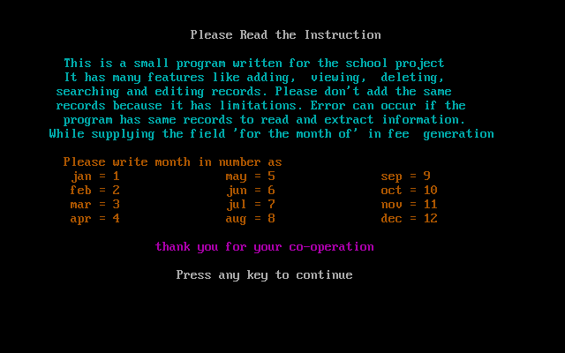

Output of the loading of the Main Menu:

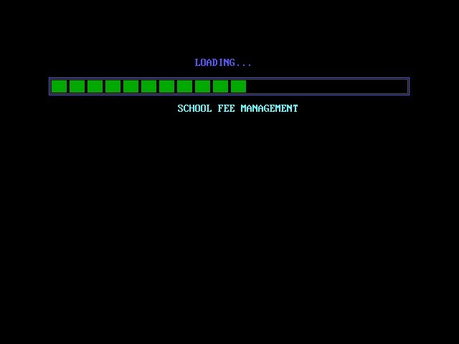

Output of the Main Menu:

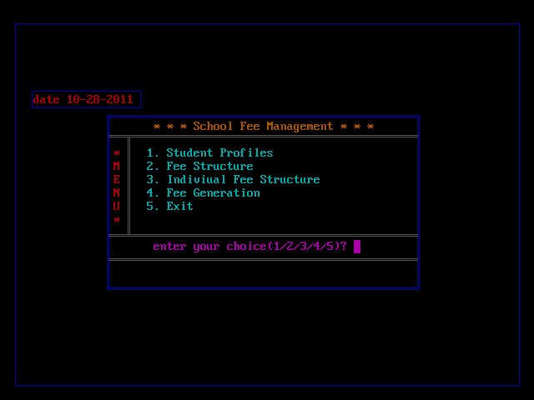

Output of the Loading of the Student Profiles:

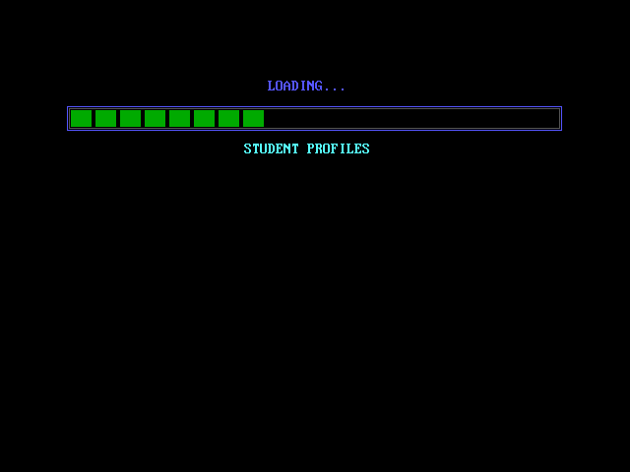

Output of the Menu of the Student Profiles:

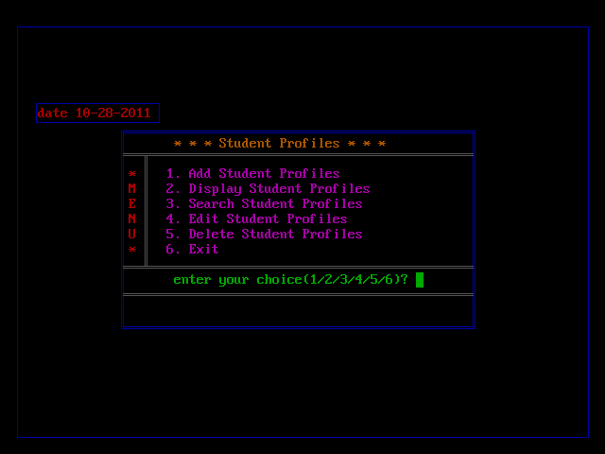

Output of Add Student Profiles:

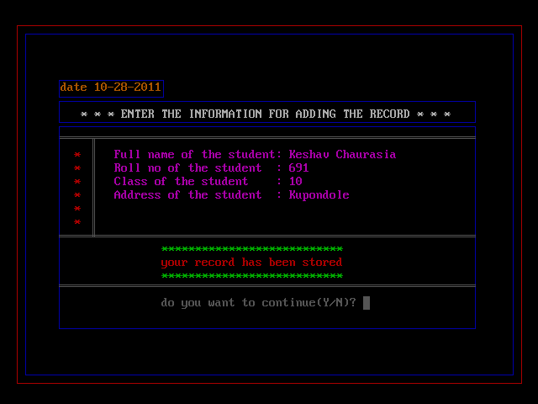

Output of the Display of the Student Profiles:

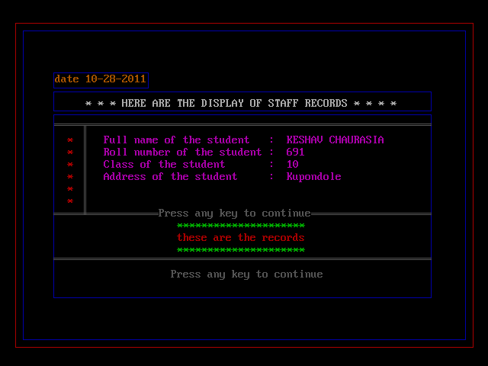

Output of the Menu of the Search of the Student Profile:

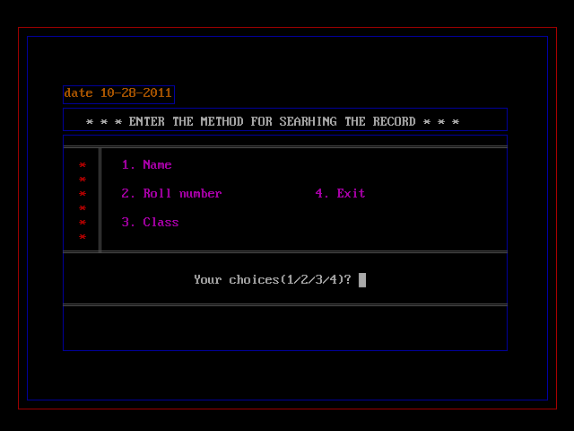

Output of the Search Method by Name:

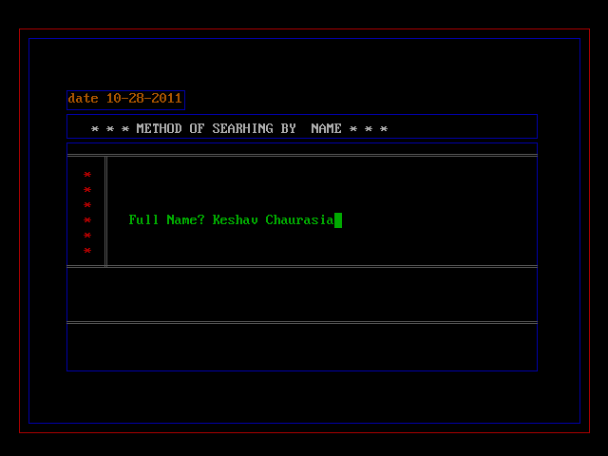

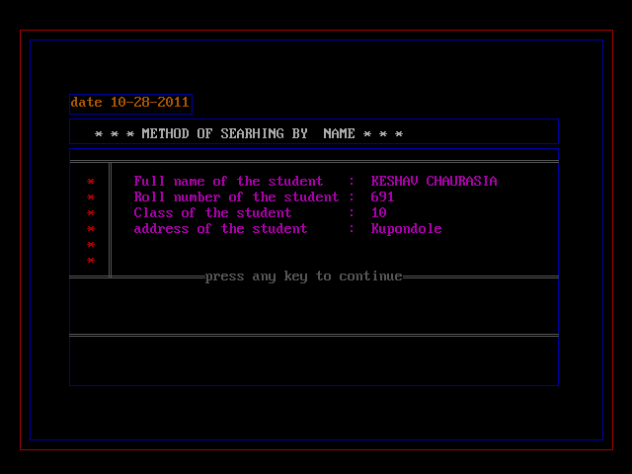

Output of the Search Method by Roll Number:

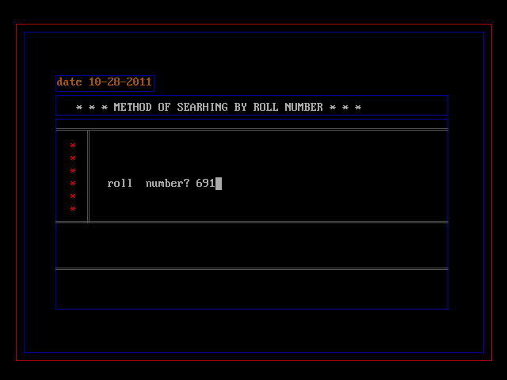

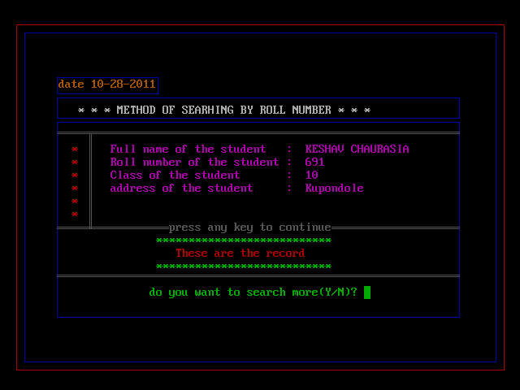

Output of the Search Method by Class:

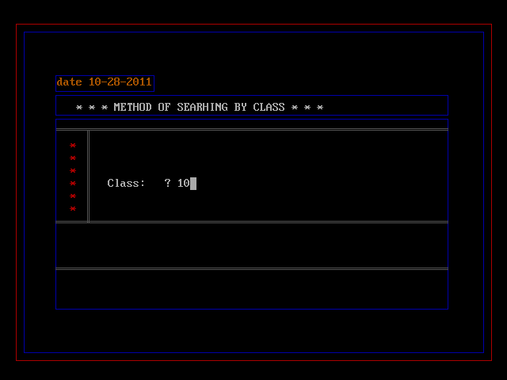

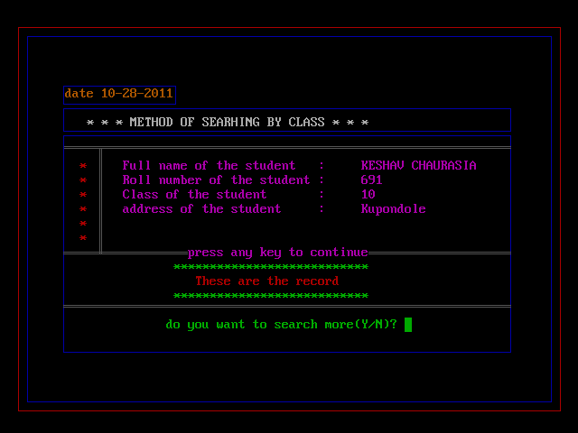

Output of the Edit of the Student Profiles:

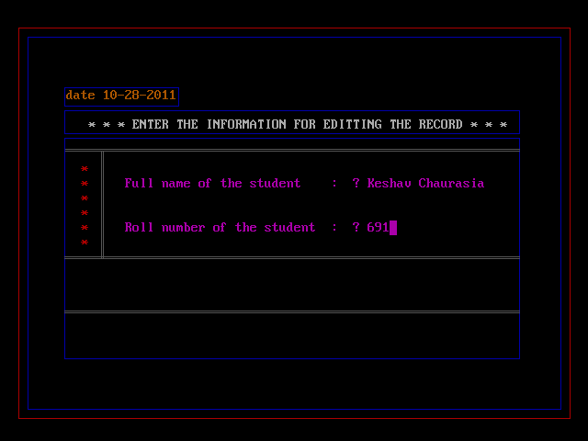

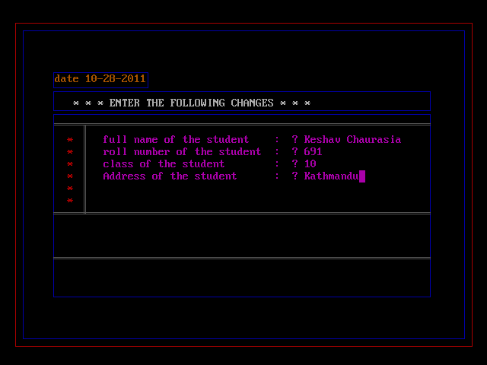

Output of the Delete of the Student Profiles:

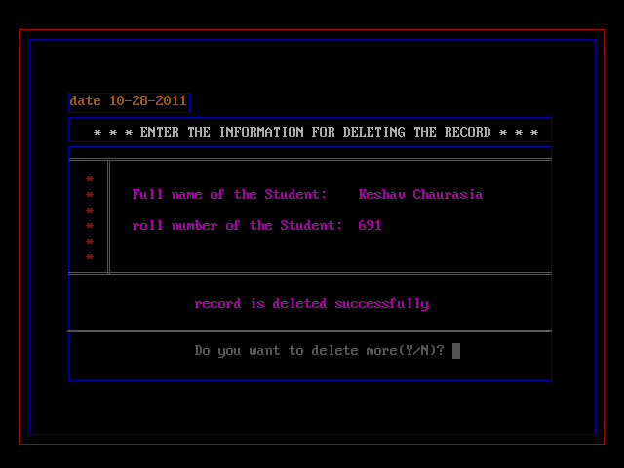

Output of the Loading of the Bill Structure:

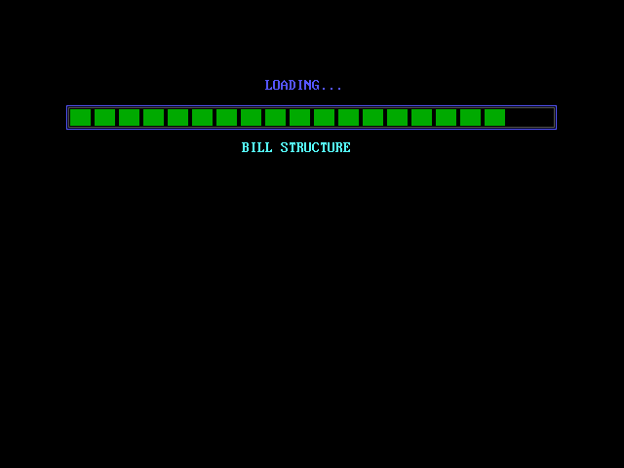

Output of the Menu of the Fee Structures:

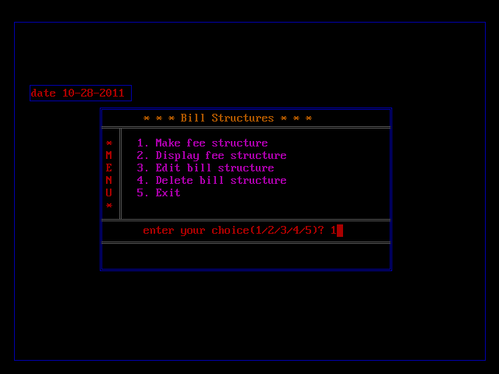

Output of the Making of Fee structures:

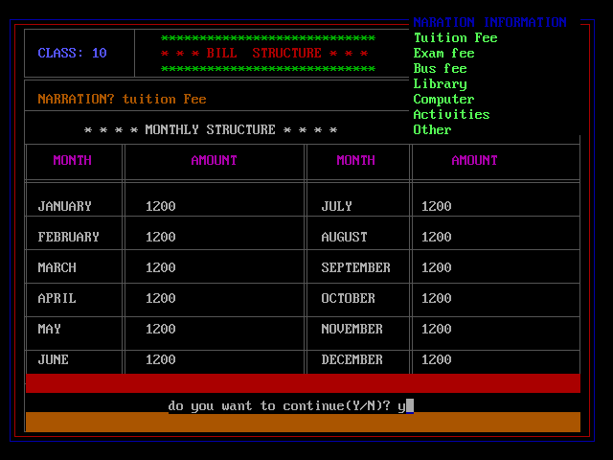

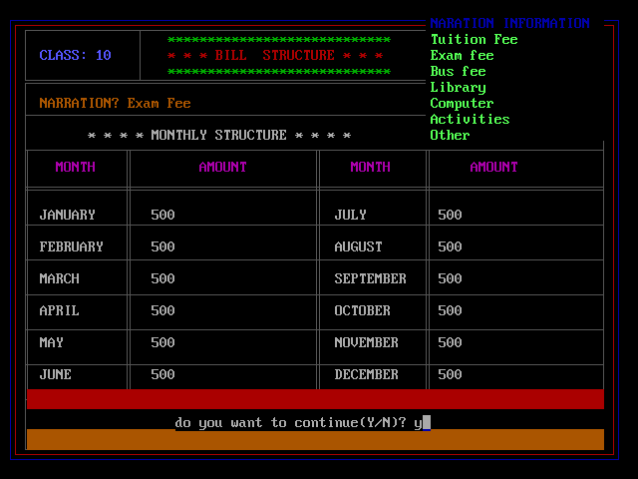

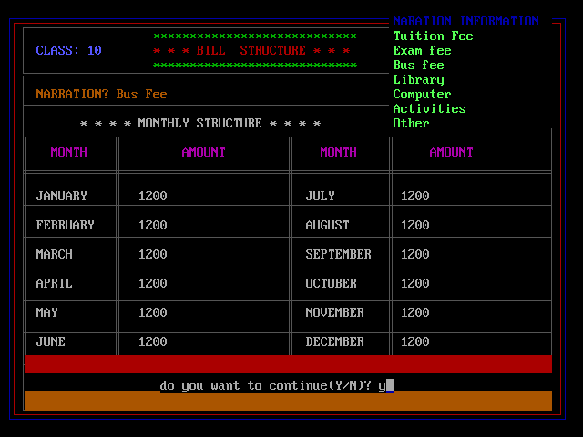

Output of the Display of Fee structure:

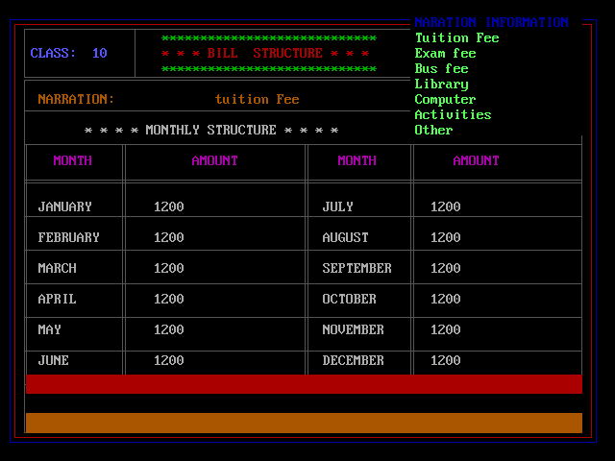

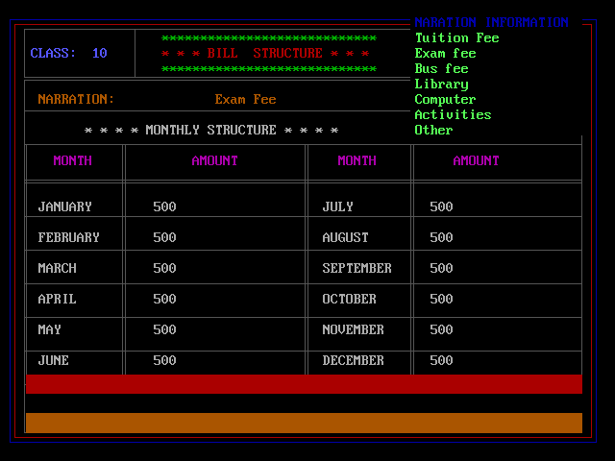

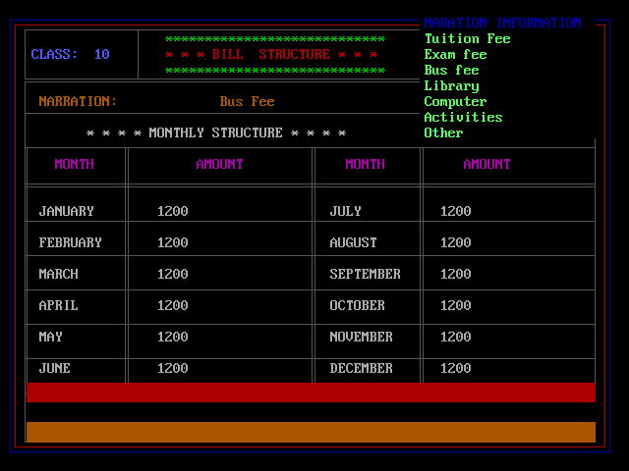

Output of the edit of the Fee structure:

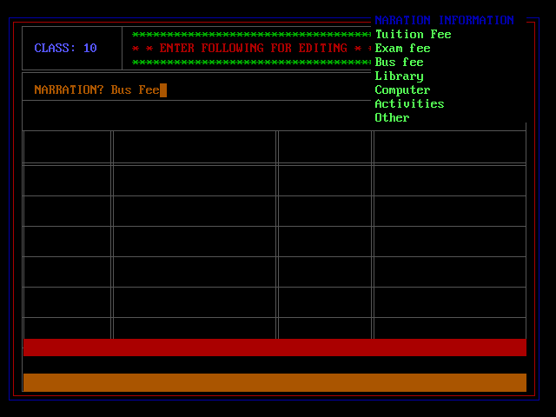

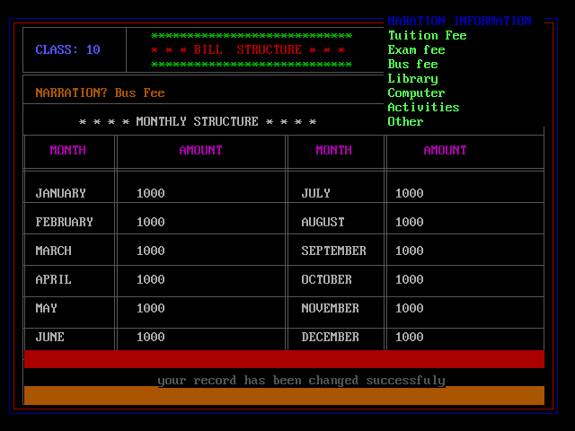

Output of the Delete Fee Structure:

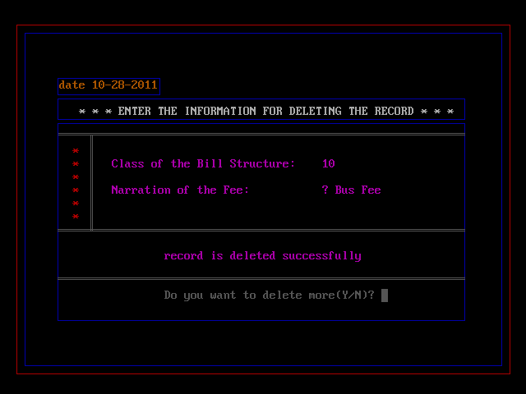

Output of the Loading of the Individual Fee Structure:

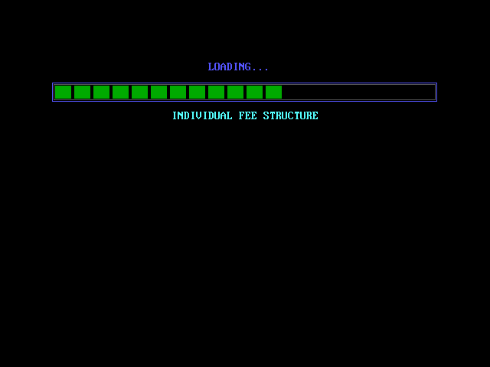

Output of the Menu of the Individual Fee Structure:

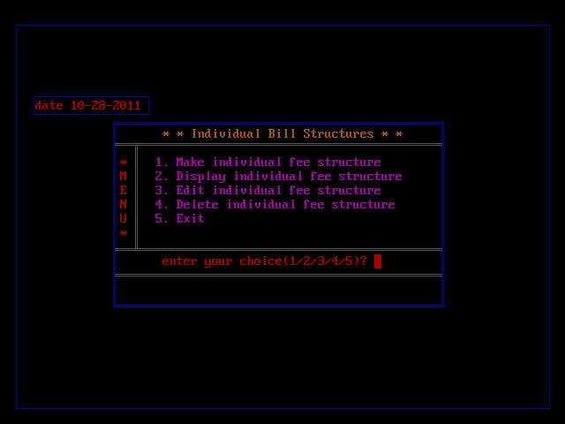

Output of the Making of the Individual Fee Structure:

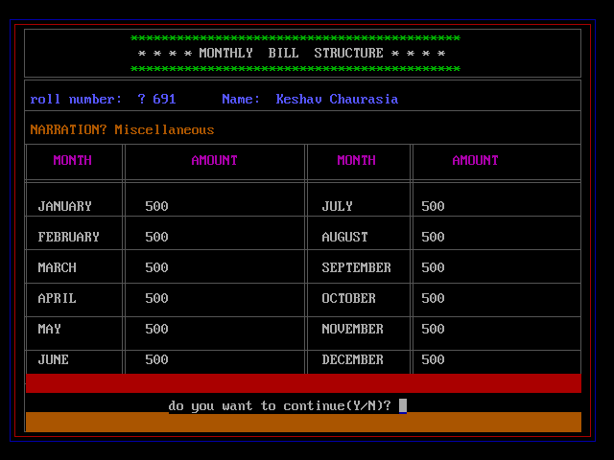

Output of the display of the Individual Fee Structure:

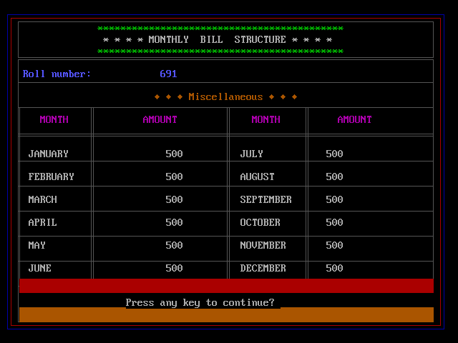

Edit of the Individual Fee Structure:

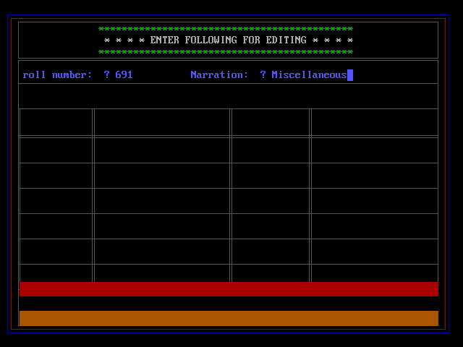

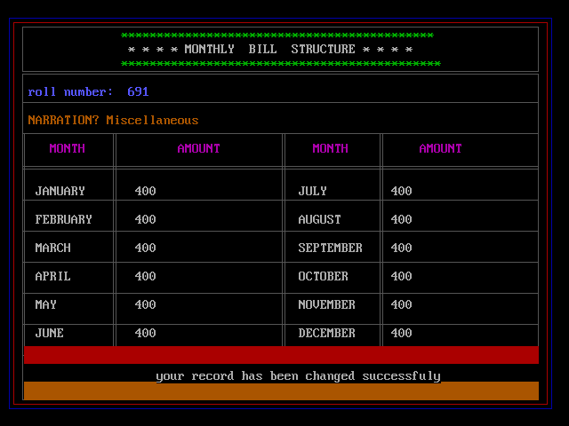

Output of the Delete of the Individual fee Structure:

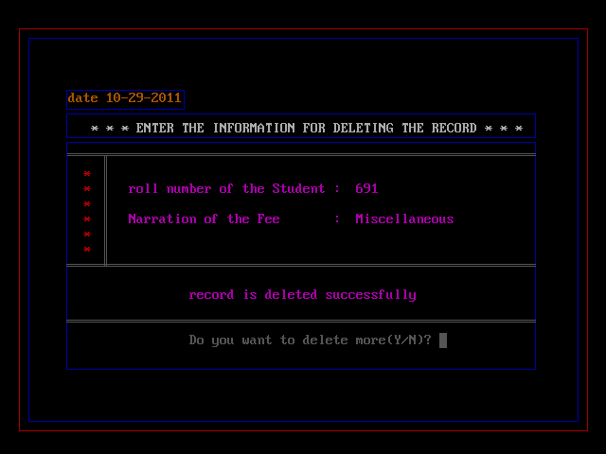

Output of the Loading of the Menu of Fee Generation:

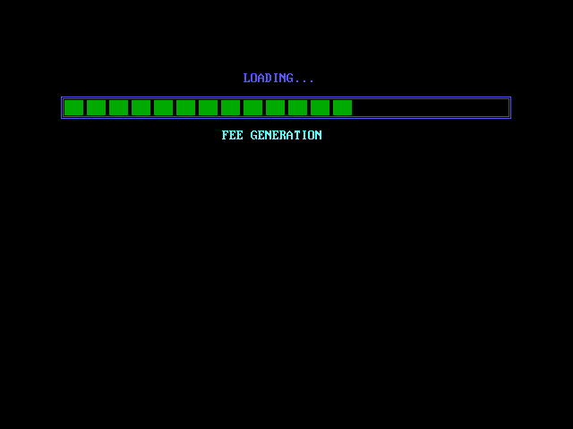

Output of the Menu of Fee Generation:

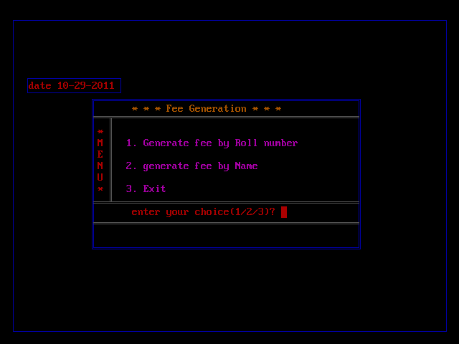

Output of the Fee Generation by Roll Number:

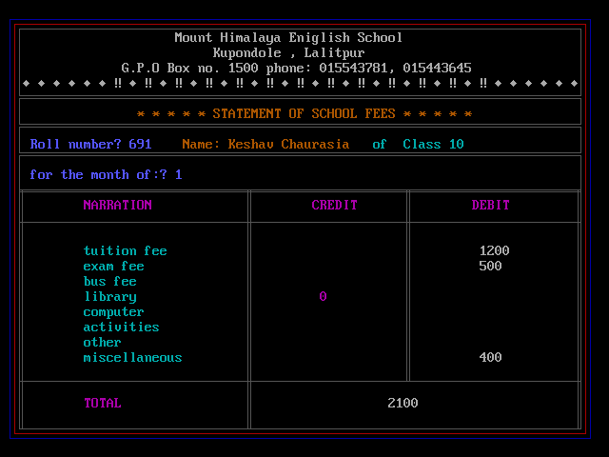

Output of the Fee Generation by Name:

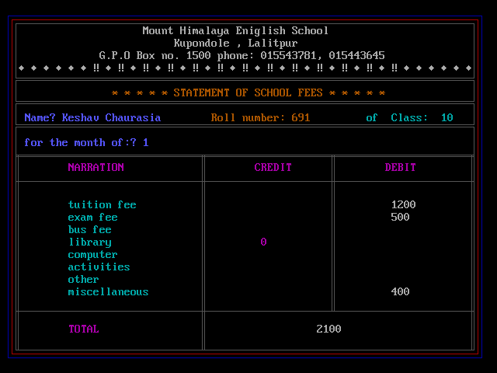

Output of the Exit:

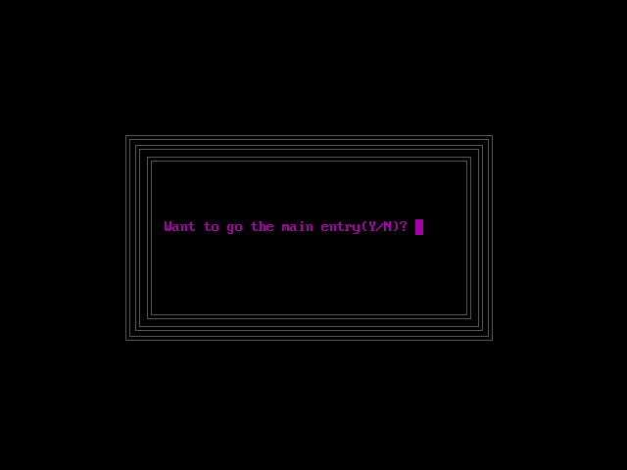

Conclusion

This is the program related to database of School Fee Management with facilities to add, display, search, edit and delete student profiles, bill structures and individual bill structures. However, this program has certain drawbacks. It adds records even if the records already exist. It works even if a field is left blank by the user. For example, while adding records, even if the user doesn’t supply any values for the field “Name”, it adds the record. It has no printing facilities.